Laravel 5.1

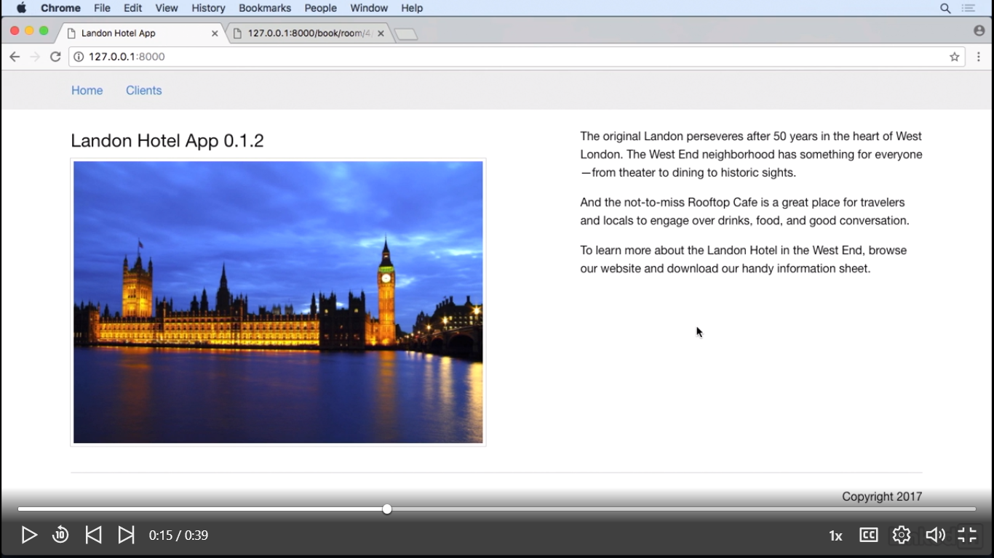

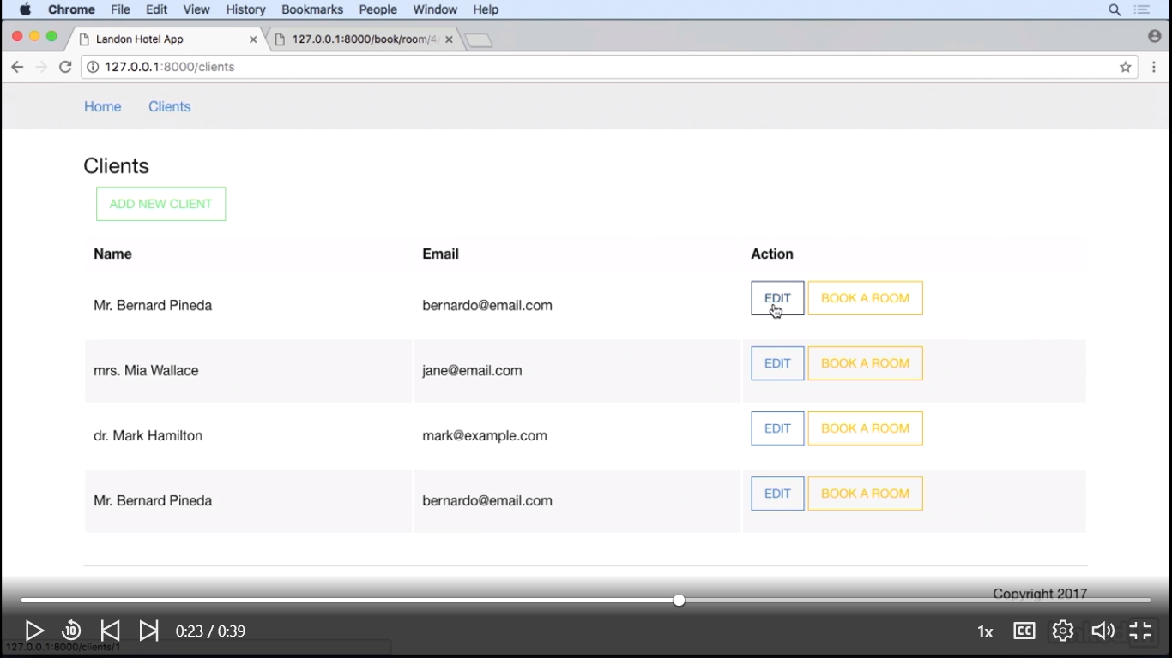

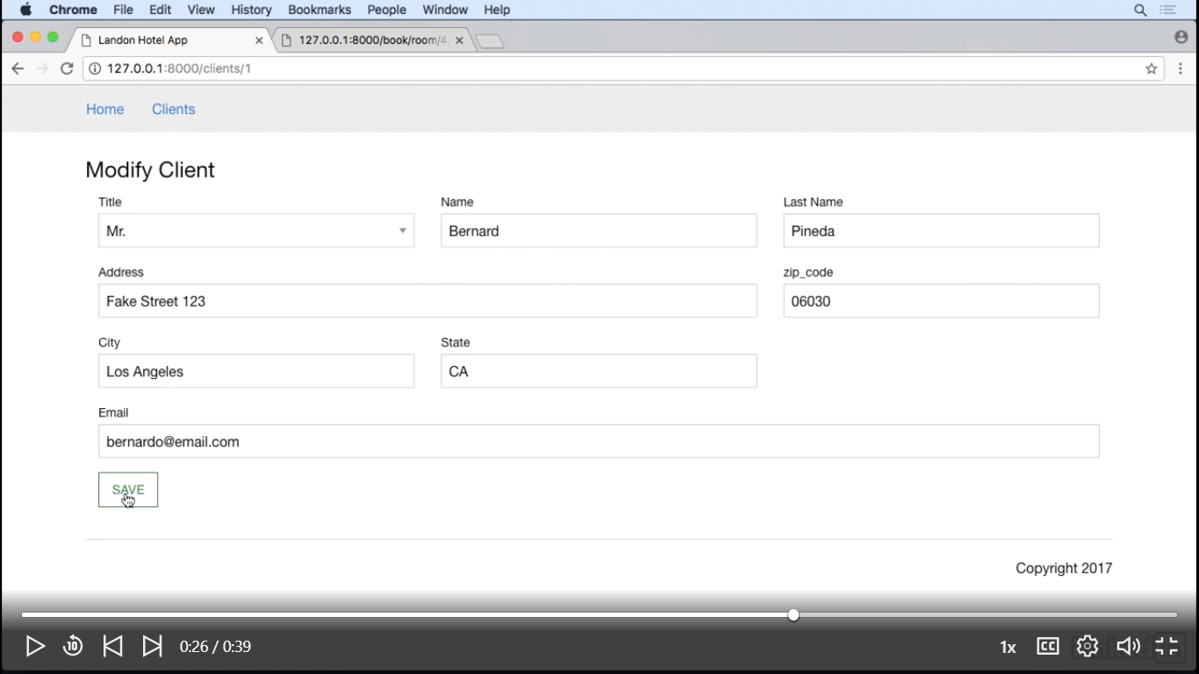

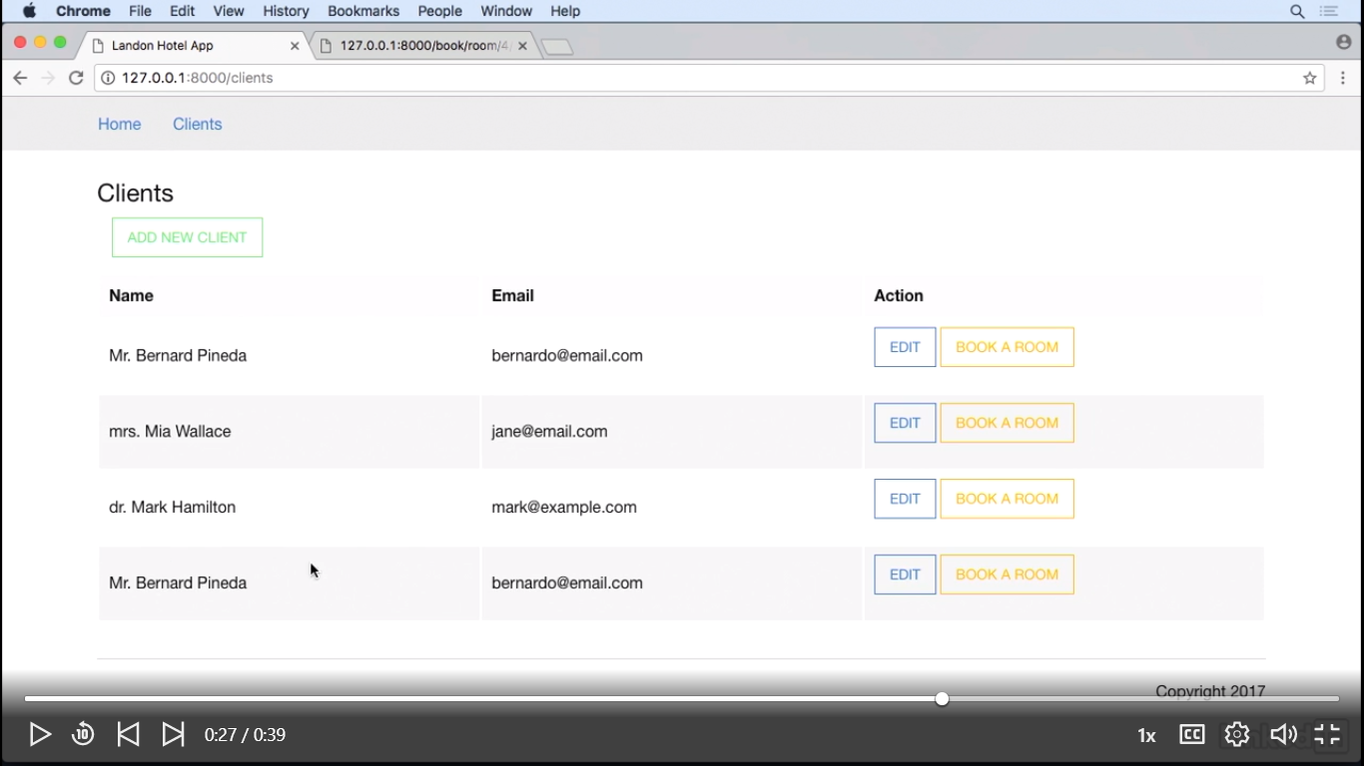

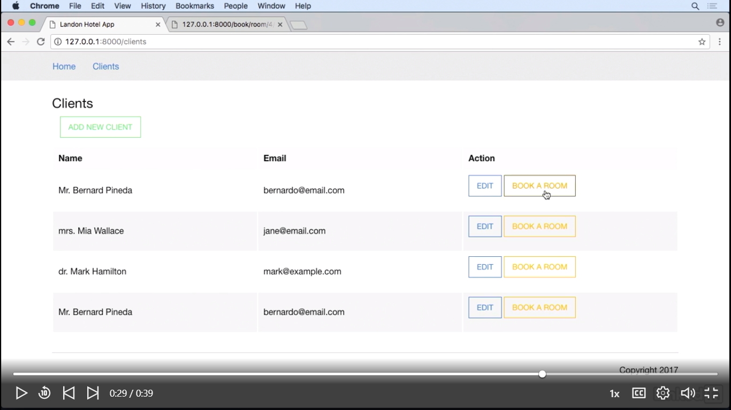

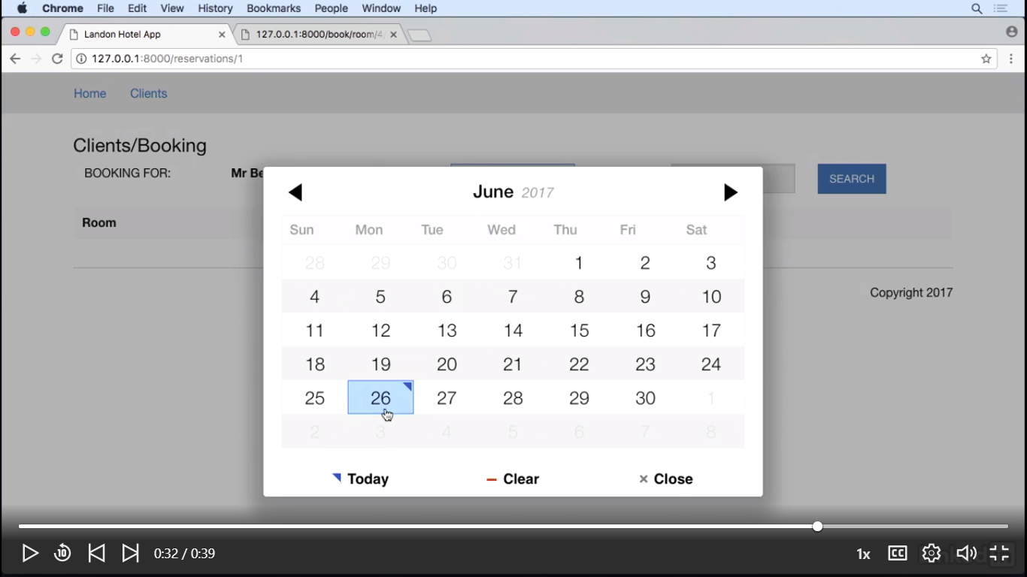

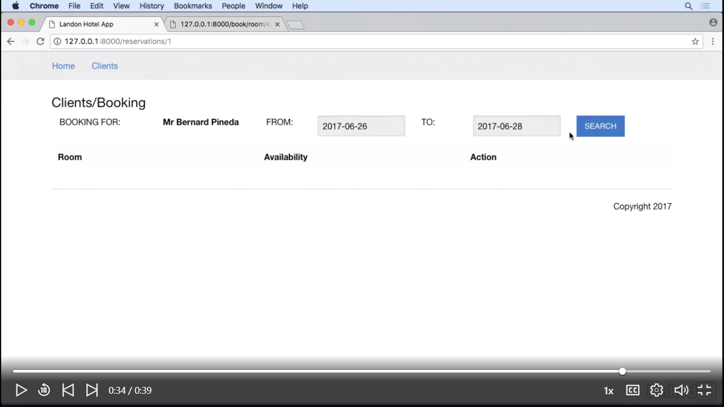

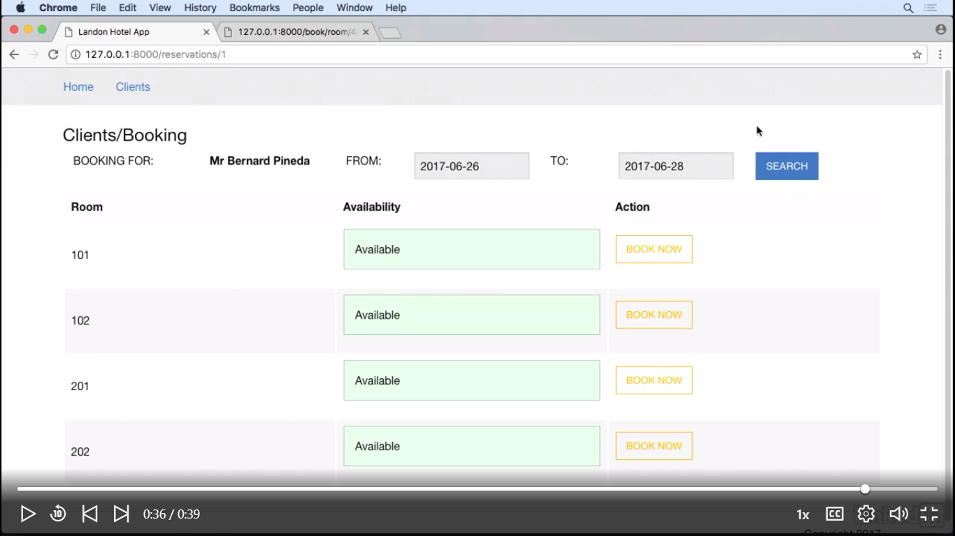

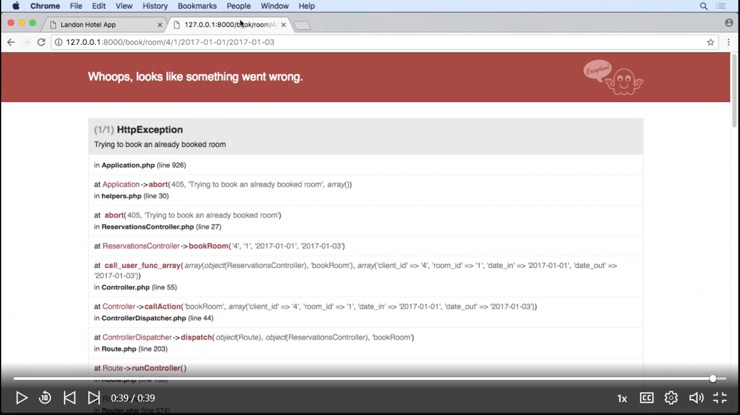

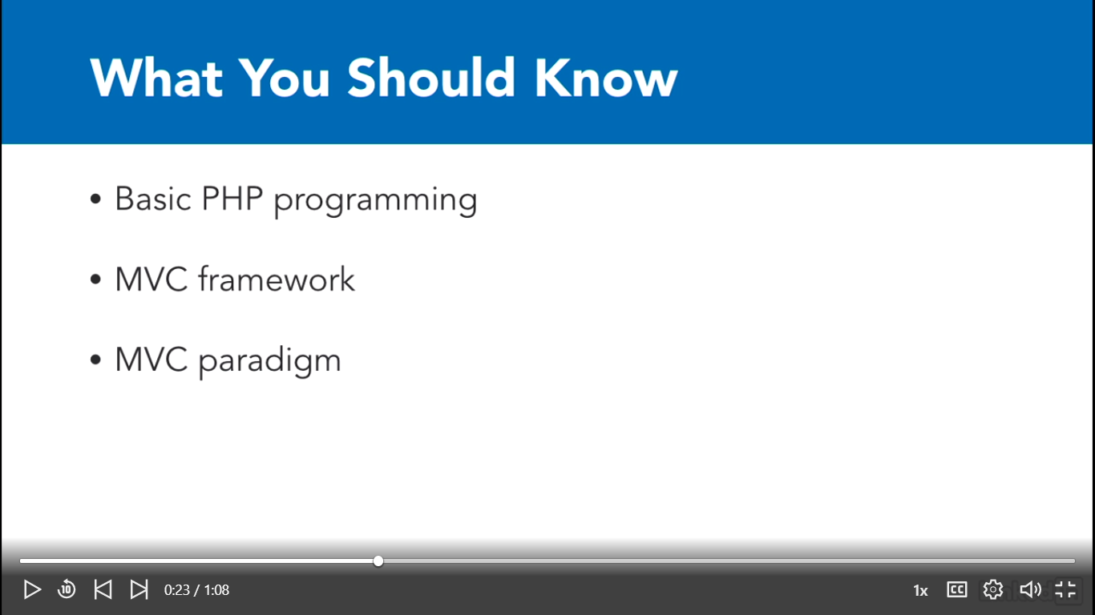

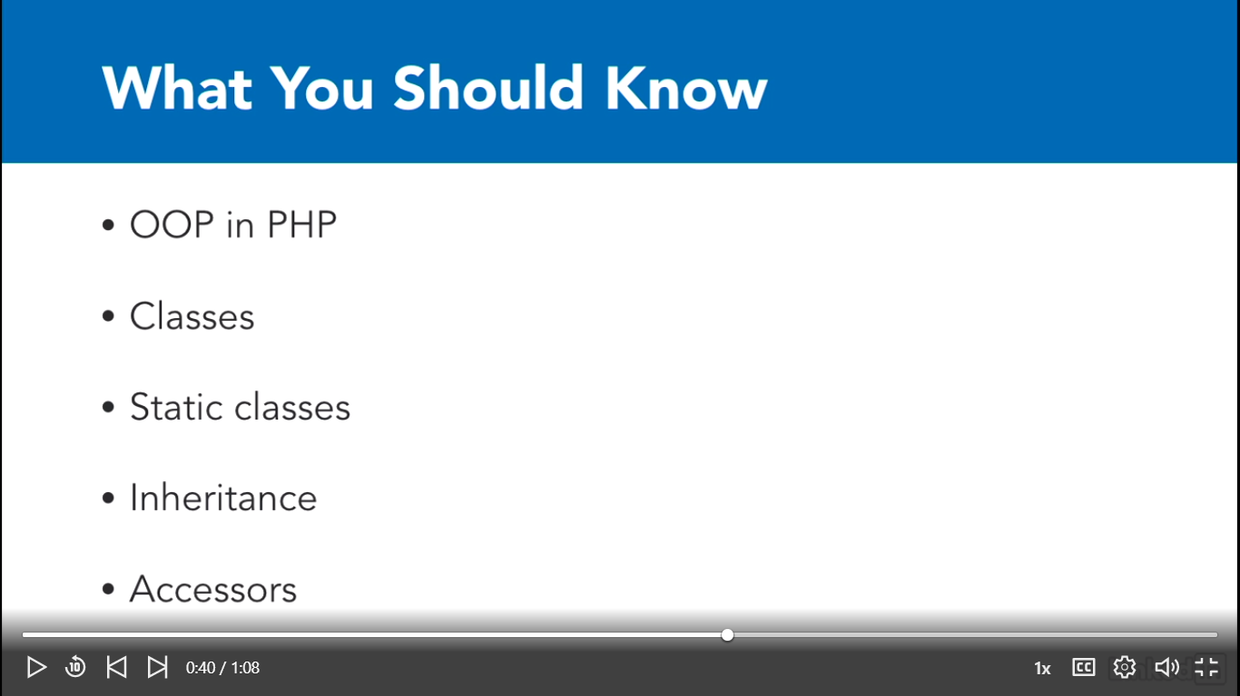

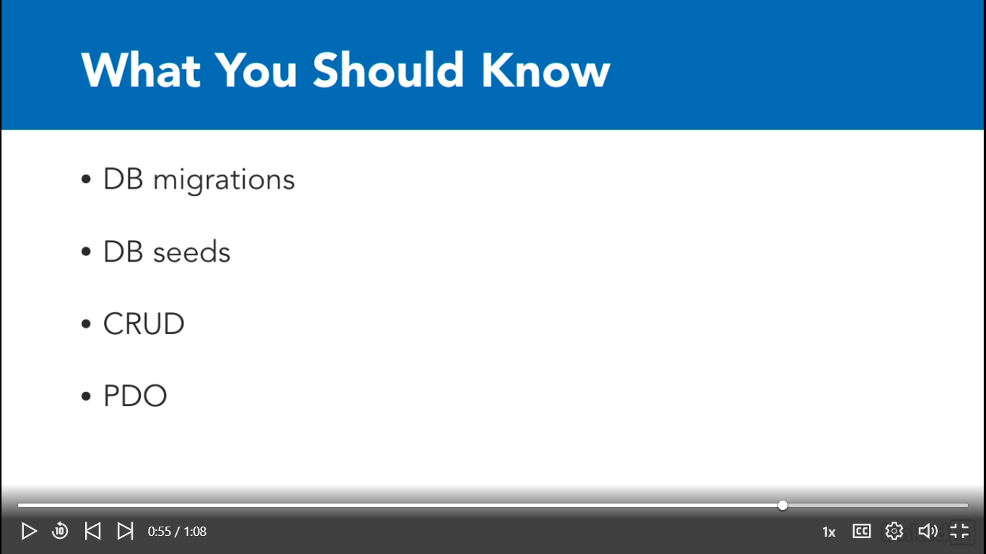

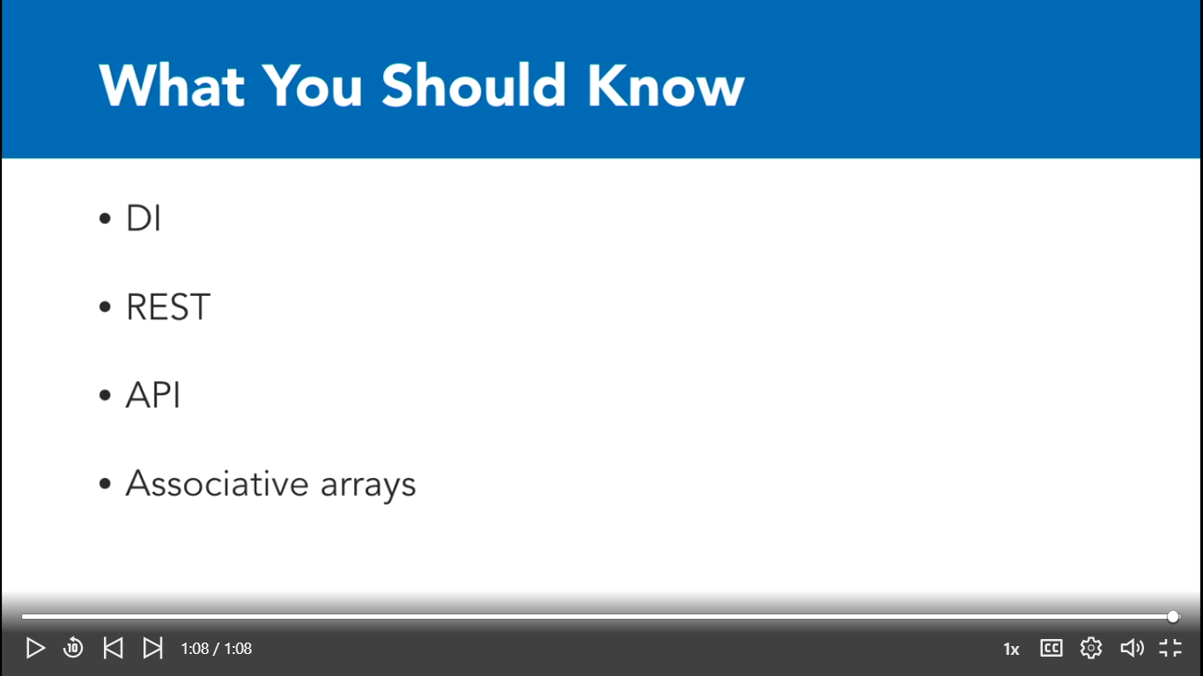

Using the exercise files

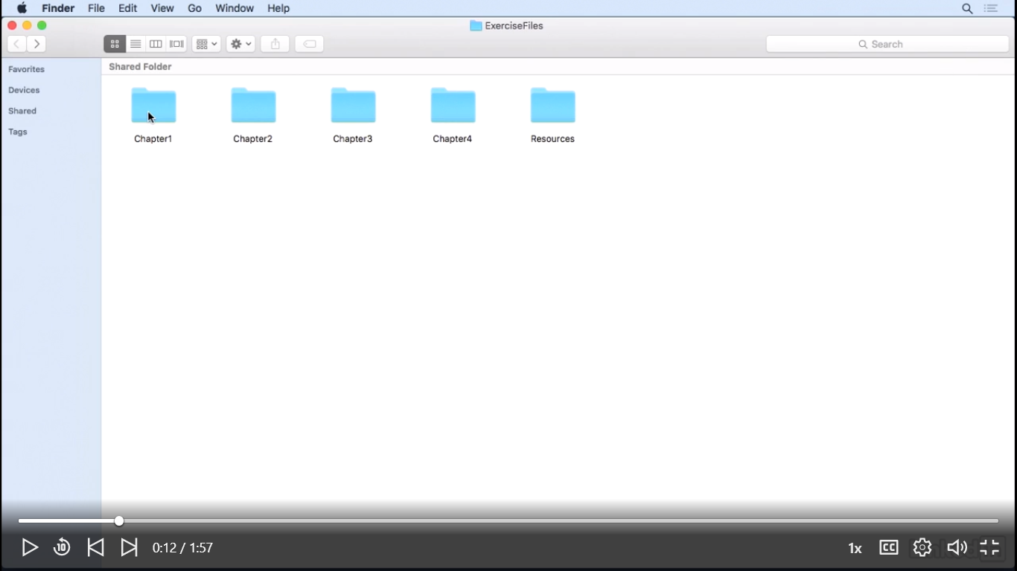

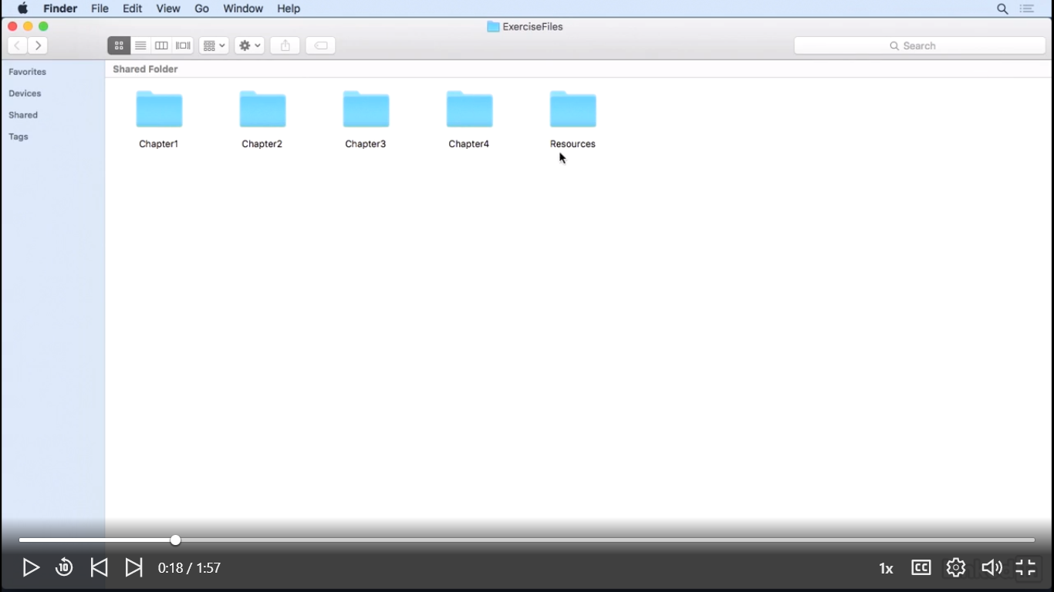

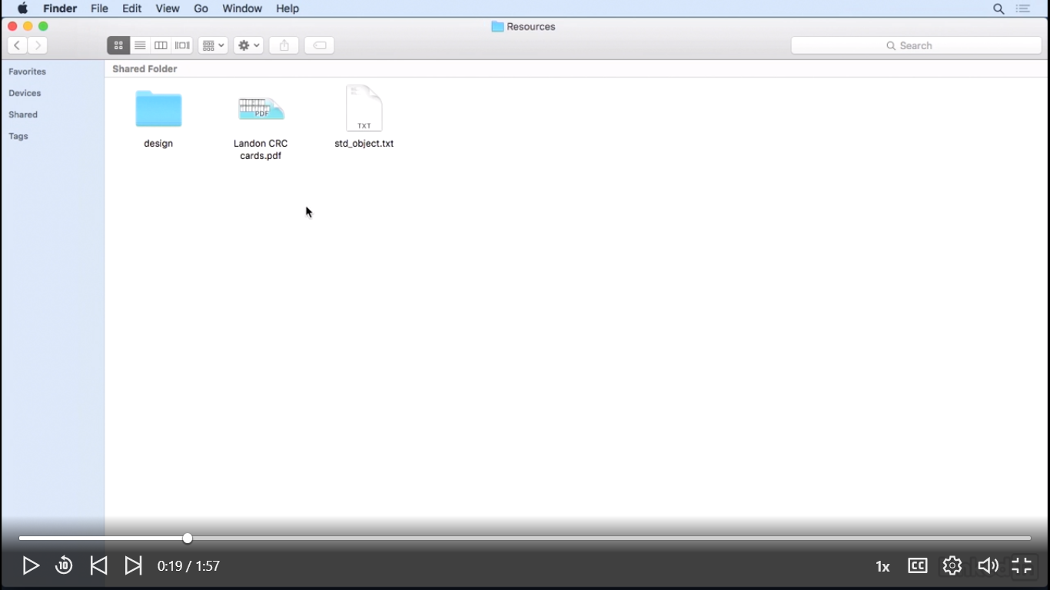

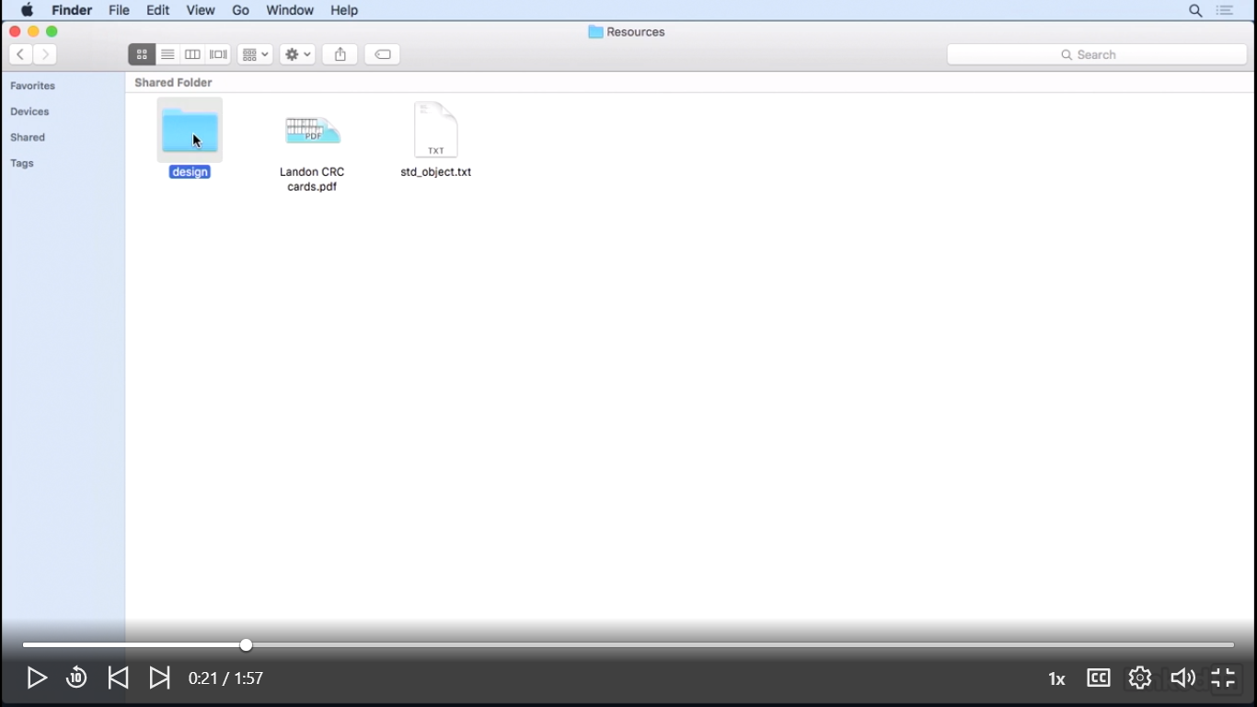

Copy the landon_app to the desktop



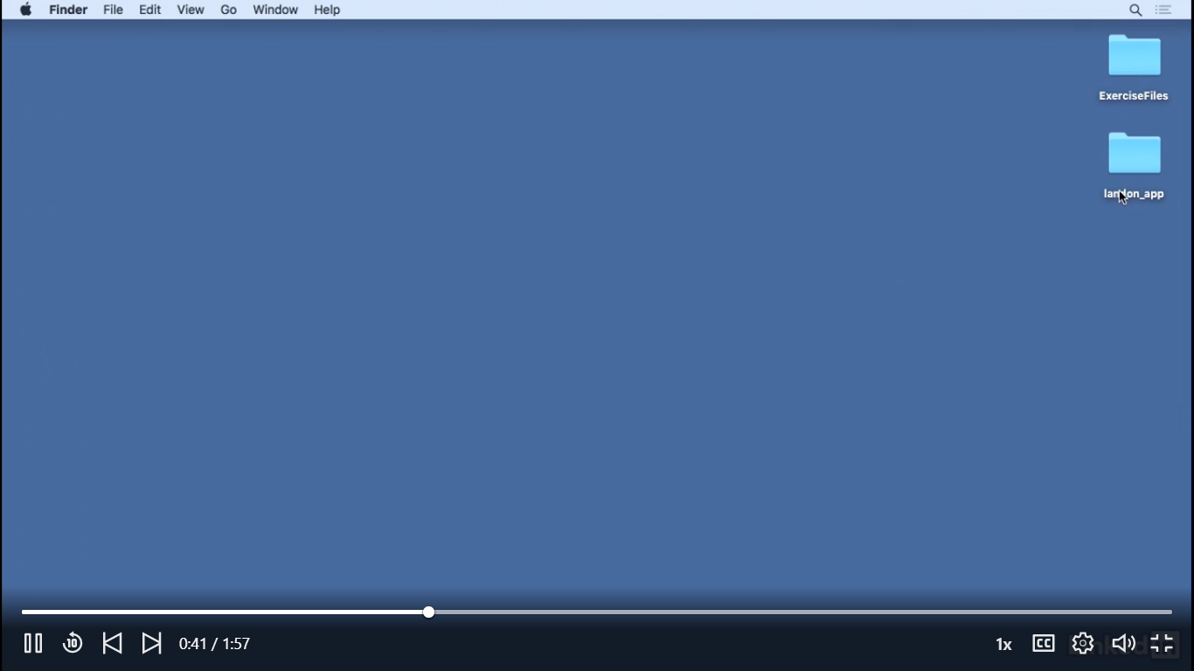

Open the console:

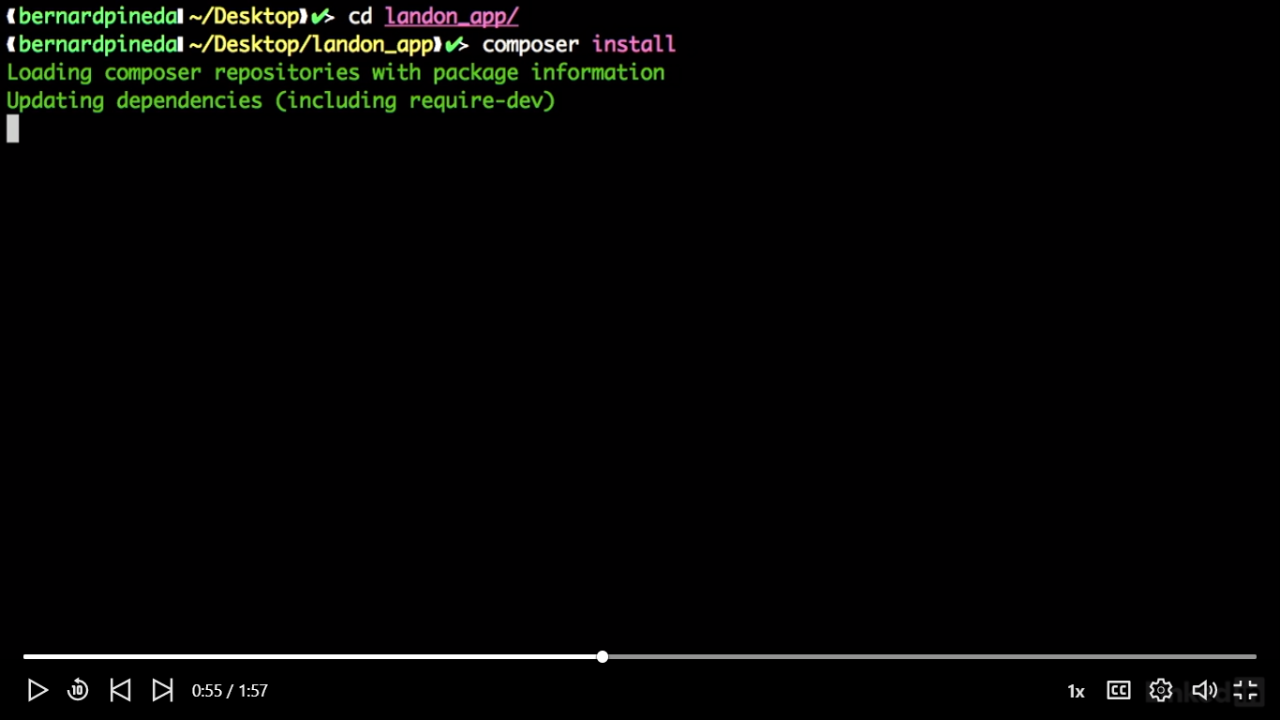

Then install artisan:

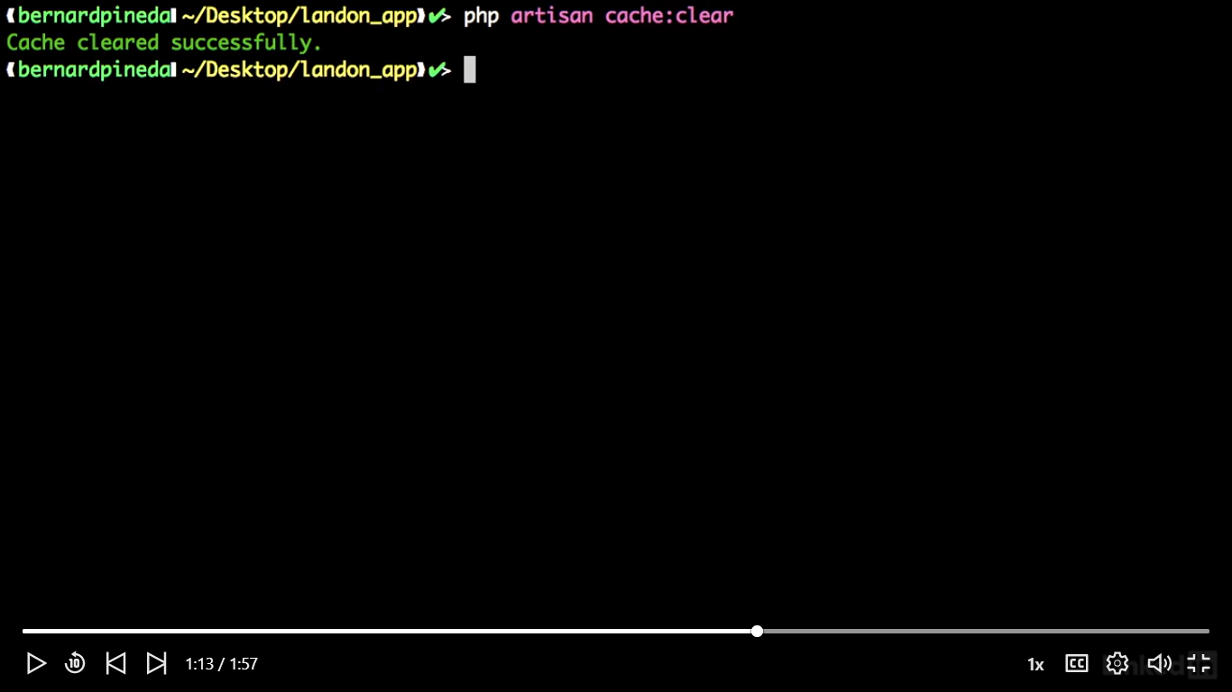

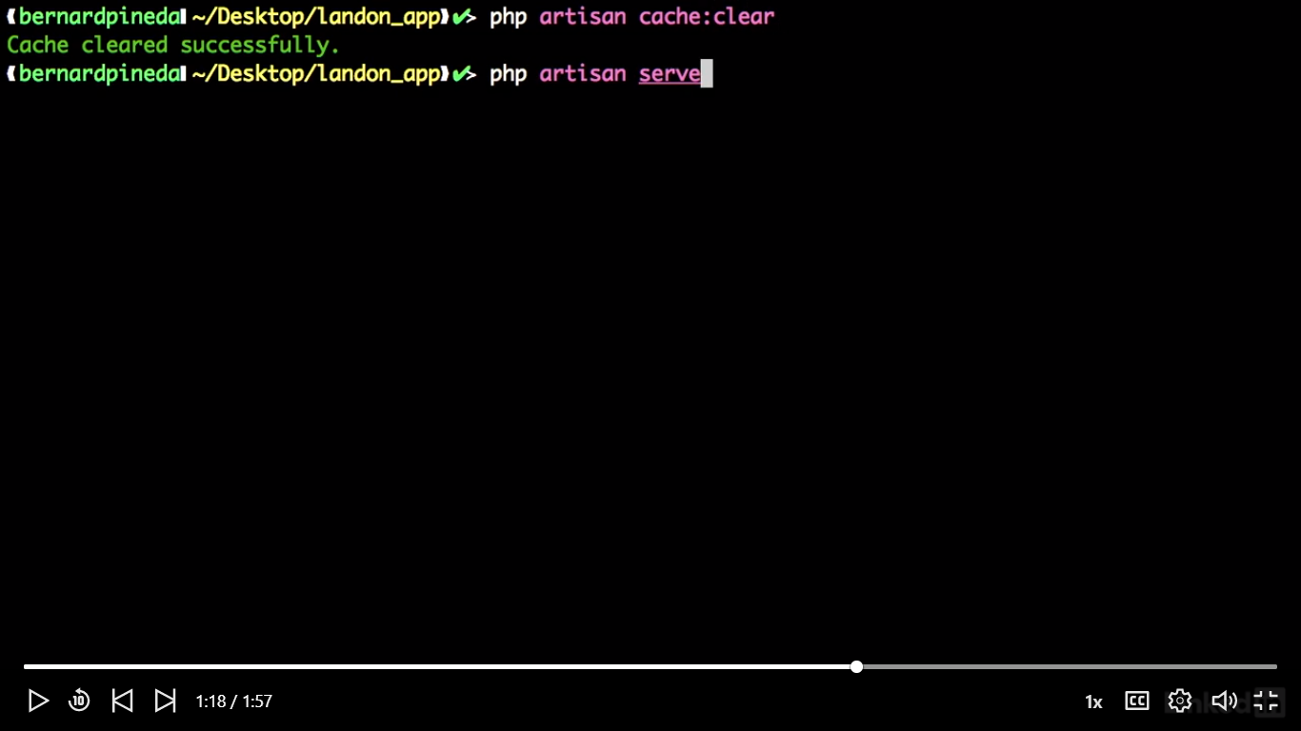

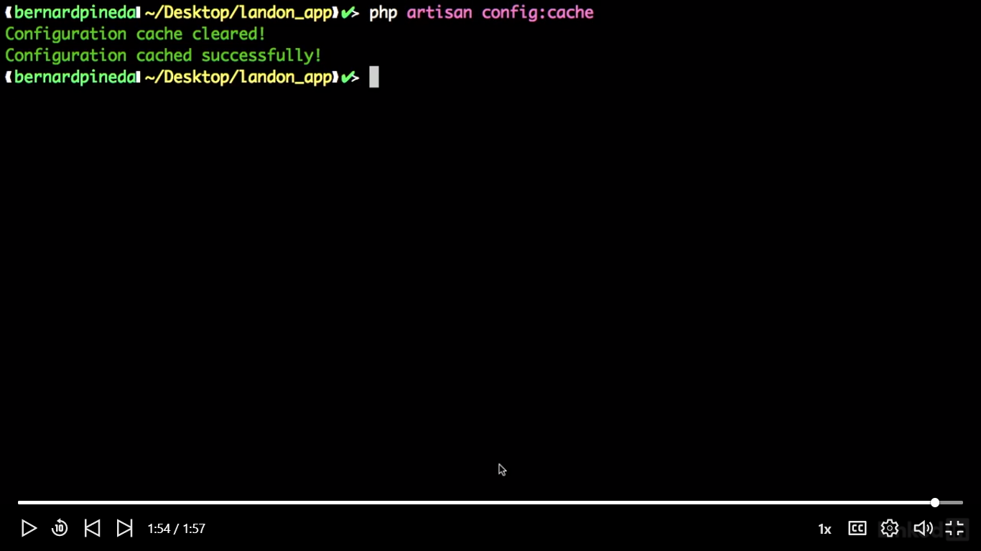

Install Xcode

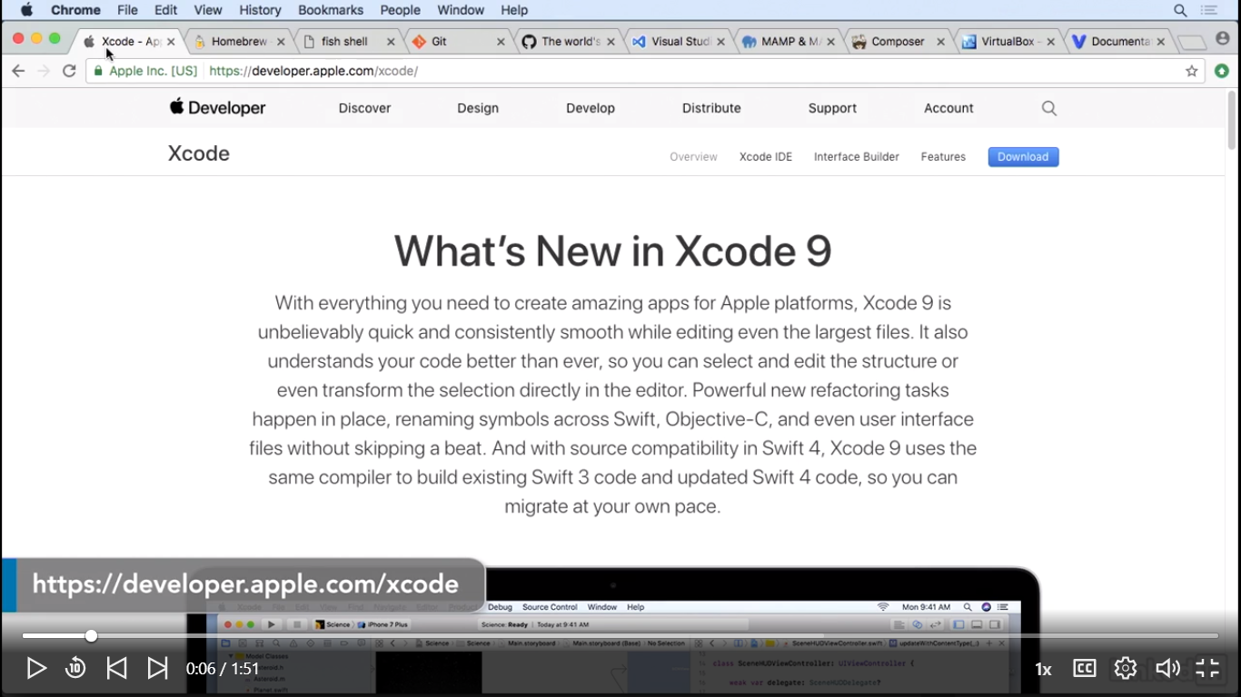

Install Homebrew

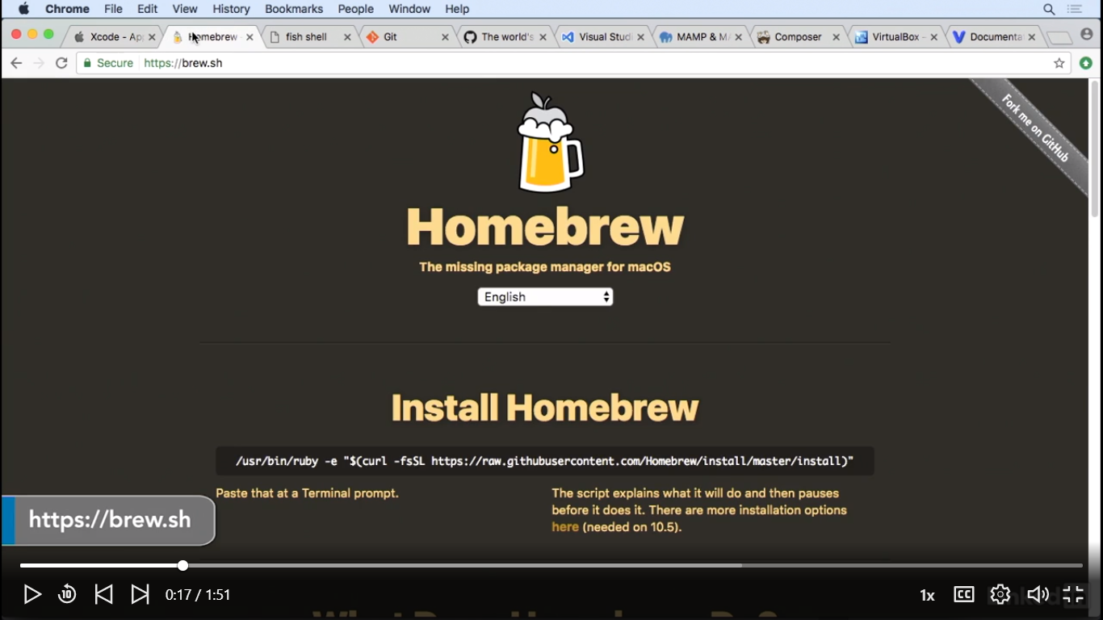

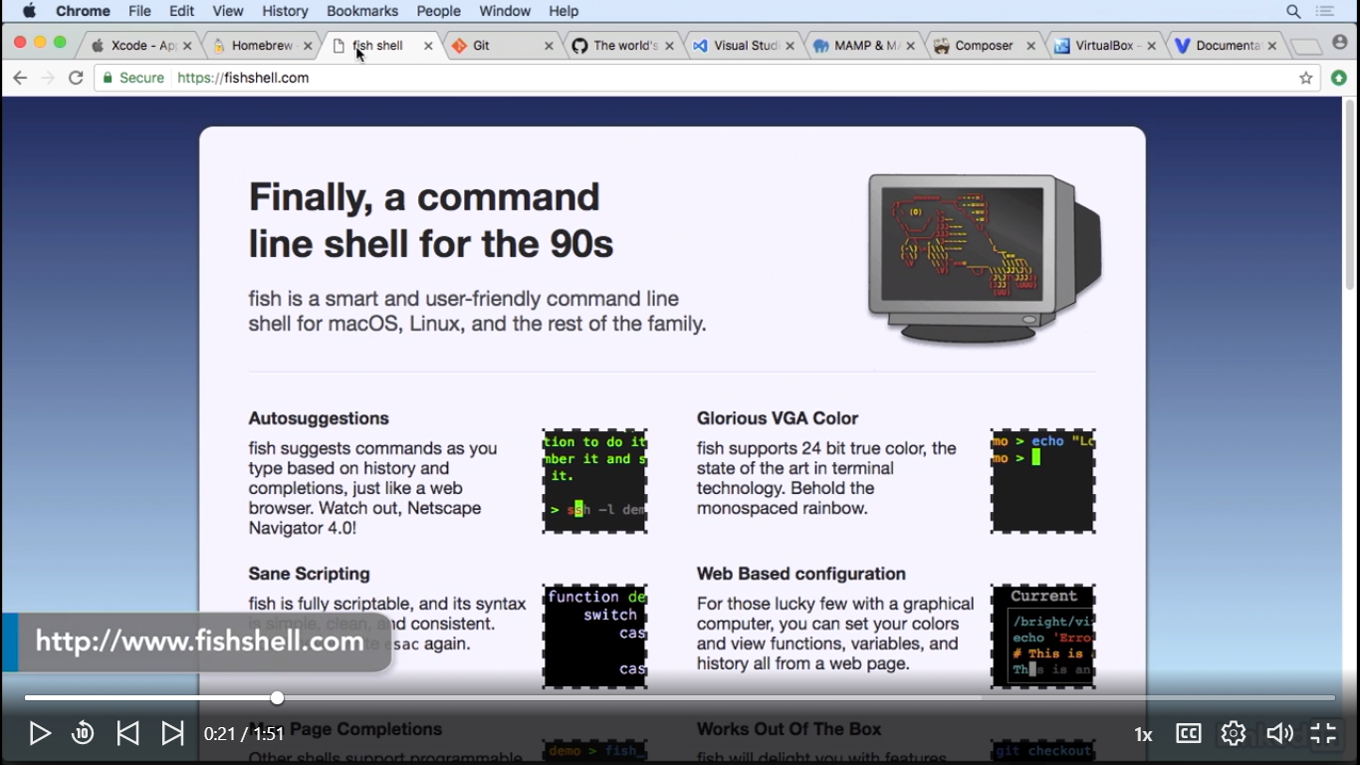

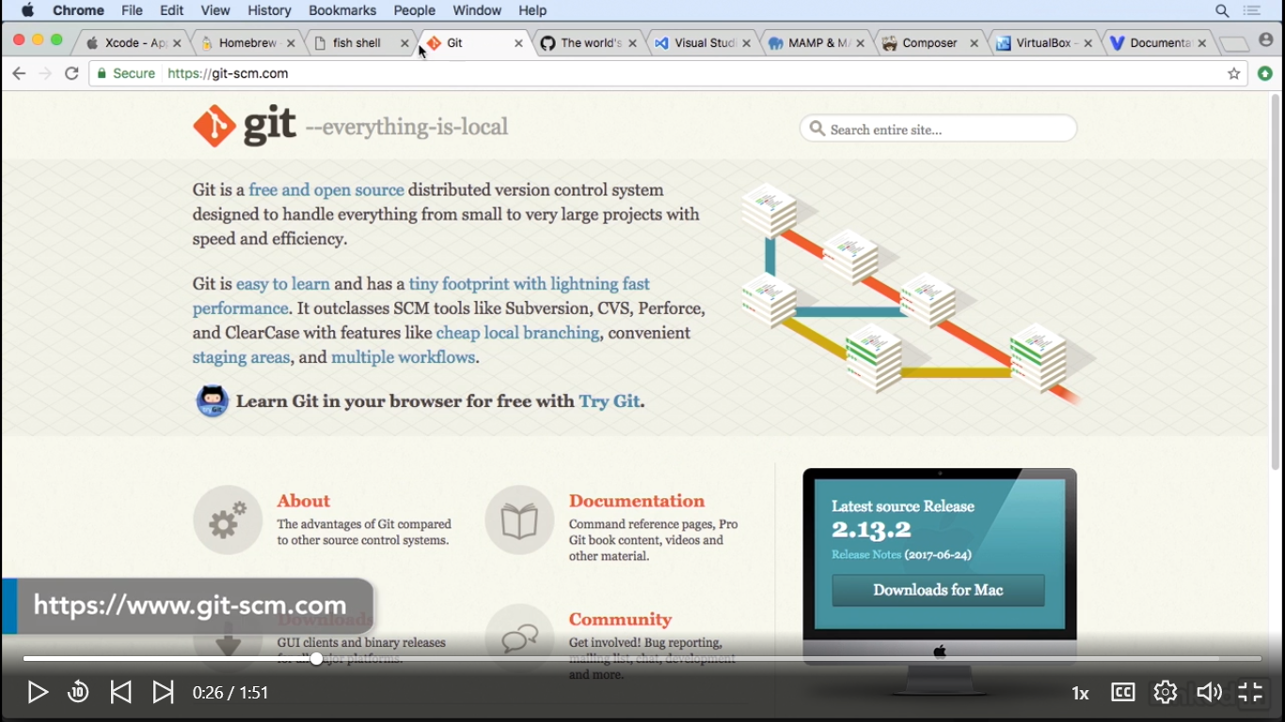

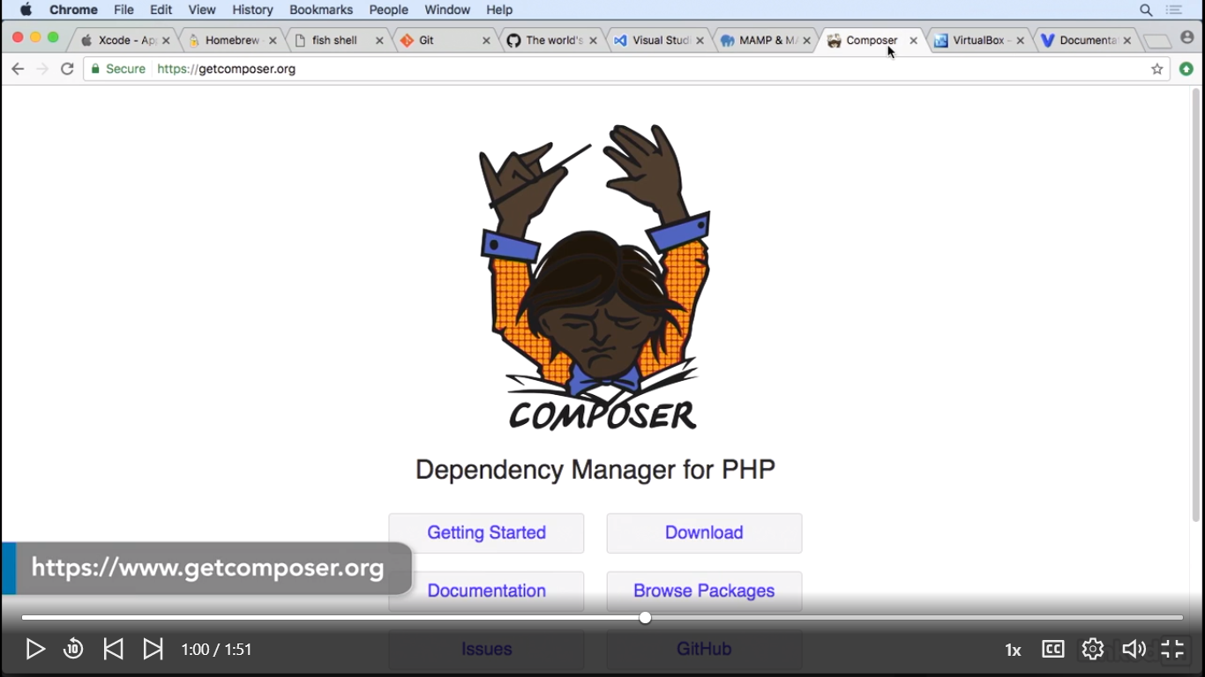

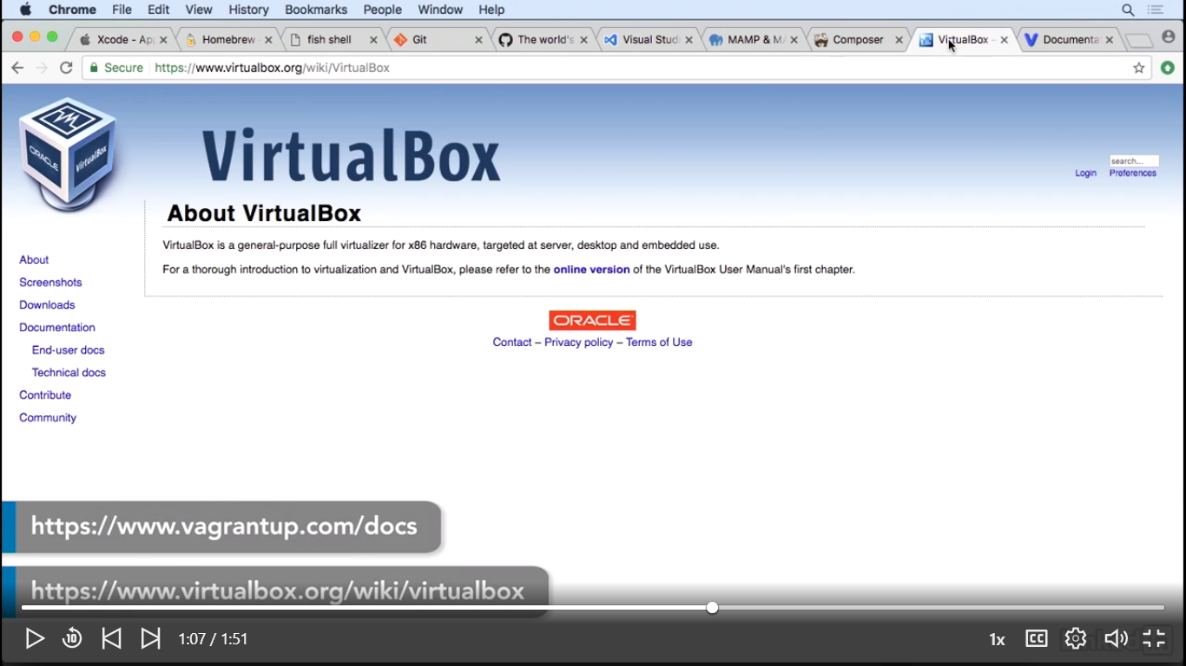

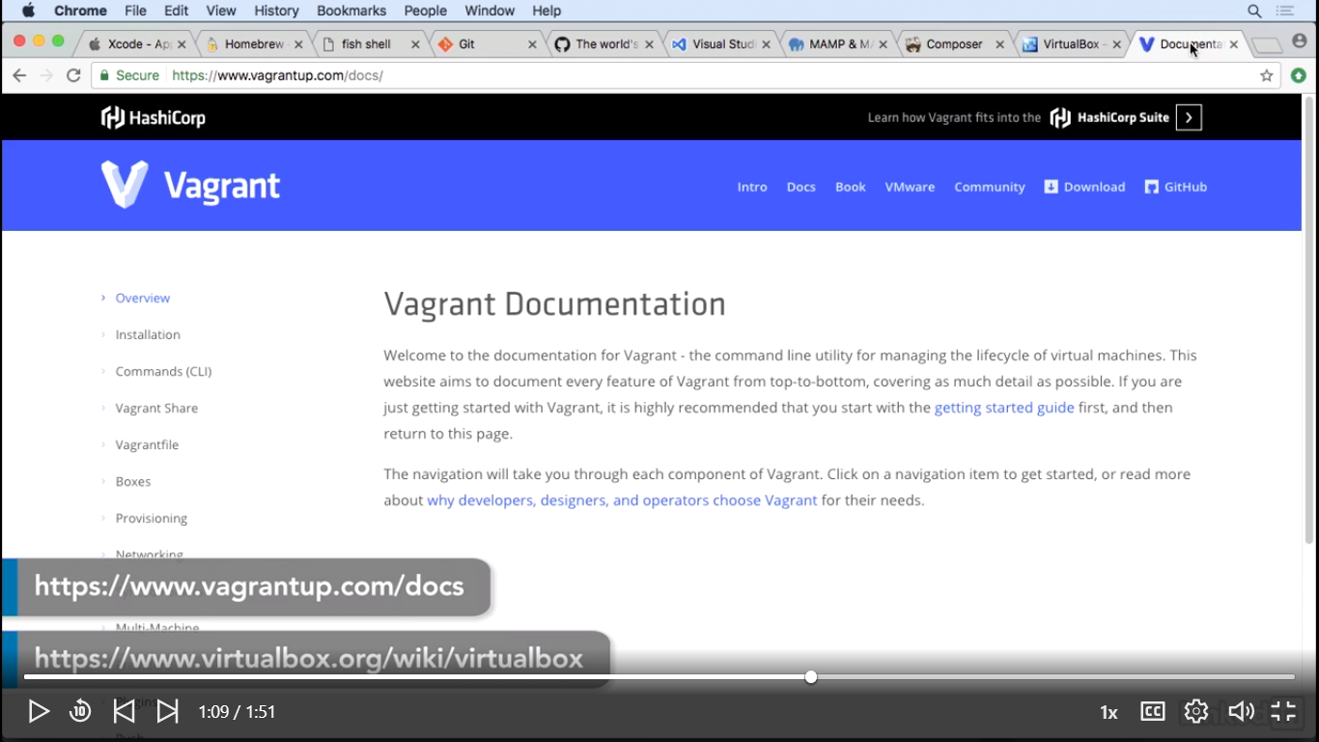

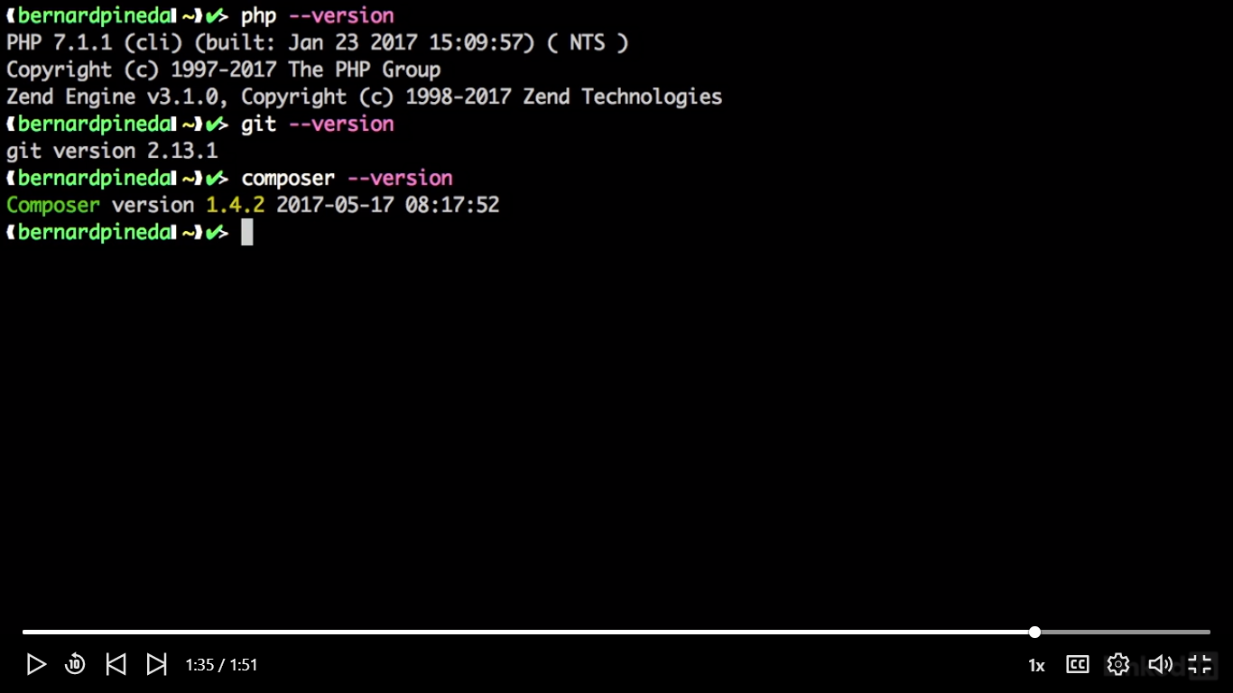

Installation for Windows

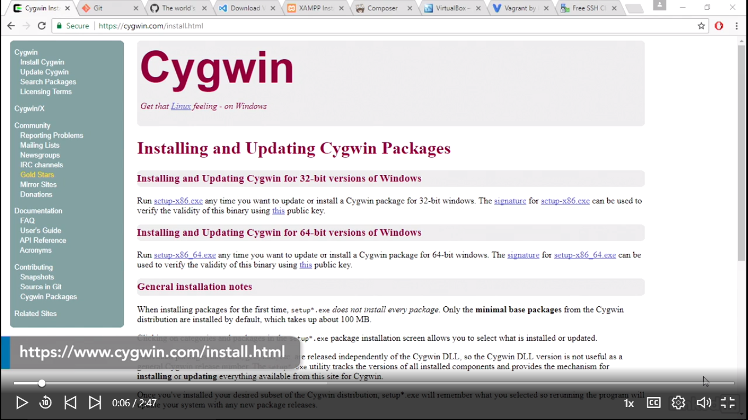

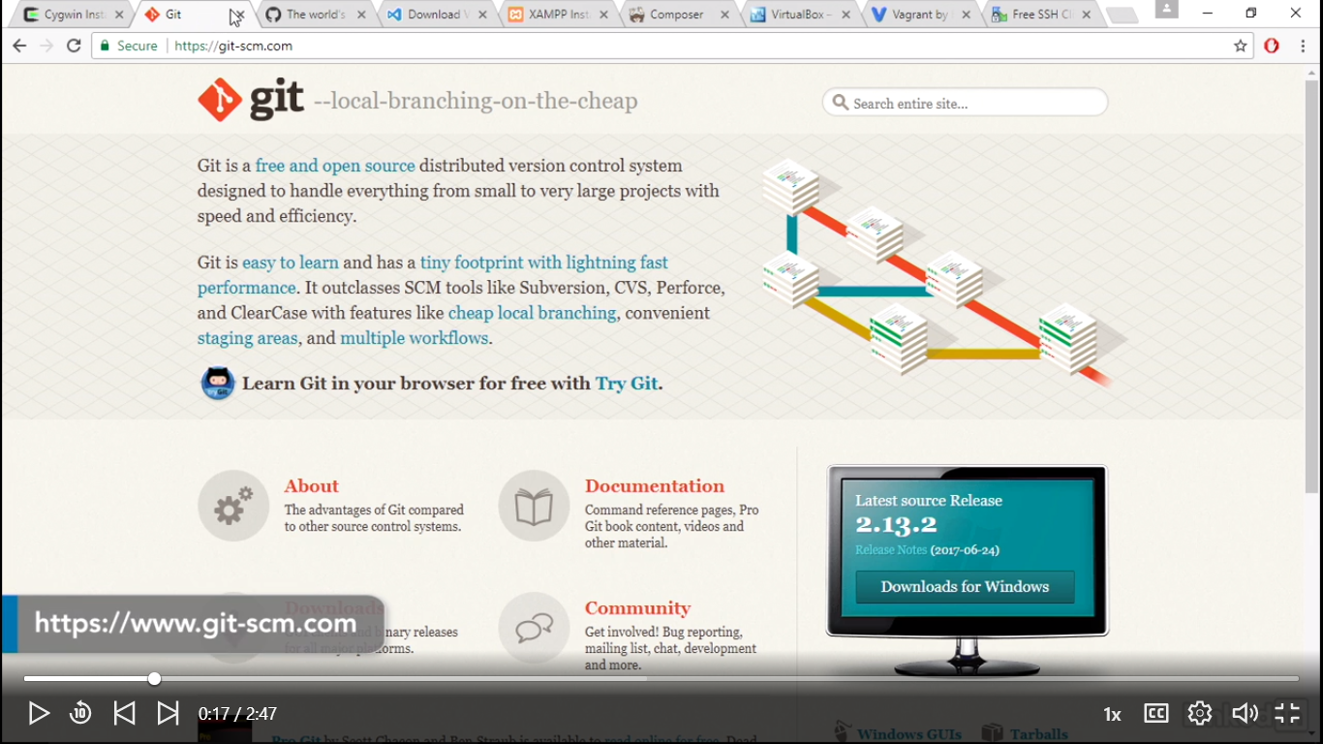

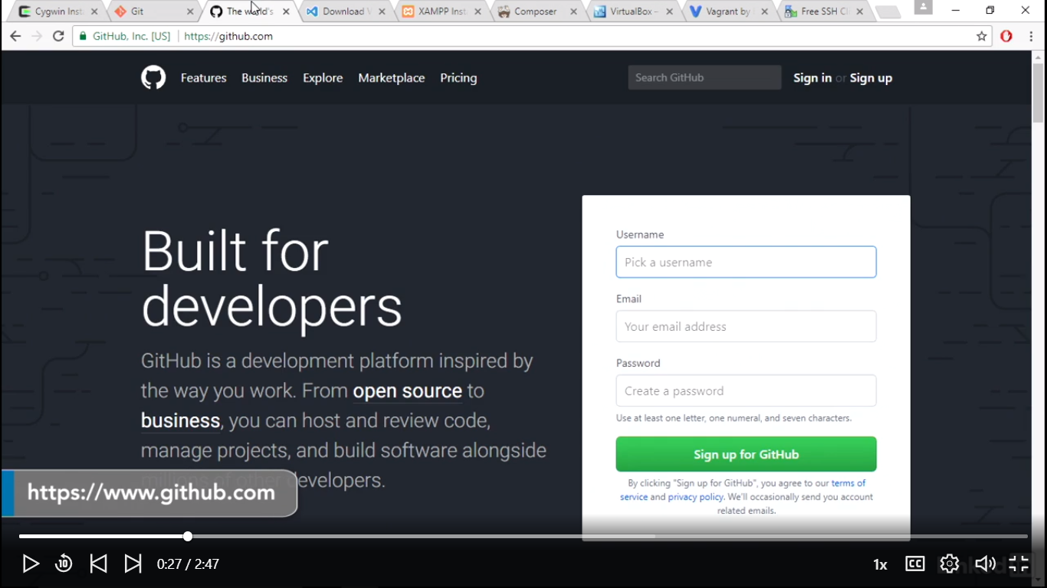

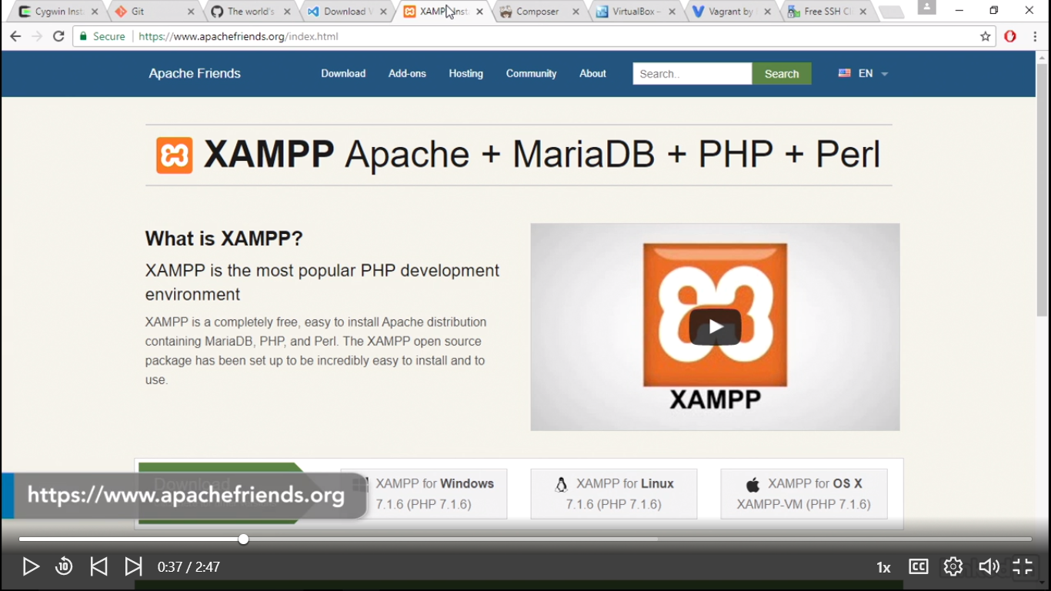

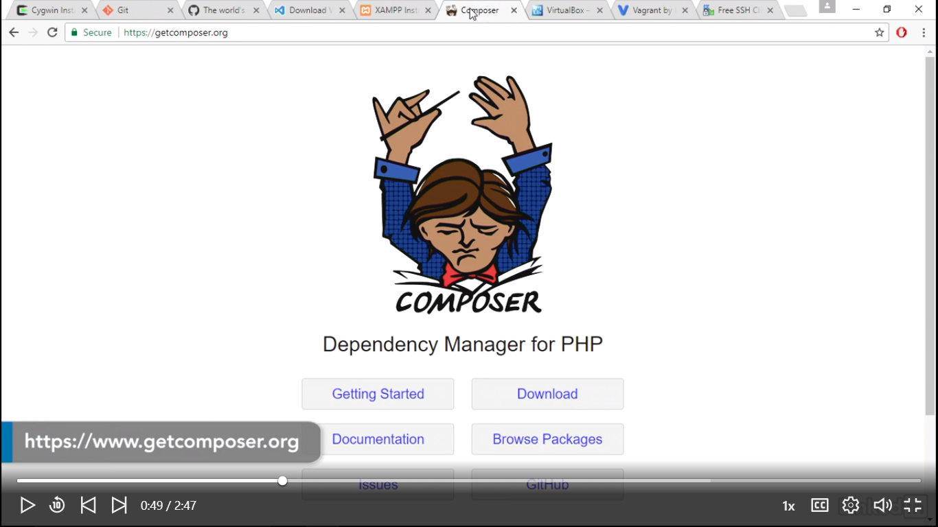

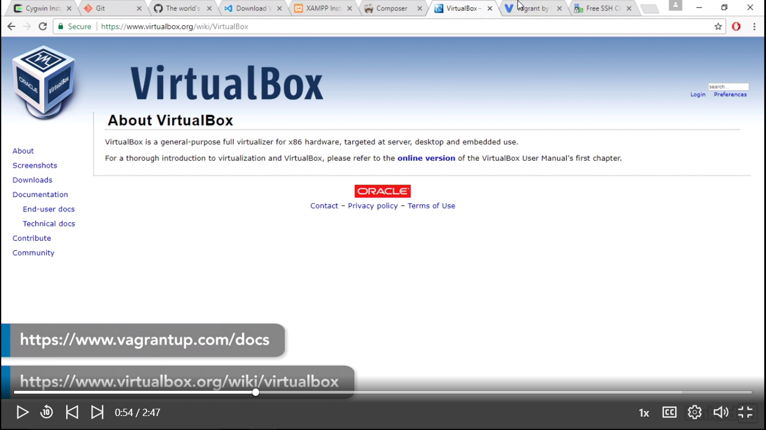

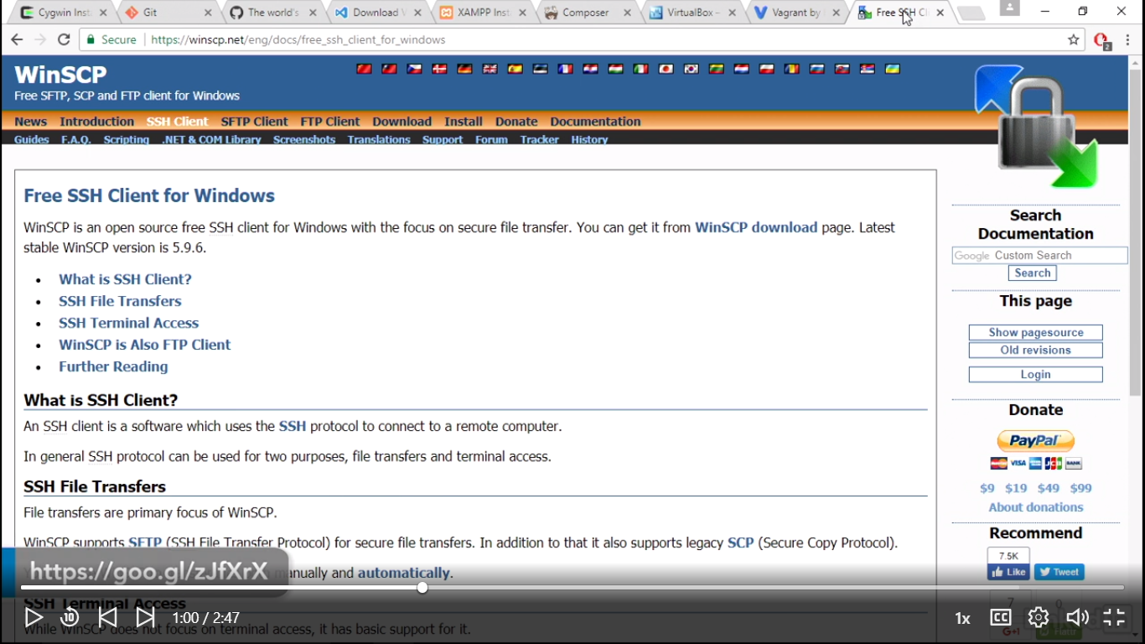

Edit Windows Environment variable:

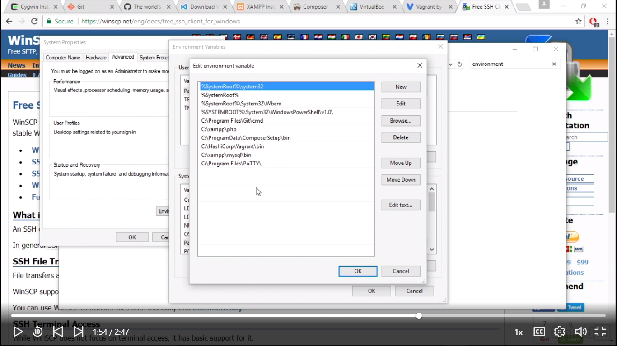

Min Windows:

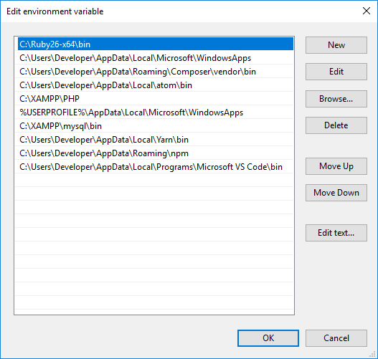

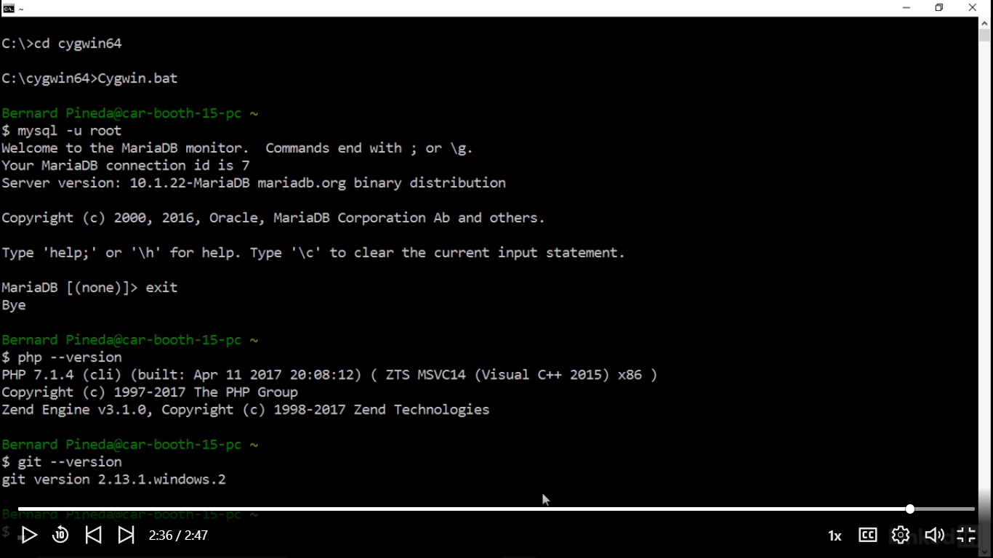

WHAT IS LARAVEL

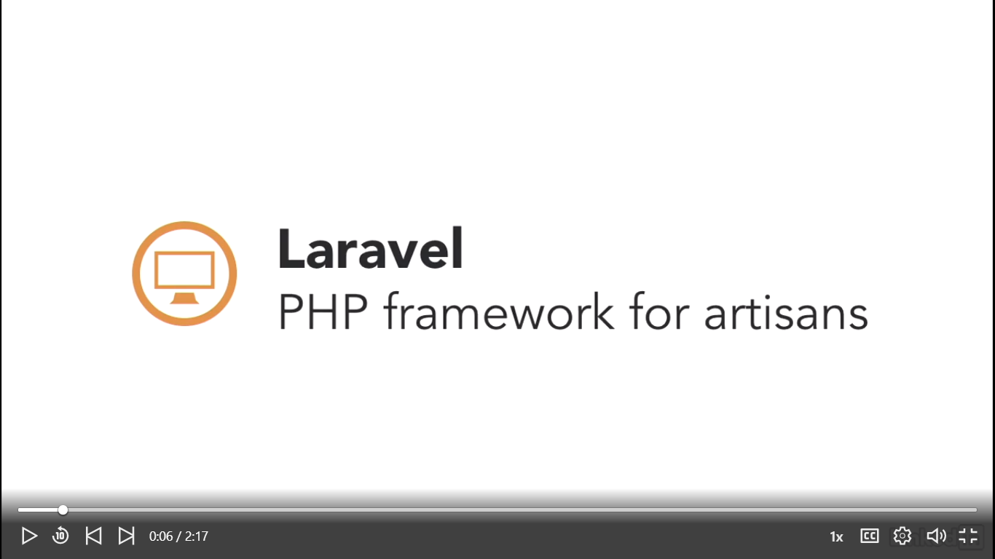

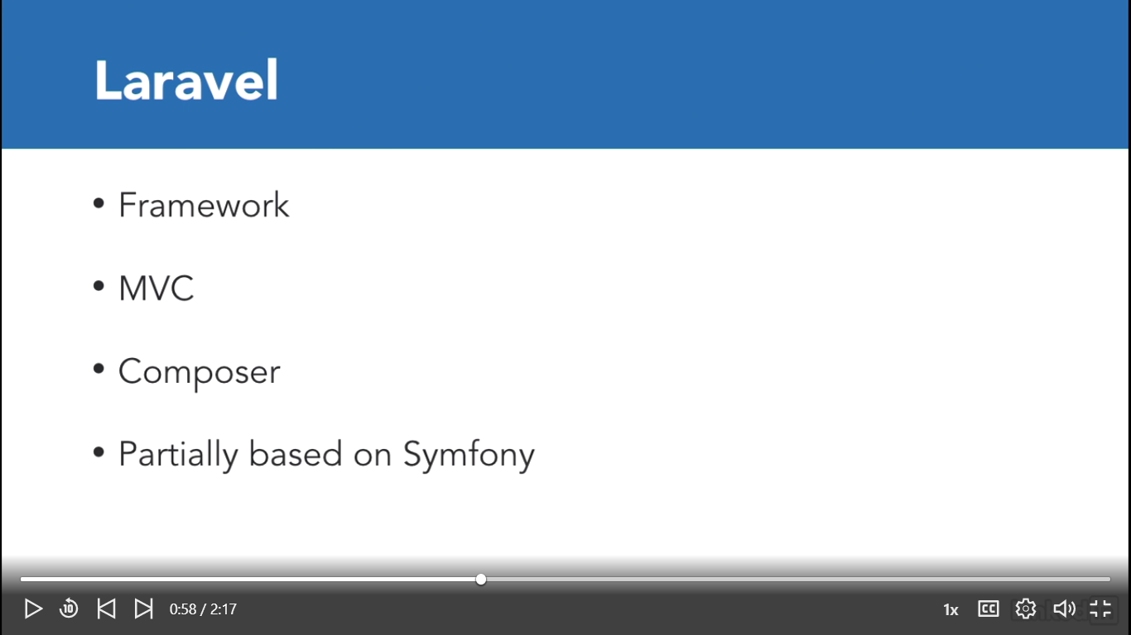

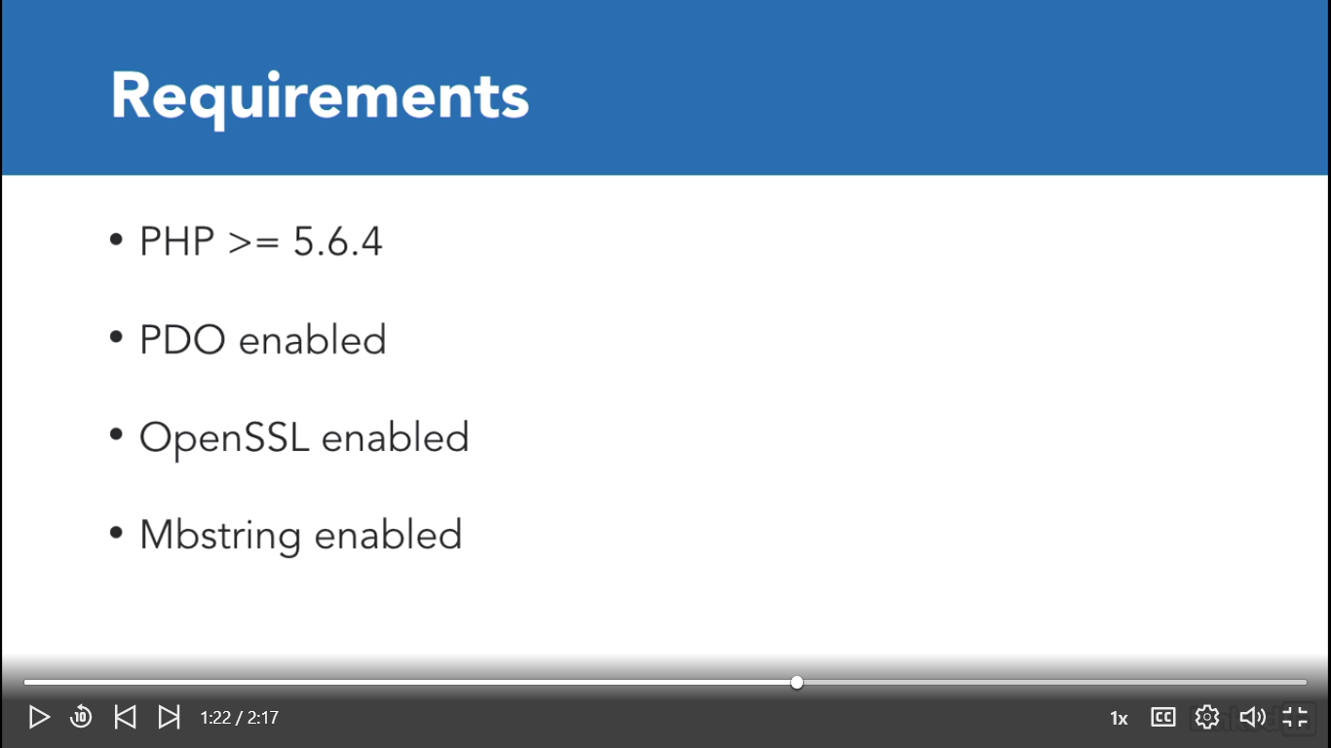

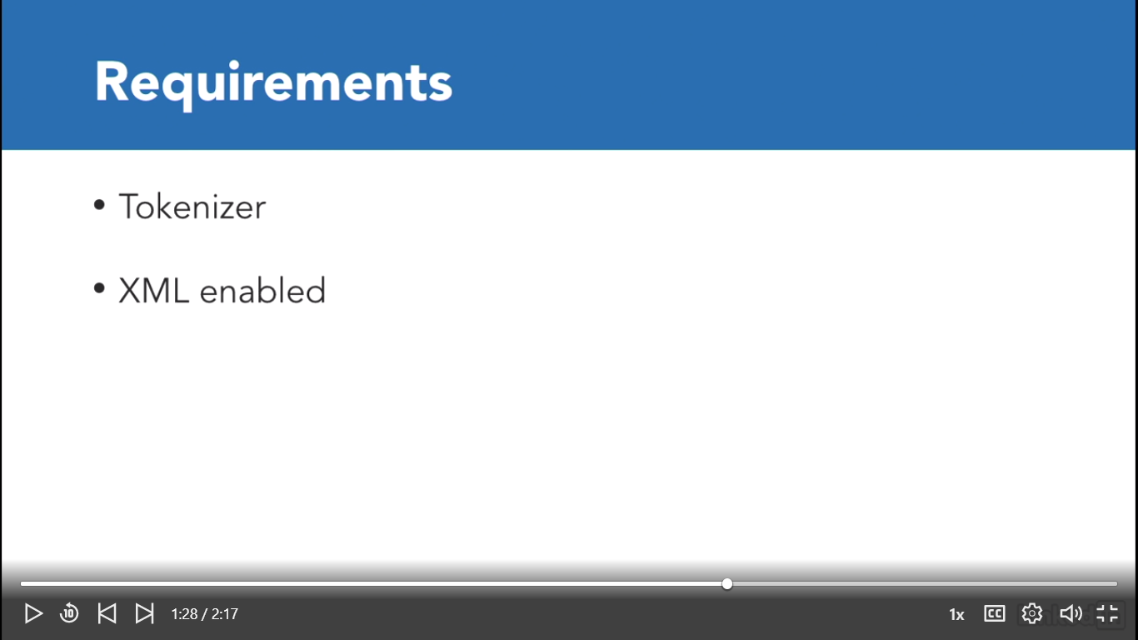

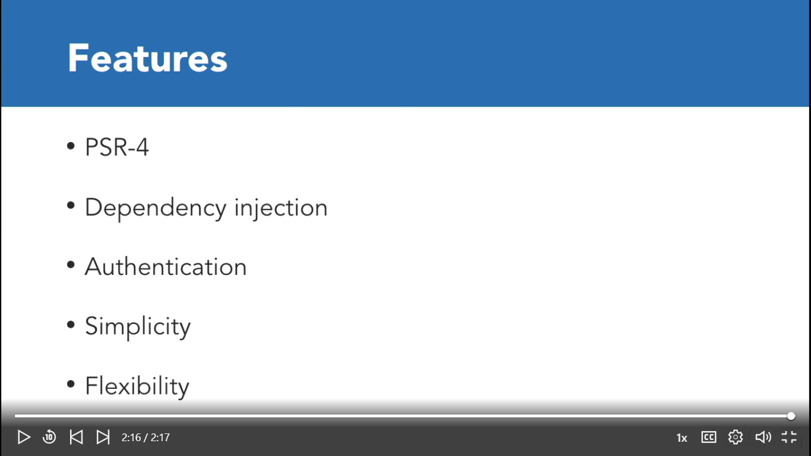

Get A copy of Laravel- Using composer

Man kan lave en project med nanv: landon_app I desktop via composer

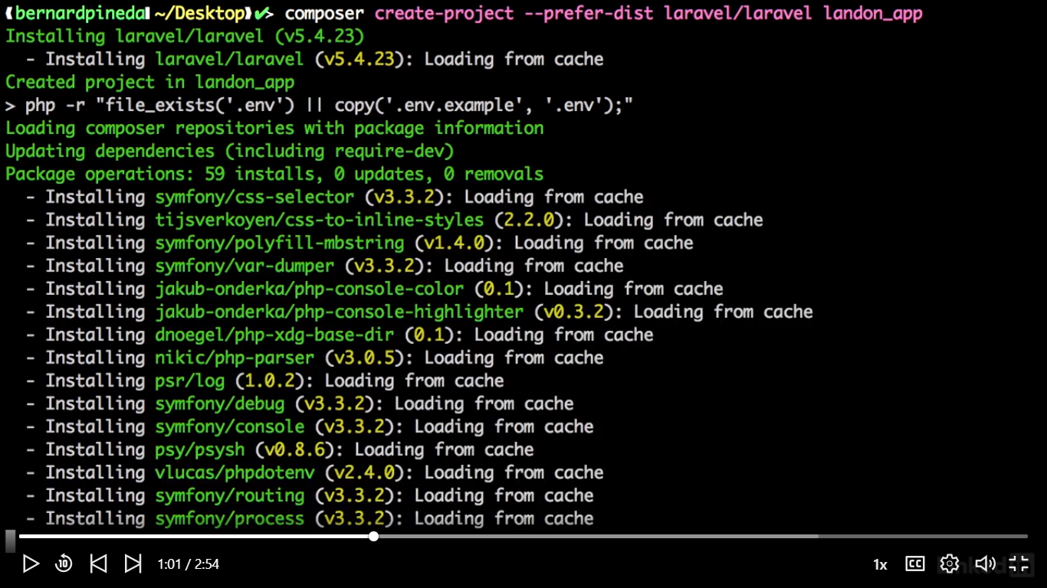

Jeg laver det samme under c:\\xampp\htdocs via console:

C:\xampp\htdocs>composer create-project --prefer-dist laravel/laravel landon_app

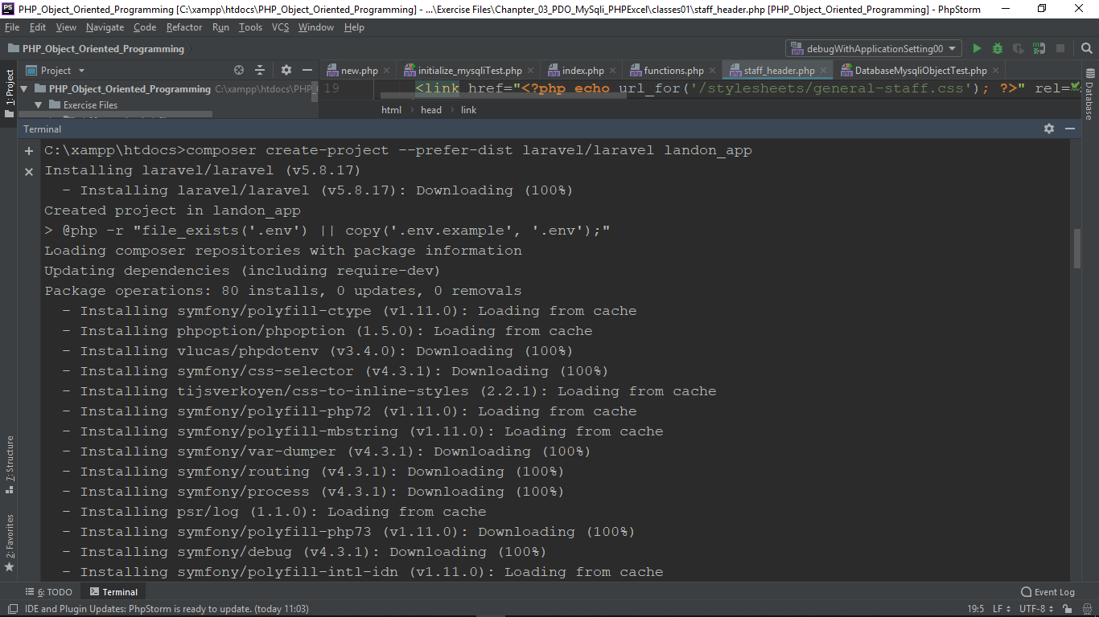

Så starter vi vores Laravel via Link(Husk under projekt Mappe C:\xampp\htdocs\landon_app):

C:\xampp\htdocs\landon_app >>php artisan serve

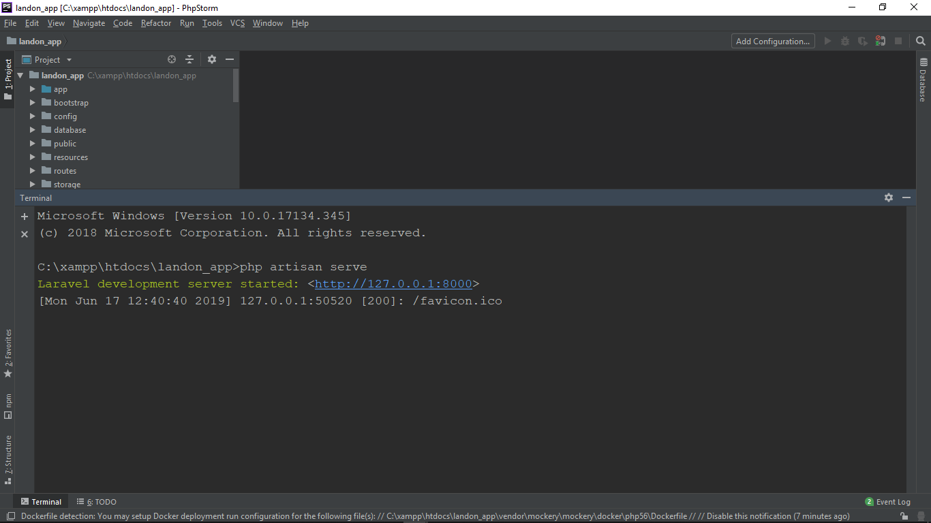

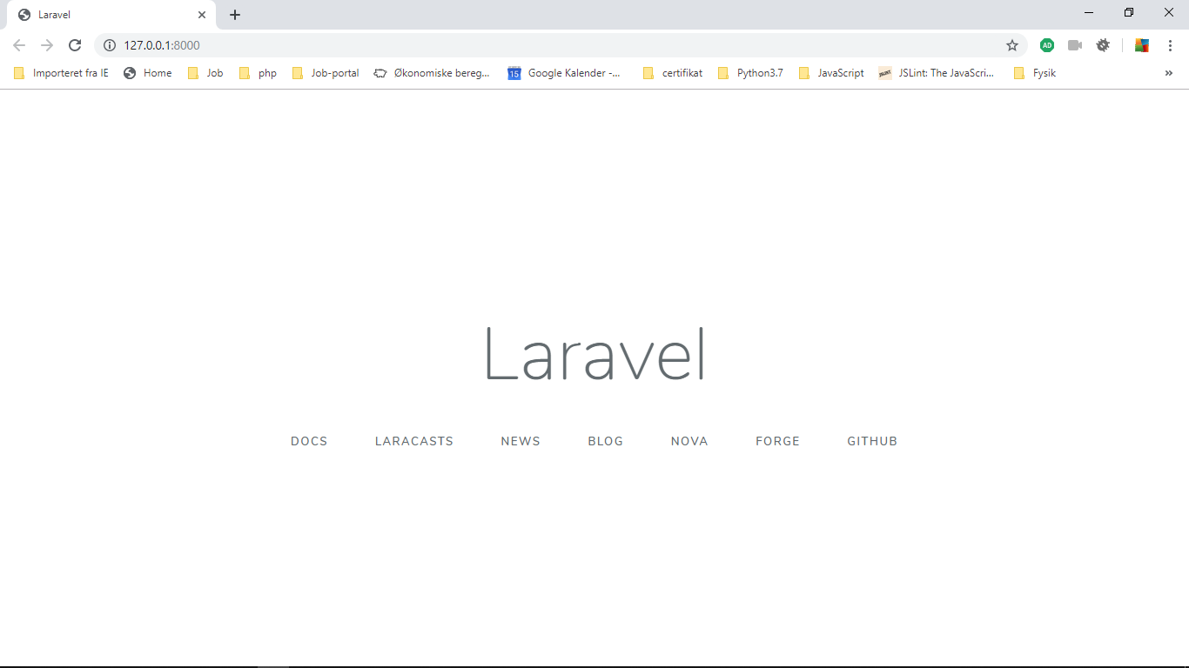

For at dependency opretholdes I vores project skal vi slette 1 mappe og en fil, hvor dependeny opdaterers

1. Vendor(Mappe)
2. Composer.lock(fil)

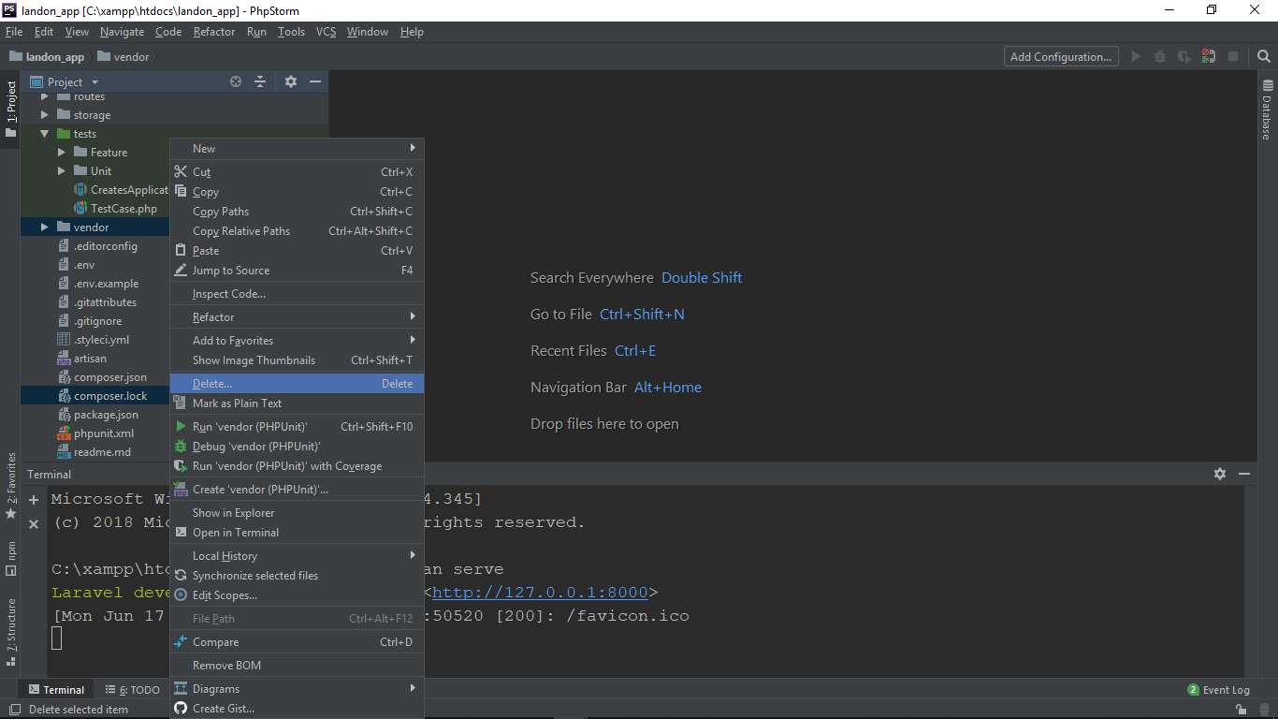

Og bagefter laver en >>composer install

C:\xampp\htdocs\landon_app>composer install

Discovered Package: laravel/tinker

Discovered Package: nunomaduro/collision

Package manifest generated successfully.

Og stater vores server igen: >>php artisan serve

Arkitektur

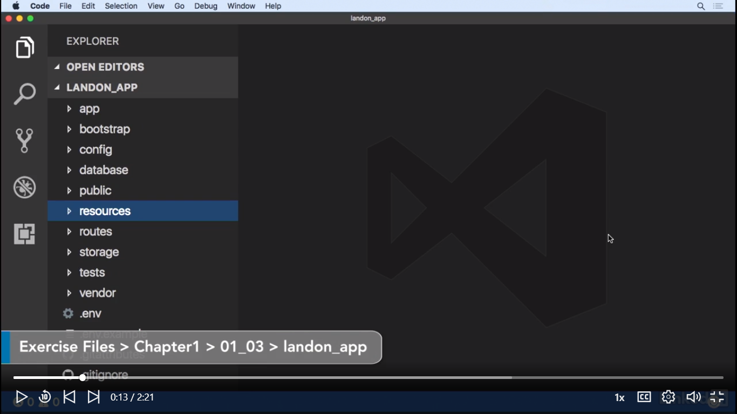

# Finder Views, Controller, Models

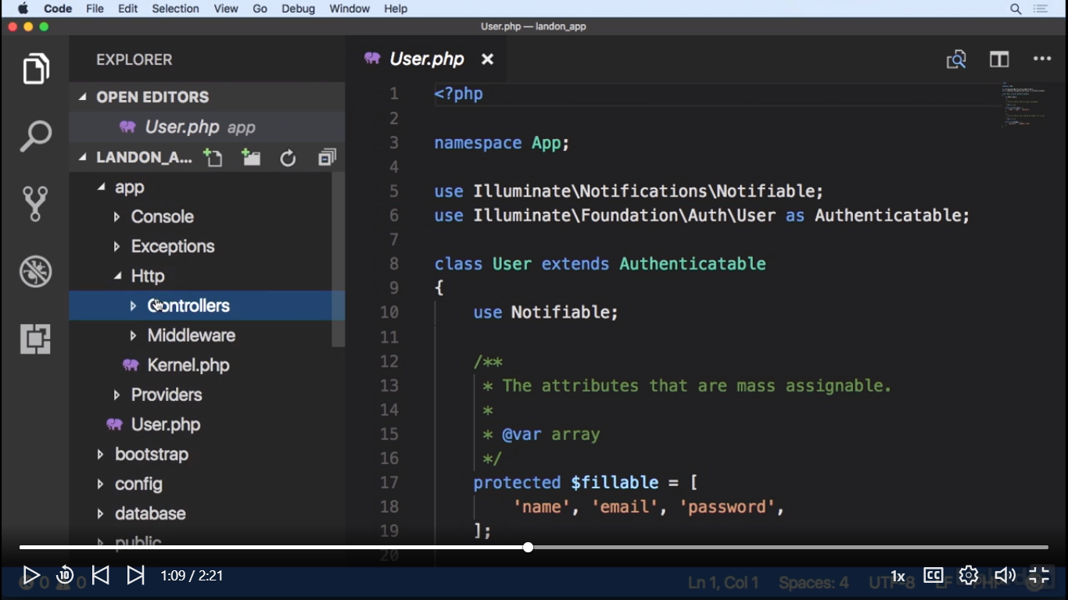

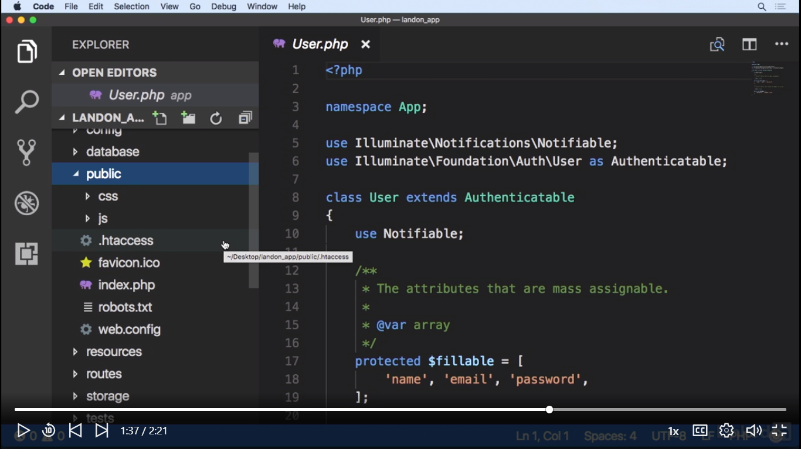

Our application routes which define the URLs that serve our application are defined in routes/web.php. Now let's take a look at our public folder which will serve all of our application assets such as images, java script libraries and CSS files. One important thing that we need to keep in mind with this folder is the fact that once we deploy our application to a production environment we should point our web server document route to the index.php file contained in this folder. The reason for this is that this file is the entry point of our whole application. It's the file that will be loaded and it's the one in charge of loading Laravel into memory. And finally we have the database folder. In here we will group our migrations which will help us create our database structure seeds. Which will hold our application seeds which may help us to fill our database with test data.

# Database Folder:

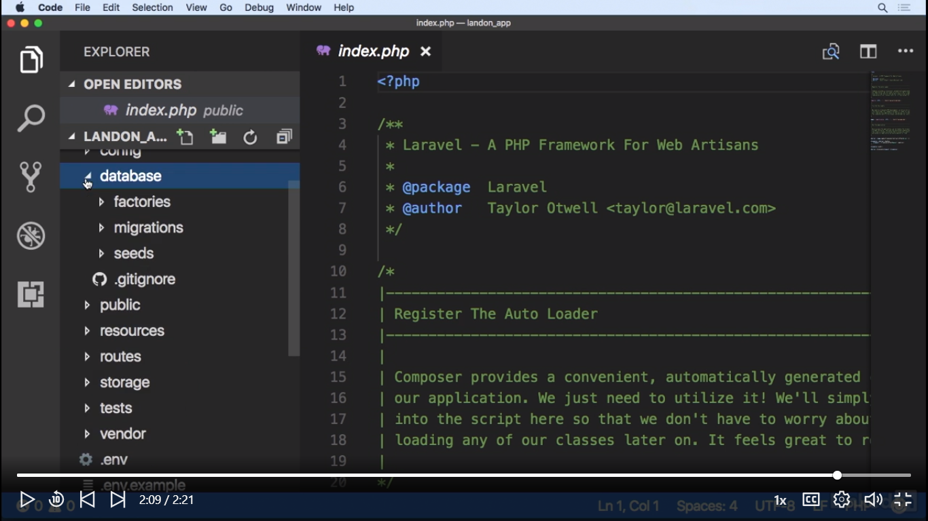

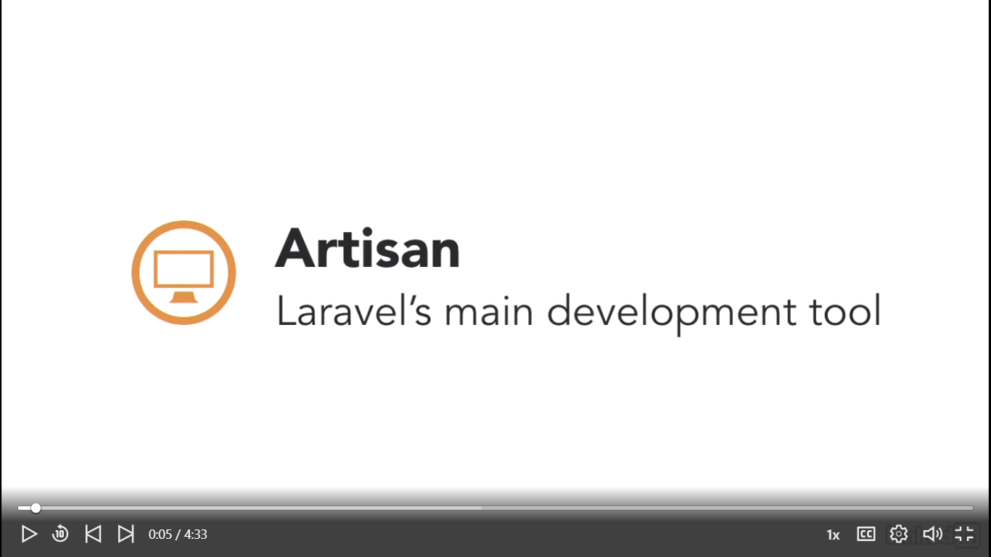

Det er artisan der hjælper at lave nedenståend opgaver:

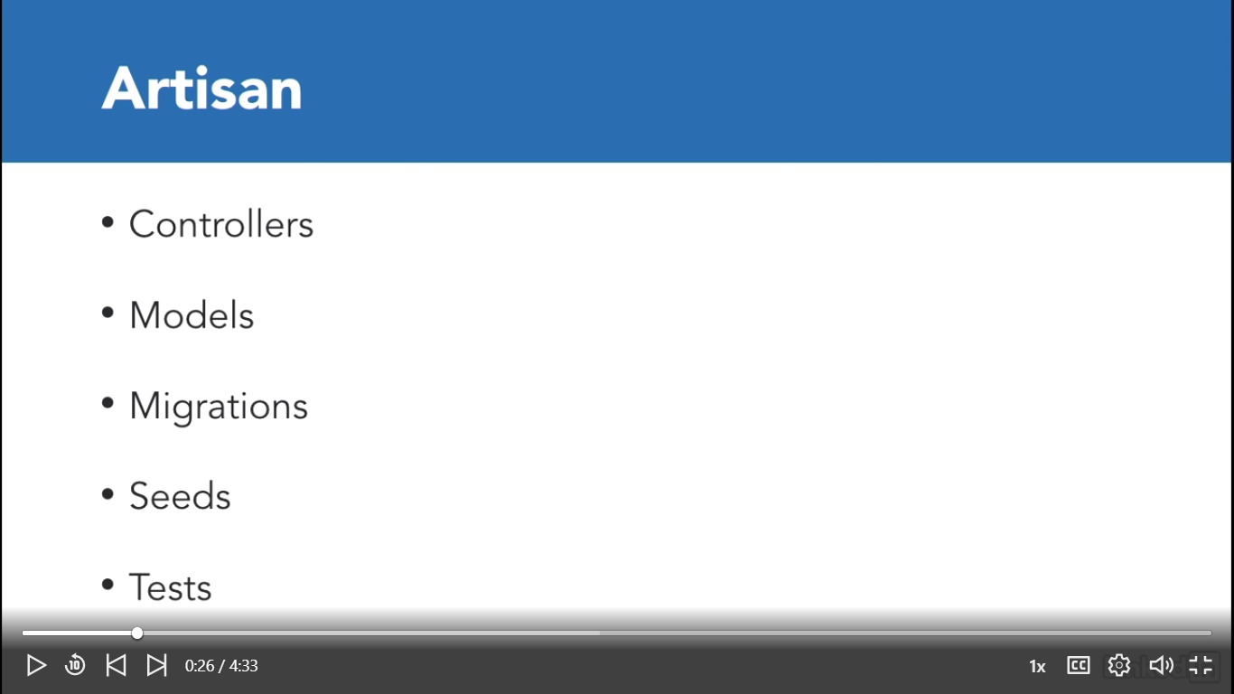

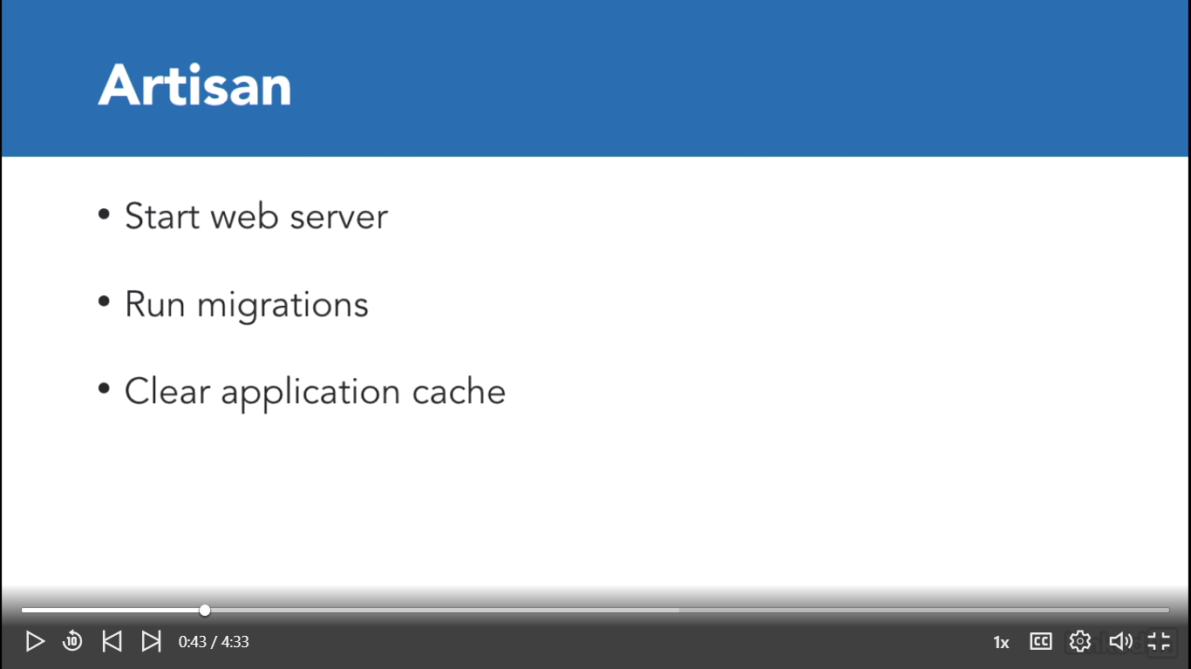

Nu kan vi stater vores application via komman line:

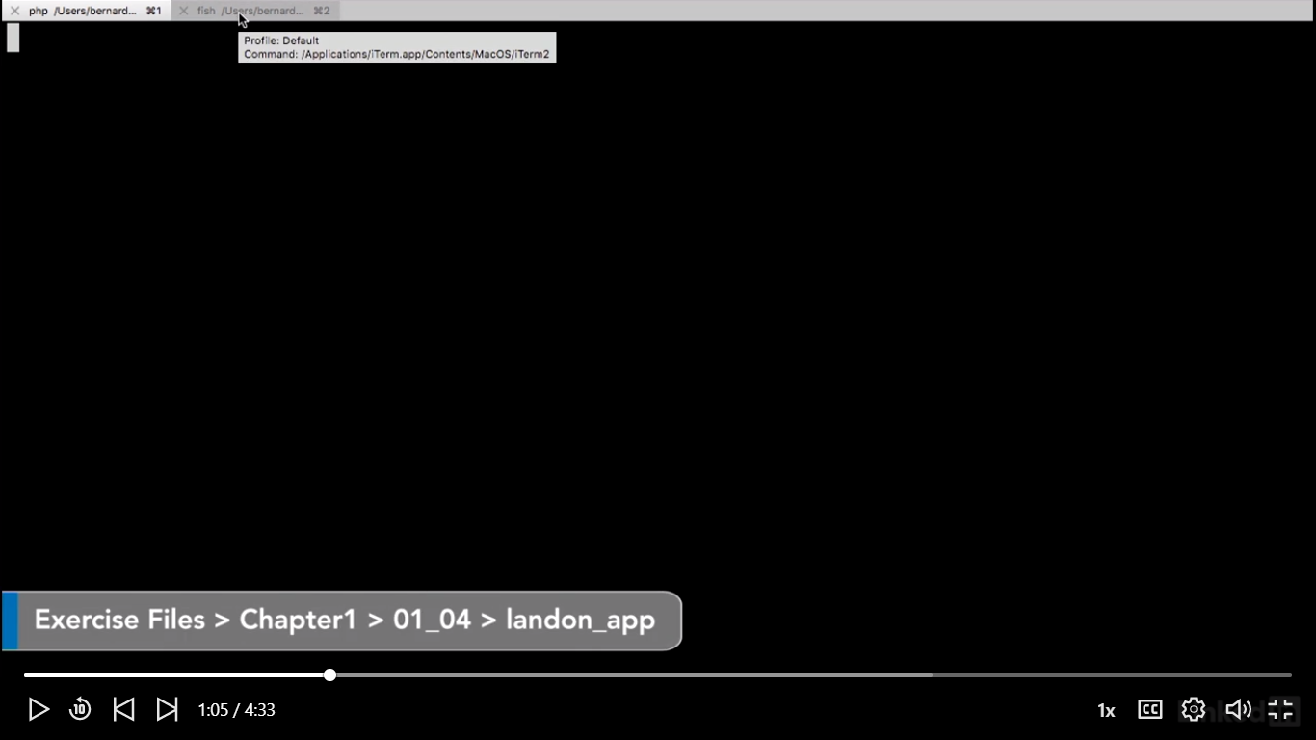

Via kommand: >>php artisan down kan vi gå forward

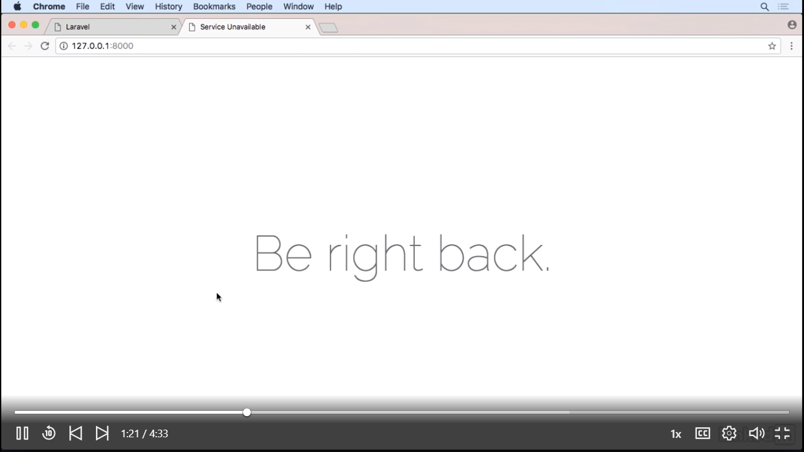

Og Via kommand: >>php artisan up kan vi komme tilbage som

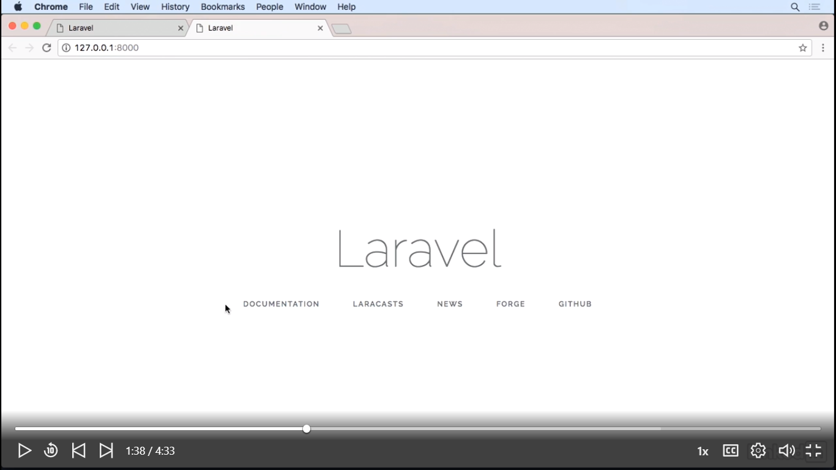

C:\xampp\htdocs\landon_app>php artisan down

Application is now in maintenance mode.

C:\xampp\htdocs\landon_app>php artisan up

Application is now live.

Vi skal slette cache via:

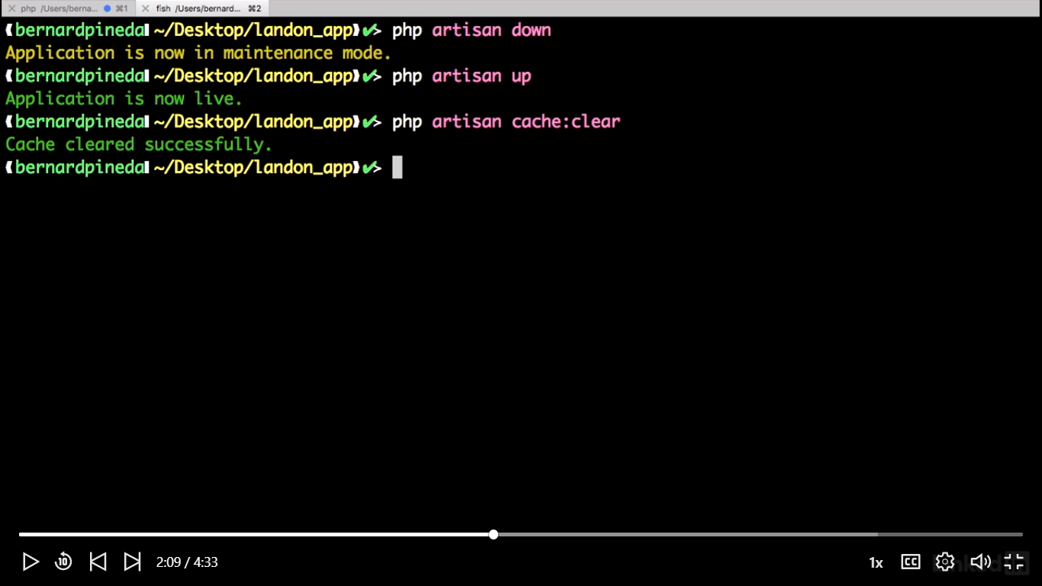

Nu Laver vi vores første controller via kommand line:

C:\xampp\htdocs\landon_app>php artisan make:controller ClientController

Controller created successfully.

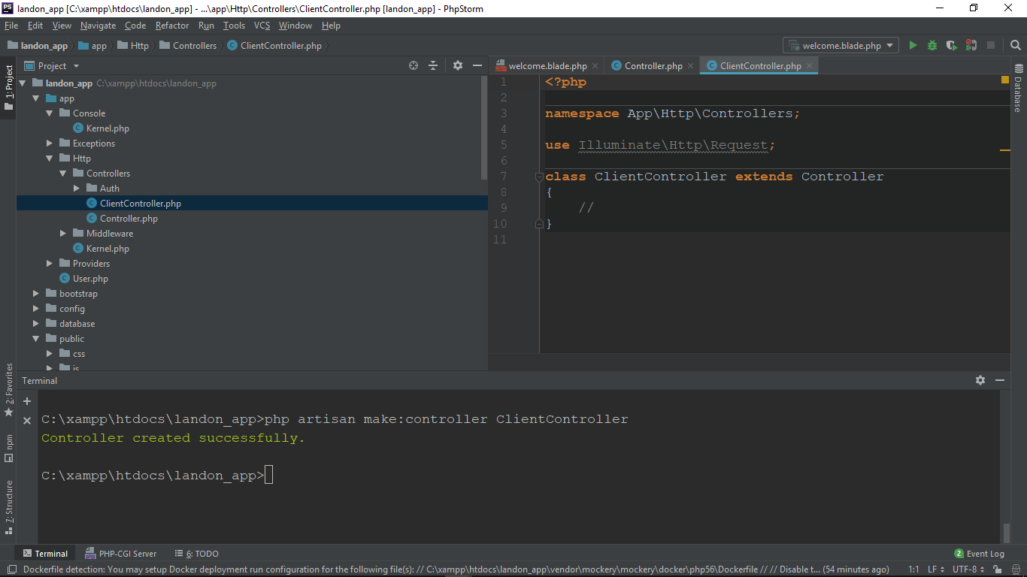

Vi kan nu lave en Model uden eller med migration. Her laver vi en uden migration med navnet: Client

C:\xampp\htdocs\landon_app>php artisan make:model Client

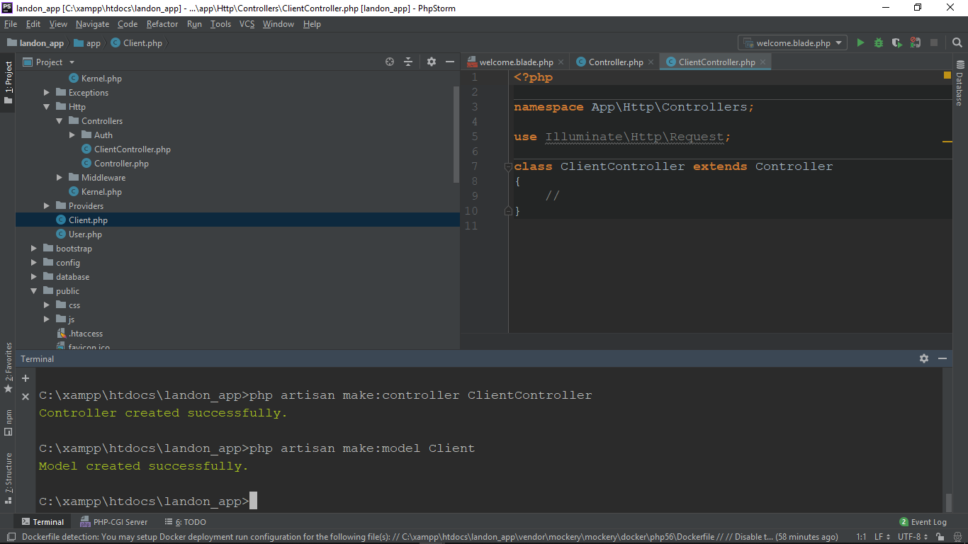

Nu laver vi en med migration som hedder Room

C:\xampp\htdocs\landon_app>php artisan make:model Room -m

Model created successfully.

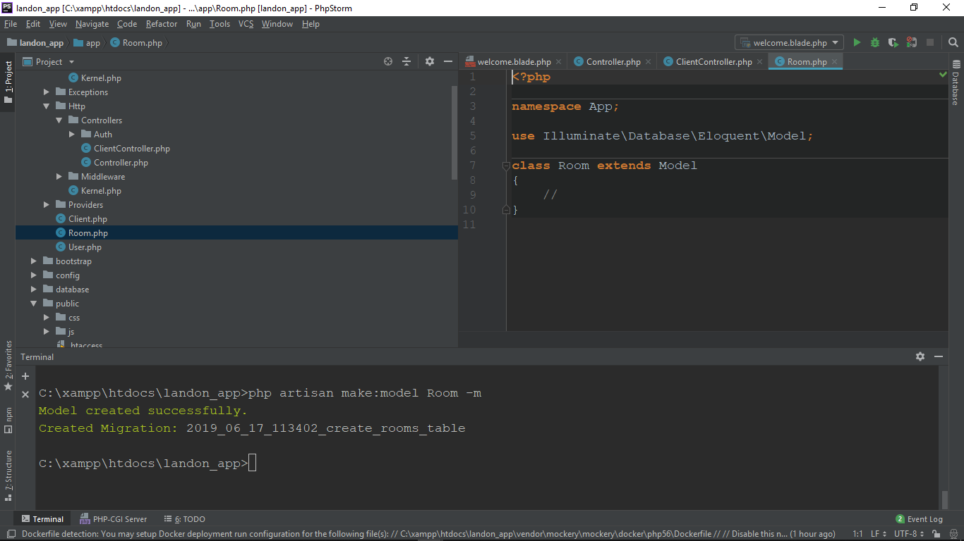

Da Room er laved med migration, så dannes 3 filer under database/migrations som:

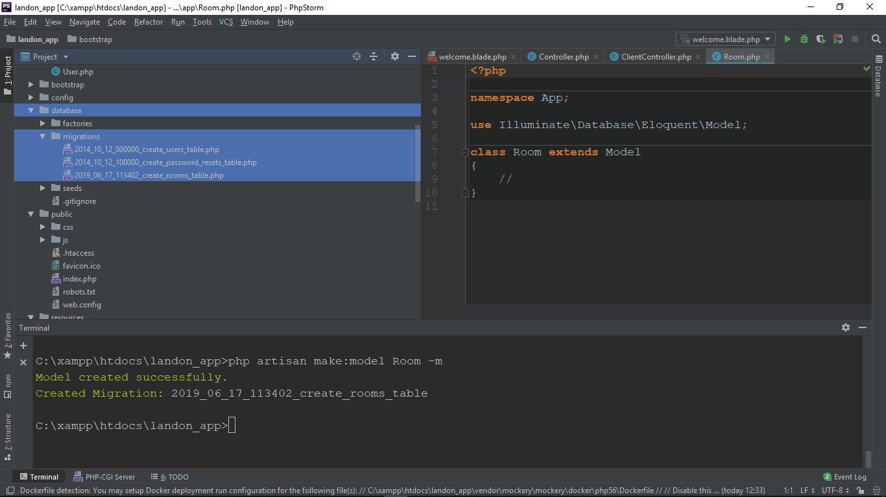

If we had configured our database correctly for this example, we could run our migrations and have a database structure based on those migrations.

That's to say, we could have some tables on our database.

Simple Web Response

Se web.php under route

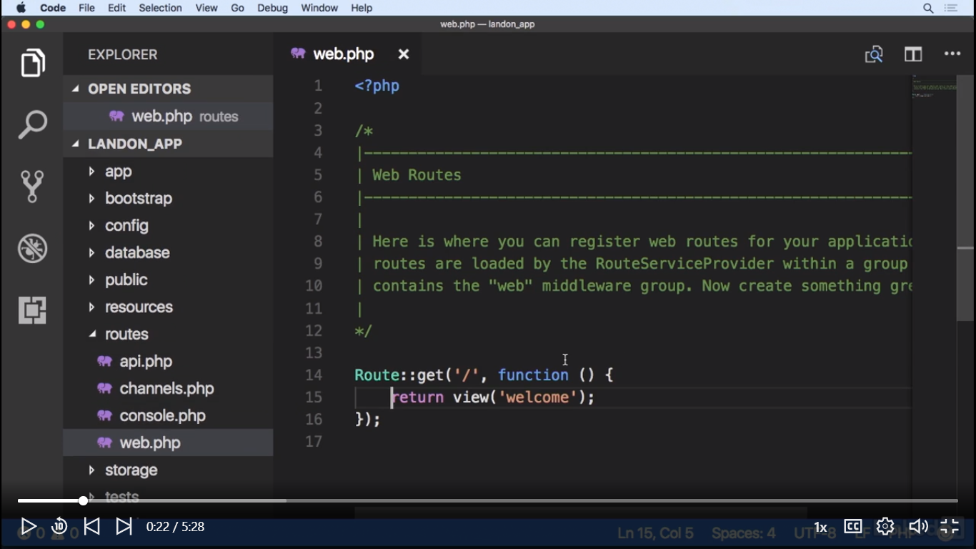

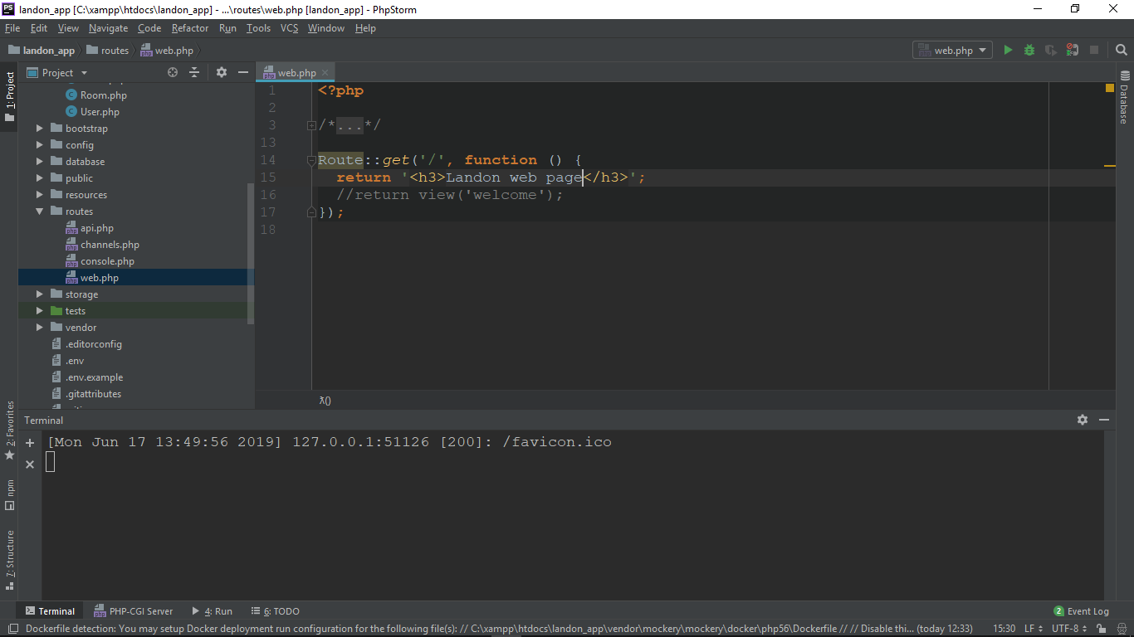

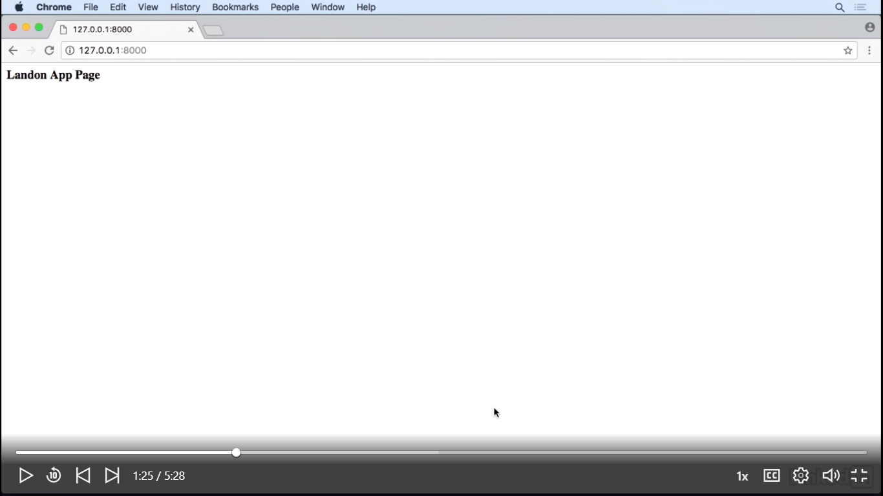

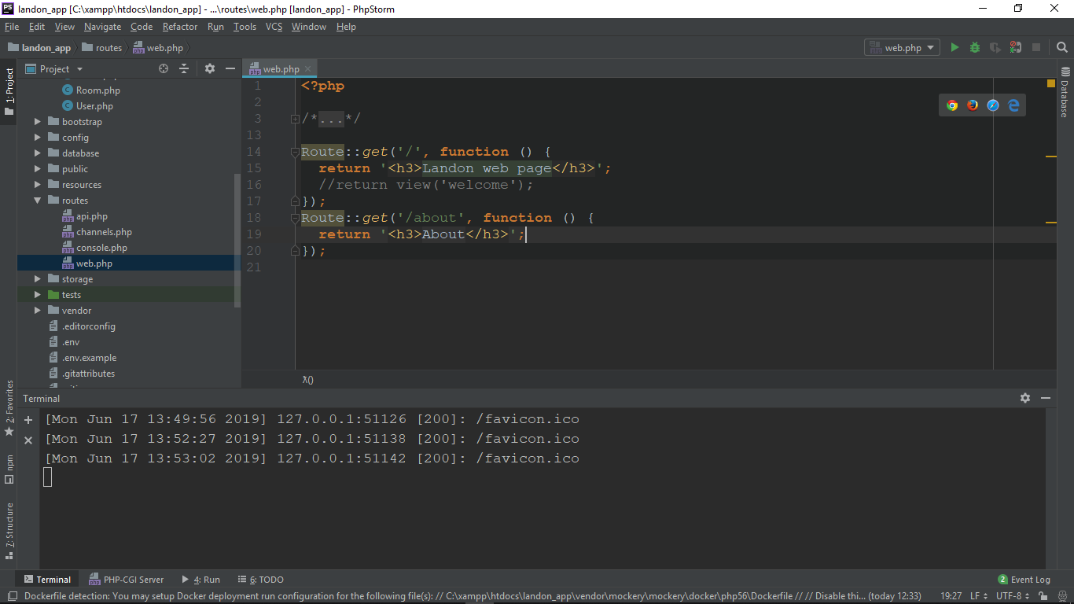

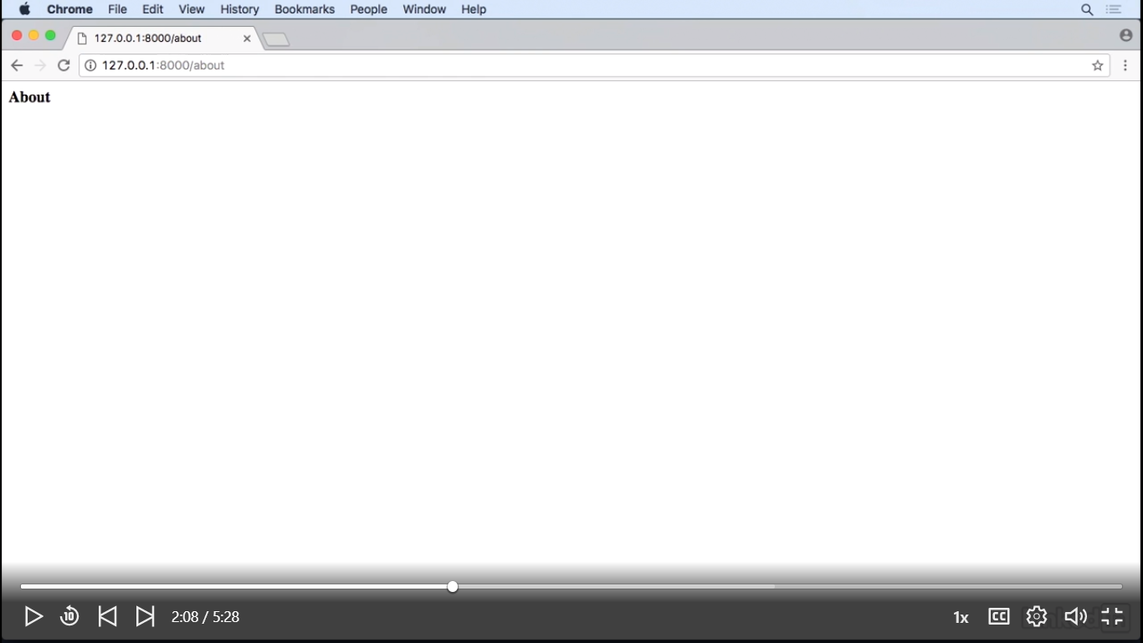

Og hvis vi tilføjer en php-array som nedenfor:

Route::*get*('/about', **function** () {  
 $response_arr = [];  
 $response_arr['auther'] = 'BP';  
 $response_arr['version'] = '0.1.1';  
 **return** $response_arr;

Får vi en json-array tilbage I browseren-> {"auther":"BP","version":"0.1.1"}

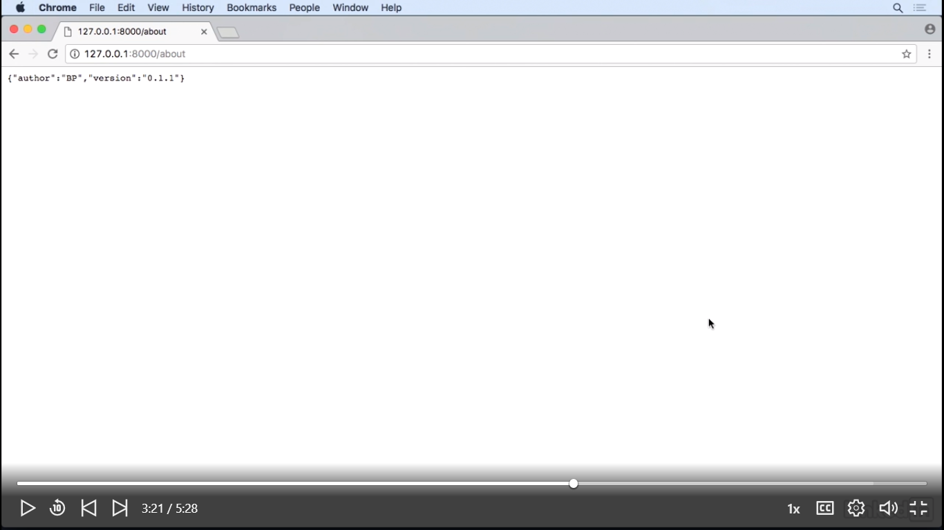And this is the basis of an API, granted it's over simplified, but we start to get an idea of how to write RESTful methods or just load simple views. What about data being sent to a view? Well, let's do that. Let's create a view called Home and have it load a view.

Nu laver vi en ny:

Route::*get*('/home', **function** () {  
 $data = [];  
 $data['version'] = '0.1.1';  
 **return** view('Welcome', $data);  
  
});

Nu åbner vi for vores view under Resoures/Views/welcome.blade.php og skiter til:

Husk:: {{ $version }} modtages variable $version

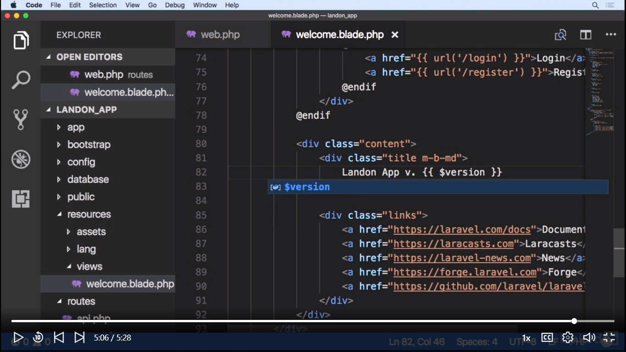

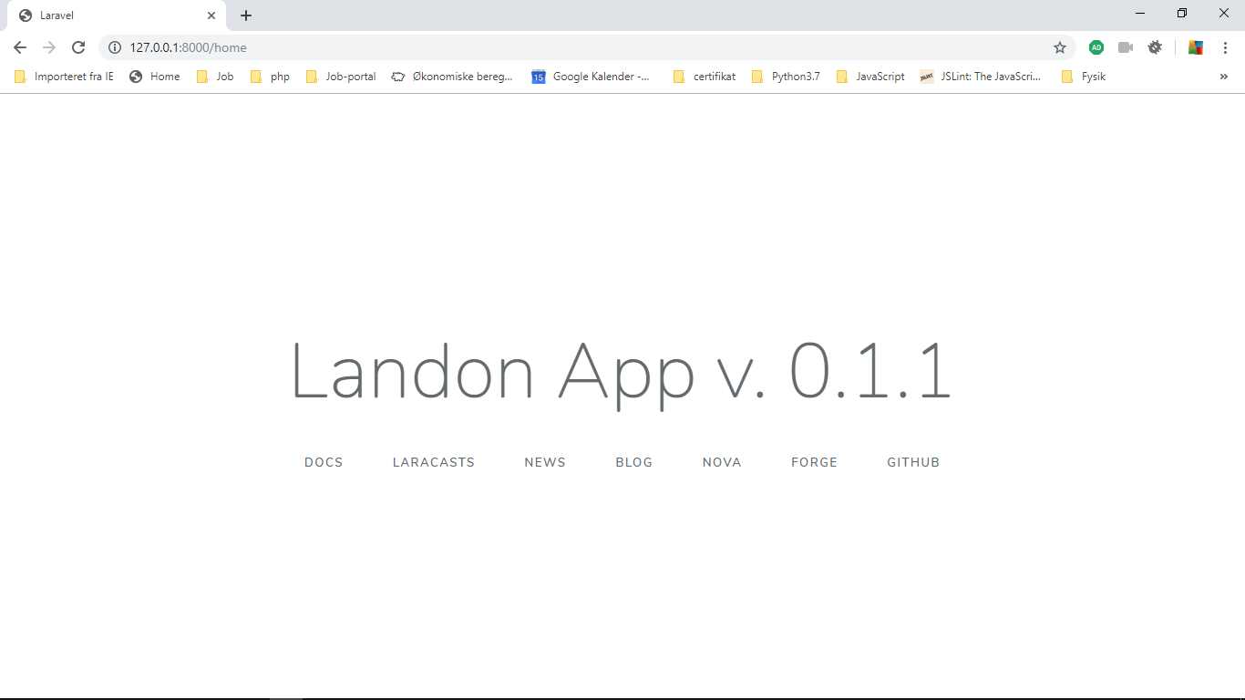

Dependency Injection(DI)

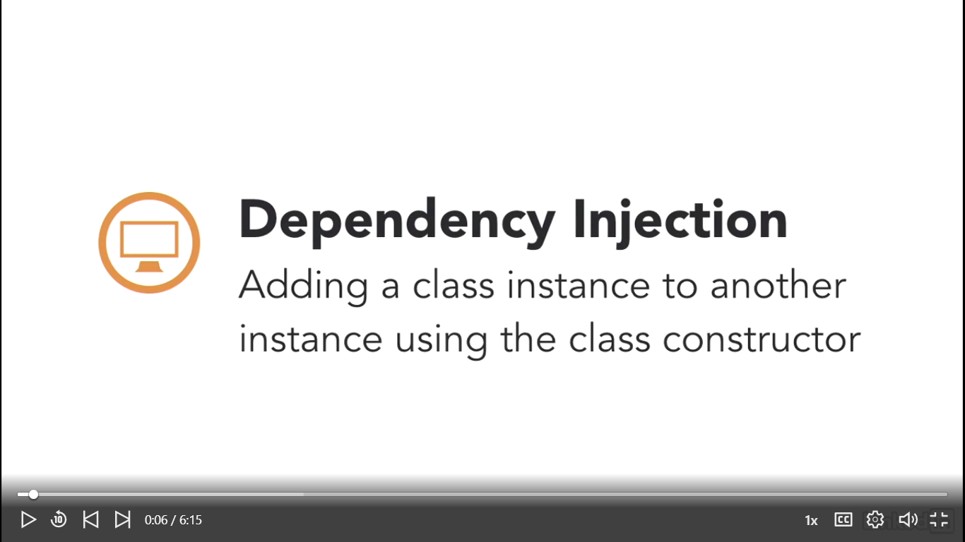

Dependency Injection, or DI mechanism. In the Laravel context, DI merely means adding a class instance to another class via it's constructor. Let's see how painless it is to inject a dependency, when we want to make a class available to our controller.

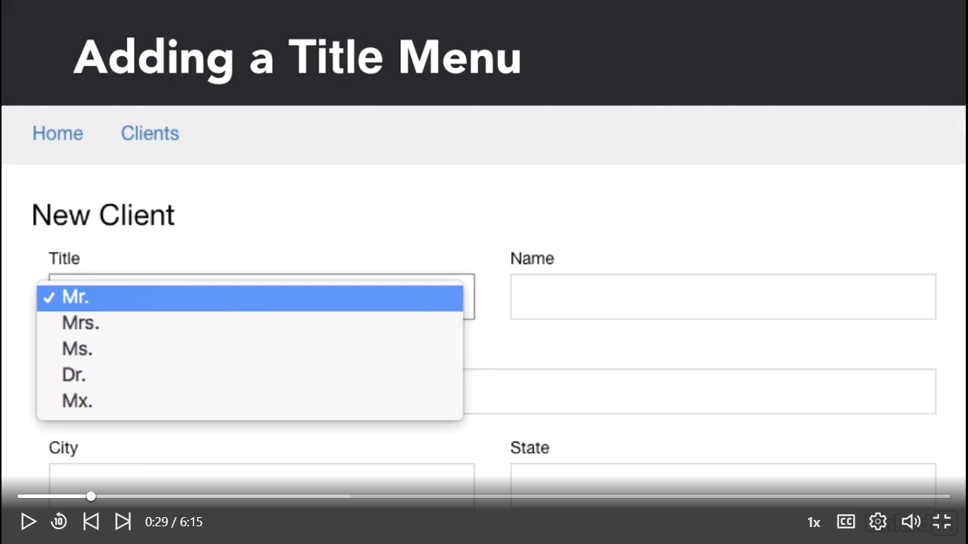

or the project, we will need a drop-down menu with titles such as, Mister, Misses, et cetera. We're going to use a model to obtain these titles.

However, since it's a static catalog, we really don't need to add a table to the database. A simple way to go, is to create a model, but not use any of the methods that will fire any database actions. Let's start by creating a title model with php, artisan, make, colon model, title. Now let's open our title model, and add an array of titles. Let's go, app, title. Then we're going to add an array as protected, titles, array,equal to an array, and inside of the array, Mister, Misses, Miss, Doctor, and MX. We'll save, and now let's remove the inheritant from eloquent. Which means extends model. What we'll do is inherit from another class, other than eloquent. Let's create a read only base model, and the title class will inherit from this class. Let's go back to the console and type, php, artisan, make, model, read only base. Let's remove the inheritance from eloquent, and now let's add the all method and the get method. Let's open our read only base model. Remove the extends model, and add the following methods and attributes, protected, titles, array, this equal an antiarray. Now public, function, all. This will just return the array with return, this, titles, array, and let's add public, function, get, that receives an ID, and returns the array with, return, this, titles array, but with the index that we're sending. Let's go back to the model and inherit from this class. We're going to copy the title. Let's go back to title, extends, read only base. Now let's inject the titles to the client controller. Let's go ahead and open http controllers, client controller. We're going to add the model with, use, APP, back slash, title, as, title. Now let's create a constructor with,public, function, underscore, underscore, construct, and let's pass a parameter to this constructor, of type, title, called, titles. Now let's add a method that we'll call with our route, with public, function, DI, and let's just print out the result. With DD, this, titles. Now let's assign the variable.This, title, too are instants that were injecting titles, and the method, all.We'll save. Finally, let's add a route for this example. Let's open routes, web, and create a new route. So let's copy lines 28 to 32. We'll erase the contents of 35 through 37, and the function, we'll also erase that function. Replace it with a string called ClientController@, and the method that we're going to call, it's called get clients I believe, DI. So it's DI, we'll call this DI, and save it. Let's go to the browser, and let's change this to DI, and we have obtained our titles from a static model. DI works great for us to deliver an inheritable read only structure. If at some point the client decided that he wants to get the titles from a database, we can transparently do the switch. This is a great technique for keeping our code really clean.

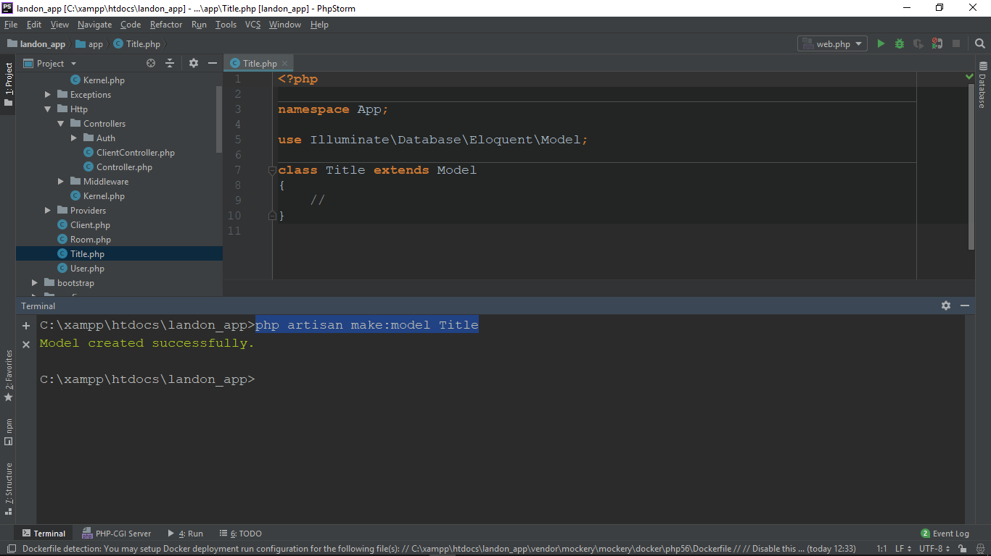

C:\xampp\htdocs\landon_app>php artisan make:model Title

Model created successfully.

C:\xampp\htdocs\landon_app>php artisan make:model ReadOnlyBase

Model created successfully.

**use** Illuminate\Database\Eloquent\Model;  
  
**class** ReadOnlyBase  
{  
 //  
 **protected** $title_array = [];  
  
 **public function** all() {  
 **return** $this->title_array;  
 }  
  
 **public function** get($id) {  
 **return** $this->title_array[$id];  
 }  
}

**<?php  
  
namespace** App;  
  
**use** Illuminate\Database\Eloquent\Model;  
  
**class** Title **extends** ReadOnlyBase  
{  
 //  
 **protected** $title_array = ['Mr', 'Mrs', 'Ms', 'Dr', 'Mx'];  
  
}

Nu finder vi vores ClientController.php og ændrer til:

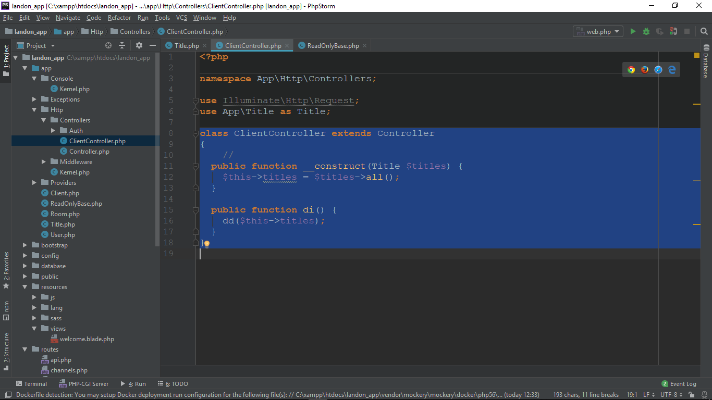

Nu tilføjer vi under routes/web.php

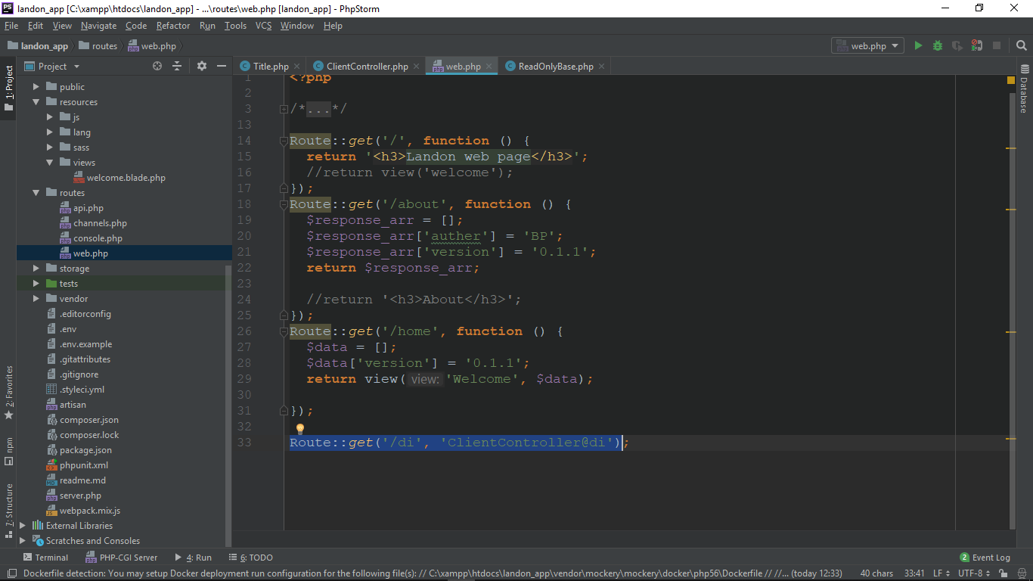

I Browseren kan vi se nu

array:5 [▼

0 => "**Mr**"

1 => "**Mrs**"

2 => "**Ms**"

3 => "**Dr**"

4 => "**Mx**"

]

we have obtained our titles from a static model. DI works great for us to deliver an inheritable read only structure. If at some point the client decided that he wants to get the titles from a database, we can transparently do the switch. This is a great technique for keeping our code really clean.

Service providers

Service providers are the command center for bootstrapping. By bootstrapping, I mean to register components to be used within our applications such as, service container bindings, event listeners, middleware, and even routes.

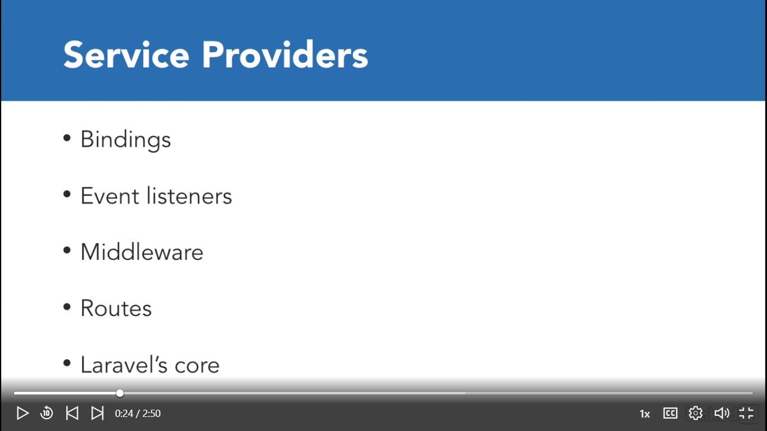

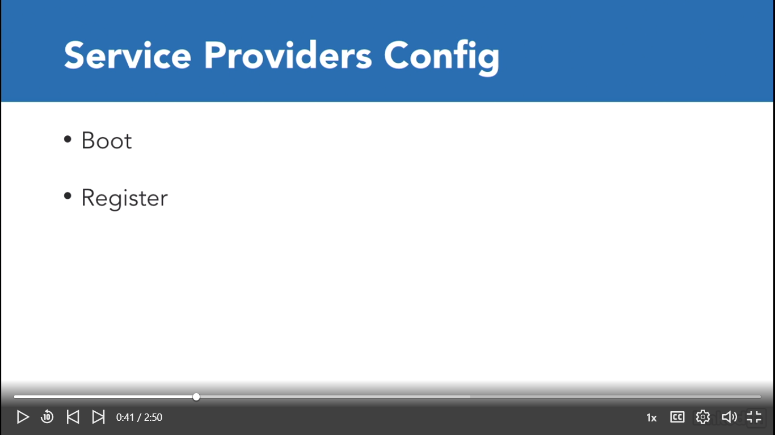

C:\xampp\htdocs\landon_app>php artisan make:provider DummyServiceProvider

Provider created successfully. Dannes DummyServiceProvider under mappen app\...\providers

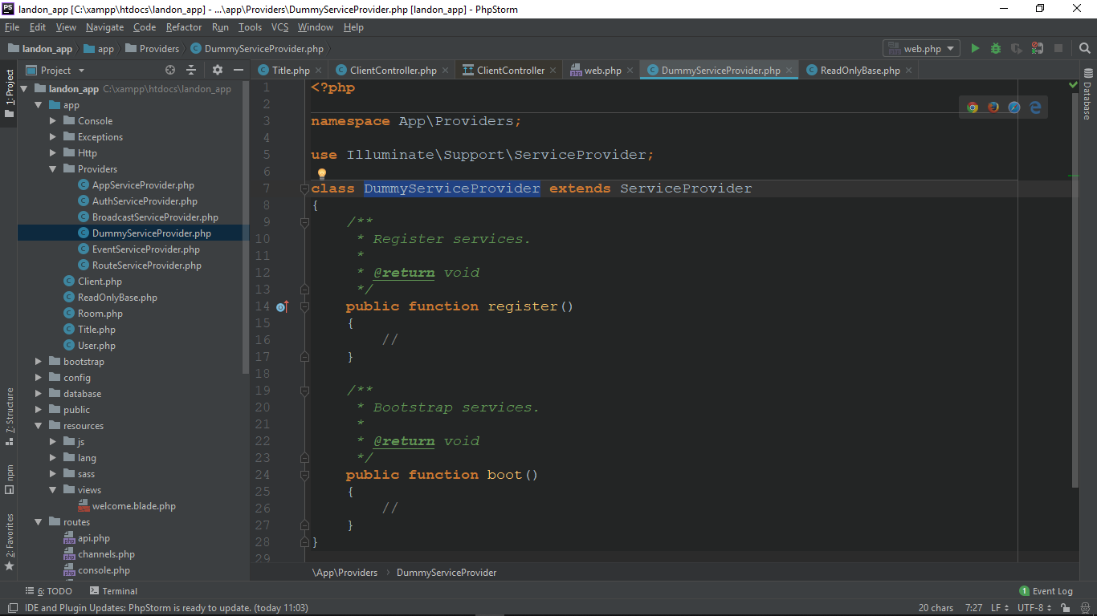

Så se app.php under config/app.php i array´et provider

'providers' => [  
  
 /*  
 * Laravel Framework Service Providers...  
 */  
 Illuminate\Auth\AuthServiceProvider::**class**,  
 Illuminate\Broadcasting\BroadcastServiceProvider::**class**,  
 Illuminate\Bus\BusServiceProvider::**class**,  
 Illuminate\Cache\CacheServiceProvider::**class**,  
 Illuminate\Foundation\Providers\ConsoleSupportServiceProvider::**class**,  
 Illuminate\Cookie\CookieServiceProvider::**class**,  
 Illuminate\Database\DatabaseServiceProvider::**class**,  
 Illuminate\Encryption\EncryptionServiceProvider::**class**,  
 Illuminate\Filesystem\FilesystemServiceProvider::**class**,  
 Illuminate\Foundation\Providers\FoundationServiceProvider::**class**,  
 Illuminate\Hashing\HashServiceProvider::**class**,  
 Illuminate\Mail\MailServiceProvider::**class**,  
 Illuminate\Notifications\NotificationServiceProvider::**class**,  
 Illuminate\Pagination\PaginationServiceProvider::**class**,  
 Illuminate\Pipeline\PipelineServiceProvider::**class**,  
 Illuminate\Queue\QueueServiceProvider::**class**,  
 Illuminate\Redis\RedisServiceProvider::**class**,  
 Illuminate\Auth\Passwords\PasswordResetServiceProvider::**class**,  
 Illuminate\Session\SessionServiceProvider::**class**,  
 Illuminate\Translation\TranslationServiceProvider::**class**,  
 Illuminate\Validation\ValidationServiceProvider::**class**,  
 Illuminate\View\ViewServiceProvider::**class**,

Og ændre

App\Providers\RouteServiceProvider::**class**,

Til:

App\Providers\DummyServiceProvider::**class**,

Og tilbagde til DummyServiceProvider.php og echo med ’ ’ metoden boot() og restister.

Nu vises på skærmen: RegsiterBoot

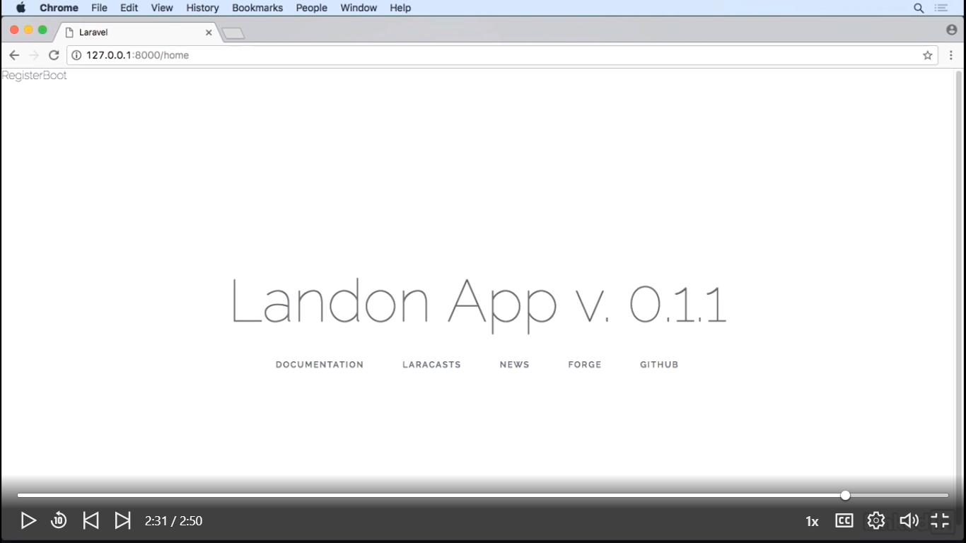

Facades and their utility

A facade is a design pattern that is an analogy to an architectural facade. Simply put, it provides a simplified interface to a more complex code or library. It helps us make a library easier to use, easier to read, and reduces external dependencies. In the Laravel context it provides a static interface to classes contained in the application service provider. A Laravel facade also provides access to a shared singleton service without requiring the end client or programmer to use the application container.

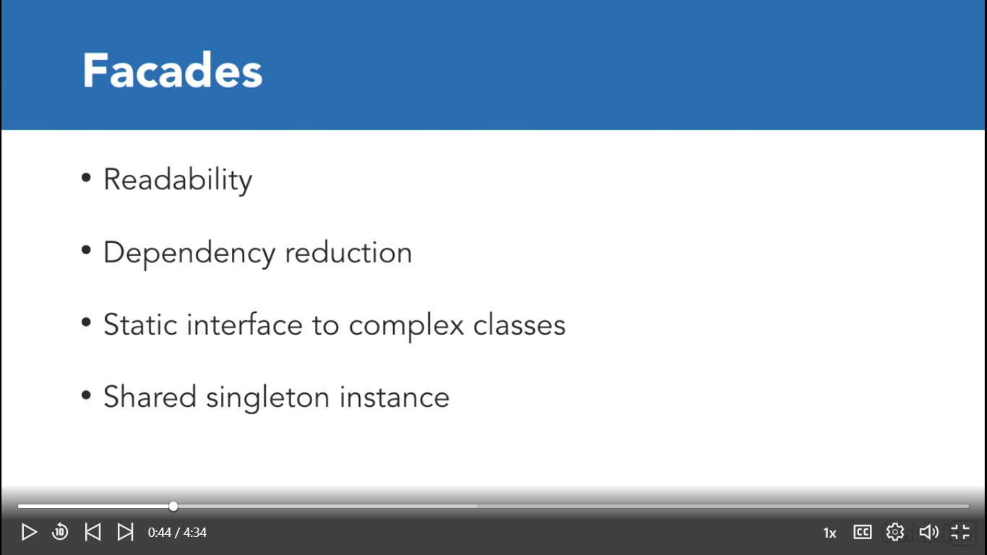

Find DB.php under C:\xampp\htdocs\landon_app\vendor\laravel\framework\src\Illuminate\Support\Facades\DB.php

Så ændre vi app.php og tilføjer

Route::*get*('/facades/db', **function** () {  
  
 **return** DB::*select*('SELECT * FROM table');

Og resultatet bliver

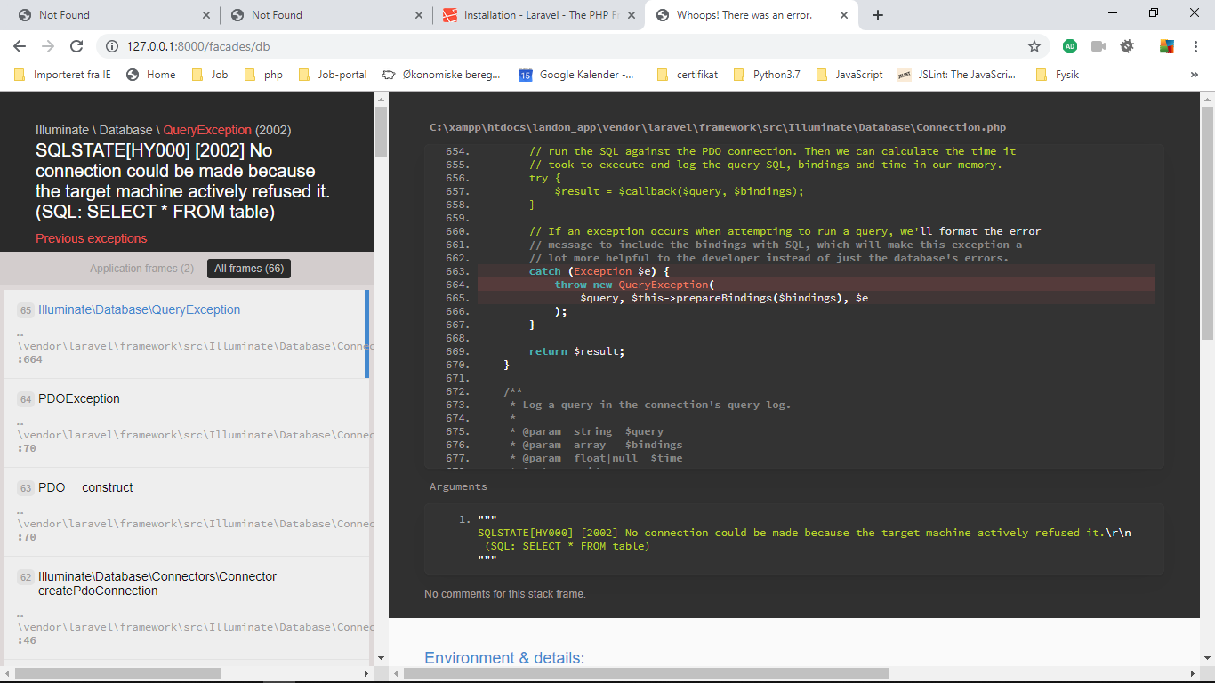

Da vi har ikke configureret database I nu.

Men vi laver i ny metode i app.php

Route::*get*('/facades/encrypt', **function** () {  
  
 **return** Crypt::*encrypt*('123456789');  
  
});

Og resultatet kan ses: <http://127.0.0.1:8000/facades/encrypt>

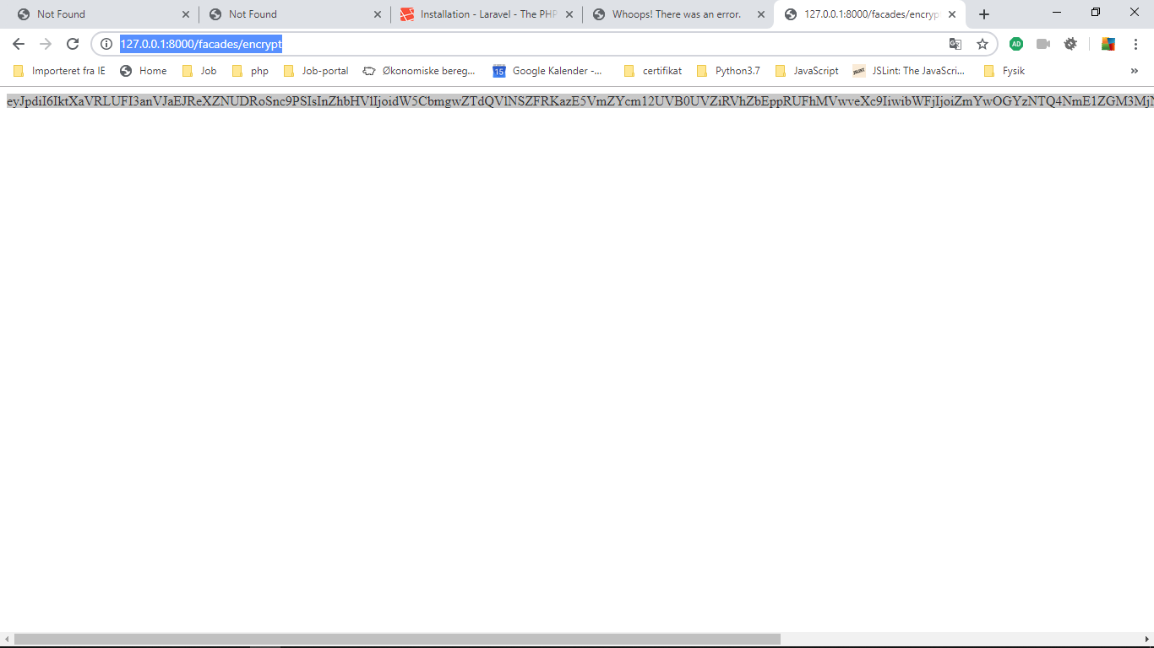

Controllers

As most PHP Frameworks Laravel has its own implementation of controllers. As we've already seen Artisan comes with a mechanism to generate controllers from scratch. So taking a look into our CRC cards we see that they 're aren't that many controllers that we need for our Landon Hotel App.

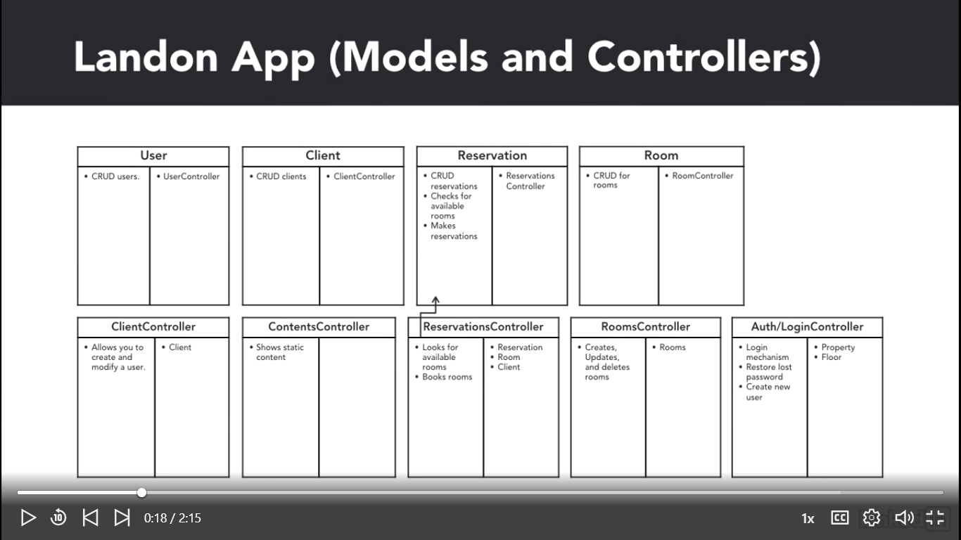

C:\xampp\htdocs\landon_app>php artisan make:controller ClientController

Controller already exists! Da vi har allerede en I forvejen

C:\xampp\htdocs\landon_app>php artisan make:controller ContentsController

Controller created successfully.

**<?php  
  
namespace** App\Http\Controllers;  
  
**use** Illuminate\Http\Request;  
  
**class** ContentsController **extends** Controller  
{  
 //  
}

This controller will serve for static HTML purposes.

C:\xampp\htdocs\landon_app>php artisan make:controller ReservationsController

Controller created successfully.

The ReservationsController will show the available rooms in a given timeframe and allow us to book a room.

C:\xampp\htdocs\landon_app>php artisan make:controller RoomsController

Controller created successfully.

The RoomsController will allow us to make CRUD a on rooms but that's only if we ever need an interface to modify the rooms.

Routing to Controller

Controllers are the bosses in the MVC context, so whenever we define a route, the basic workflow is the following:

Laravel loads the framework on the entry point and then loads the router mechanism. The router looks into web.php and decides that a url should load a controller and execute the method. The controller loads the model, which in turn, loads information, and returns this data to the controller. Lastly, the controller notes the view and passes the data to the view. The view can render on the browser as an html, json, or any format supported by the browser.

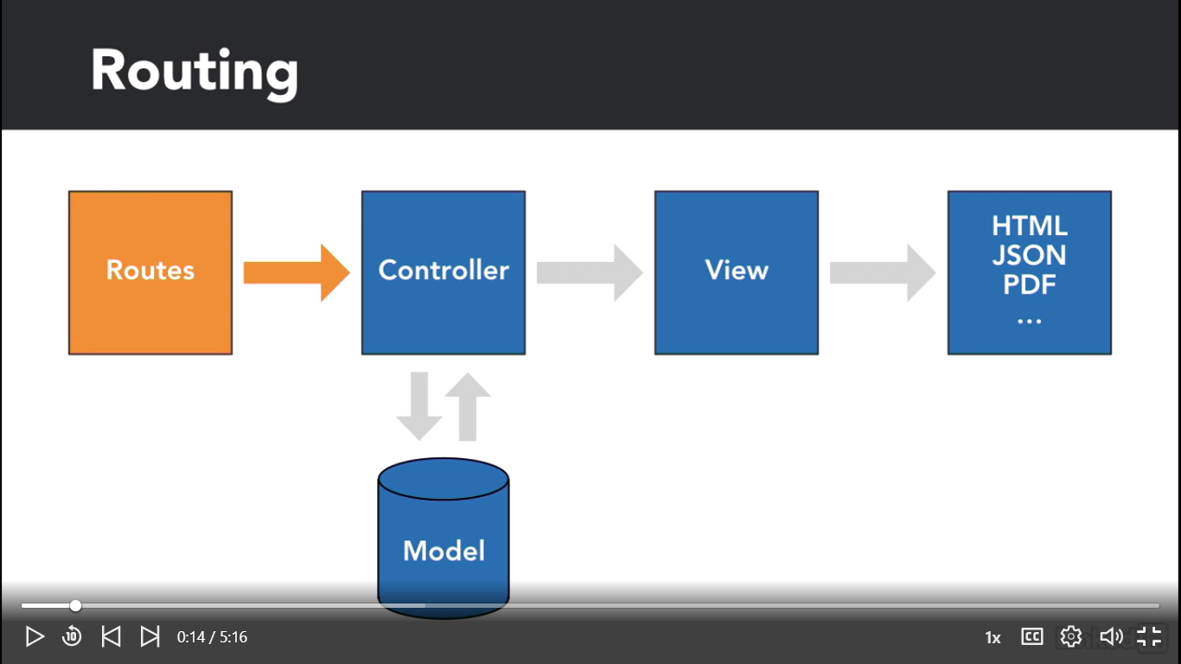

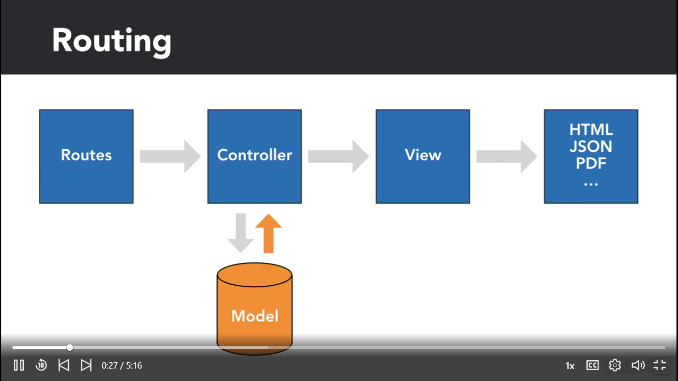

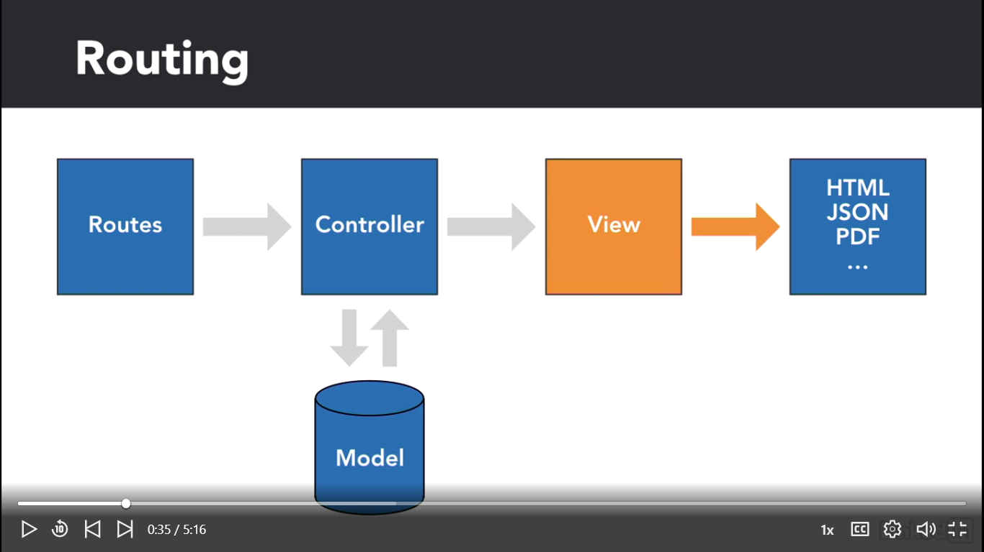

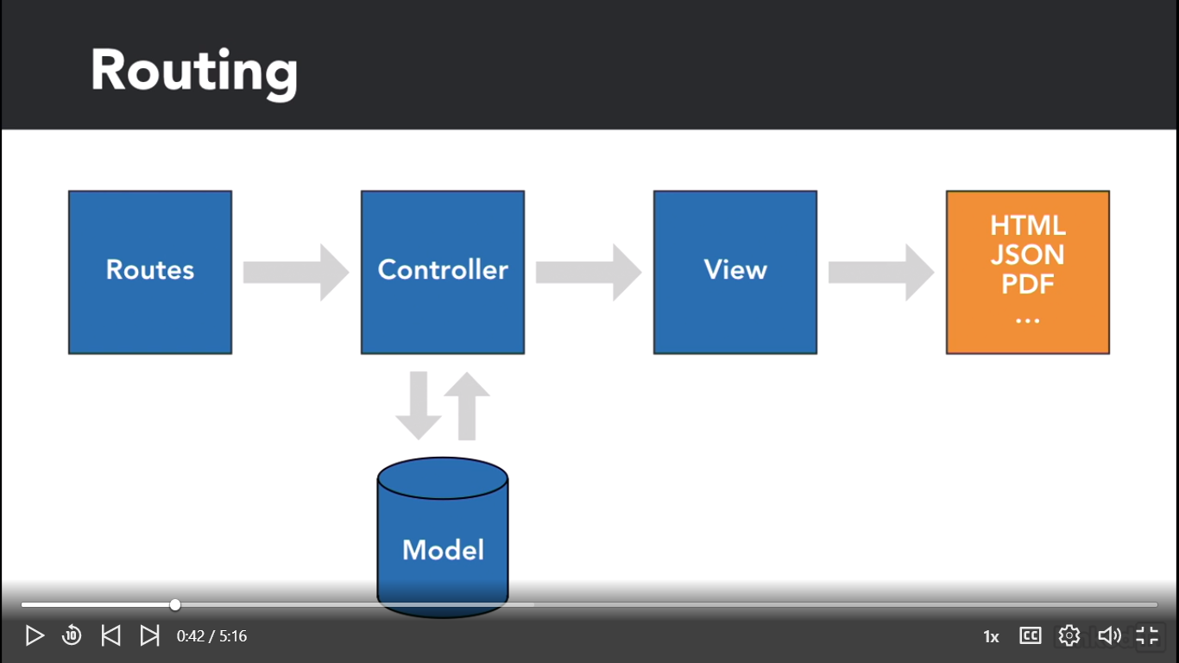

And with that, our application logic is held inside the controller. Business rules are to be contained within the model. We should avoid placing any logic, application, or business in the view. The view should just be a placeholder for information to be shown in a manner that makes sense to the enduser.

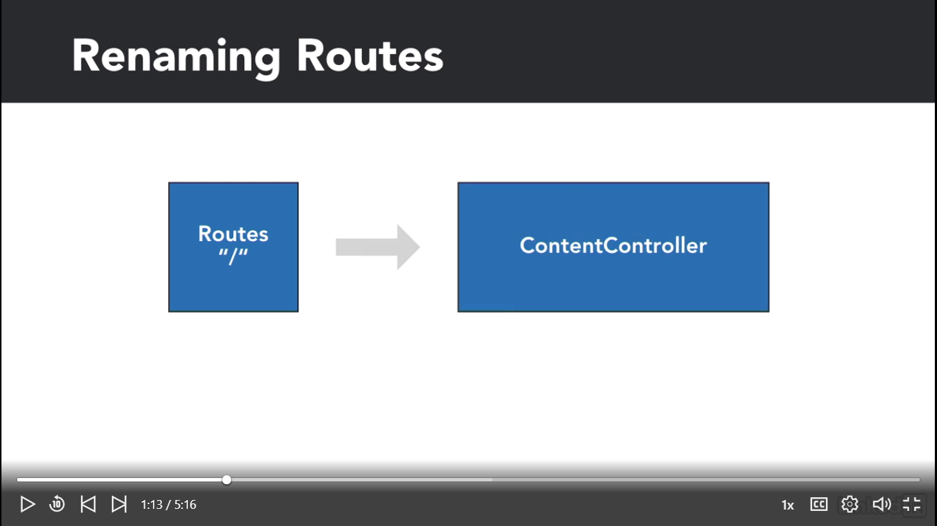

Now let's open routes, web.php. This open a side bar with command P or control B, and let's replace the function from lines 14 to 17 with a string. The string is going to be the controller's name, ContentsController, divided by an at, and the name of the method, home.

So first, let's define a route for our initial landing page, which will be managed by the ContentController, since it will only be a static page with no functionality.

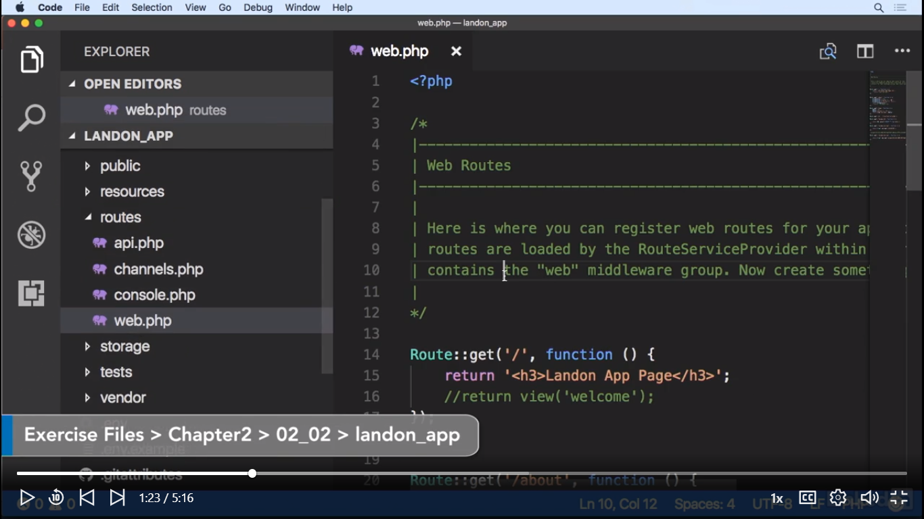

Route::*get*('/', 'ContentsController@home');

The string is going to be the controller's name, ContentsController, divided by an at, and the name of the method, home. Now let's open our ContentsController and add a home() method.

**class** ContentsController **extends** Controller  
{  
 //  
 **public function** home() {  
 **return** *__METHOD__*;  
 }  
}

We're using magic constants as placeholders just to view which methods we are calling. Later on, we will add views to each method. I Browseren kan vi se:

App\Http\Controllers\ContentsController::home

We're telling Laravel that the route slash should point to the ContentsController and it should execute the home() method.

Vi tilføger flere linier i web.php

//change the route to new. And the method is going to be newClient().  
//With that, we are telling Laravel that whenever we point our browser  
// to slash clients or slash clients slash new, each route will execute  
// a controller method.  
Route::*get*('/clients/new', 'ClientController@newClient');

Route::*post*('/clients/new', 'ClientController@create');

This is so whenever we send a form with the message post, we can execute another method for processing the form. Even if it's the same url. Ideally, we would use verbs depending on the action we would perform. For example, get is for read-only. Put would be for adding. Patch for updating. And delete for deleting. But for now, post will suffice.

**man skal til ClientController og tilføje index() metoden

**public function** index() {  
 **return** *__METHOD__*;  
}  
**public function** newClient() {  
 **return** *__METHOD__*;  
}  
**public function** create() {  
 **return** *__METHOD__*;  
}

URL with Get Parameters

Gamle metoder med parameter sendt til url: ?asset=clients&id=4

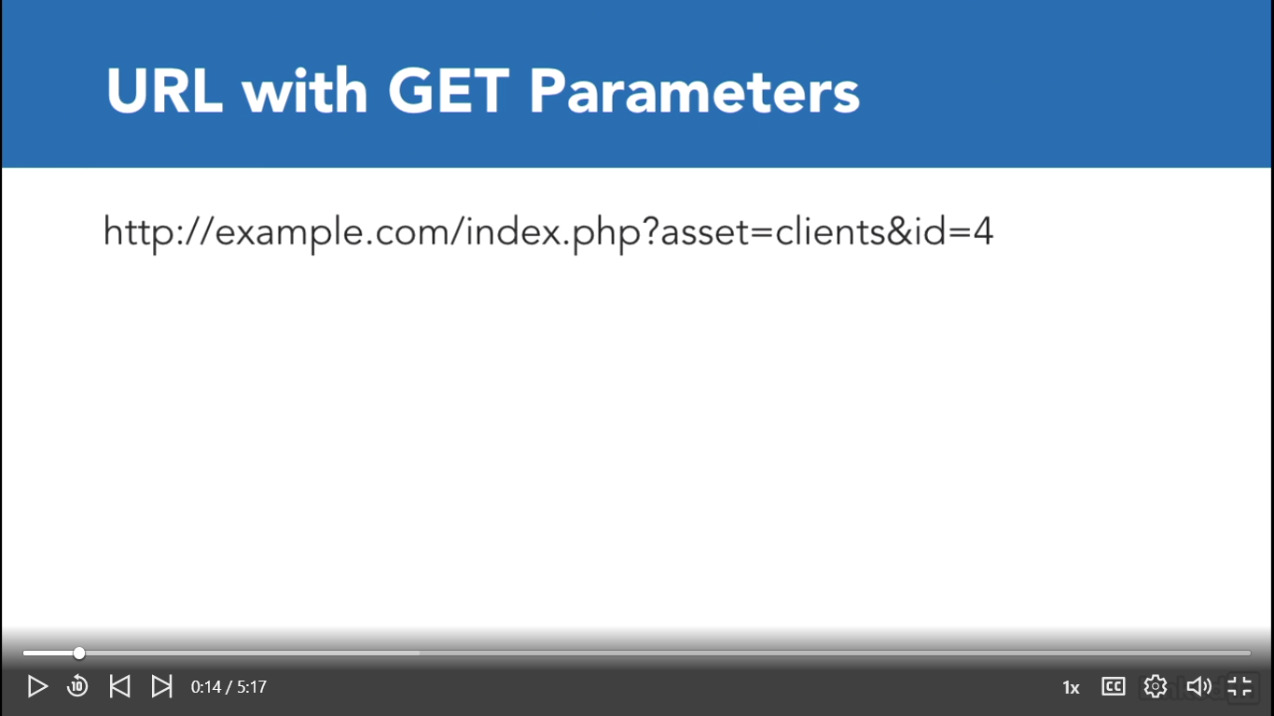

Laravel måde:

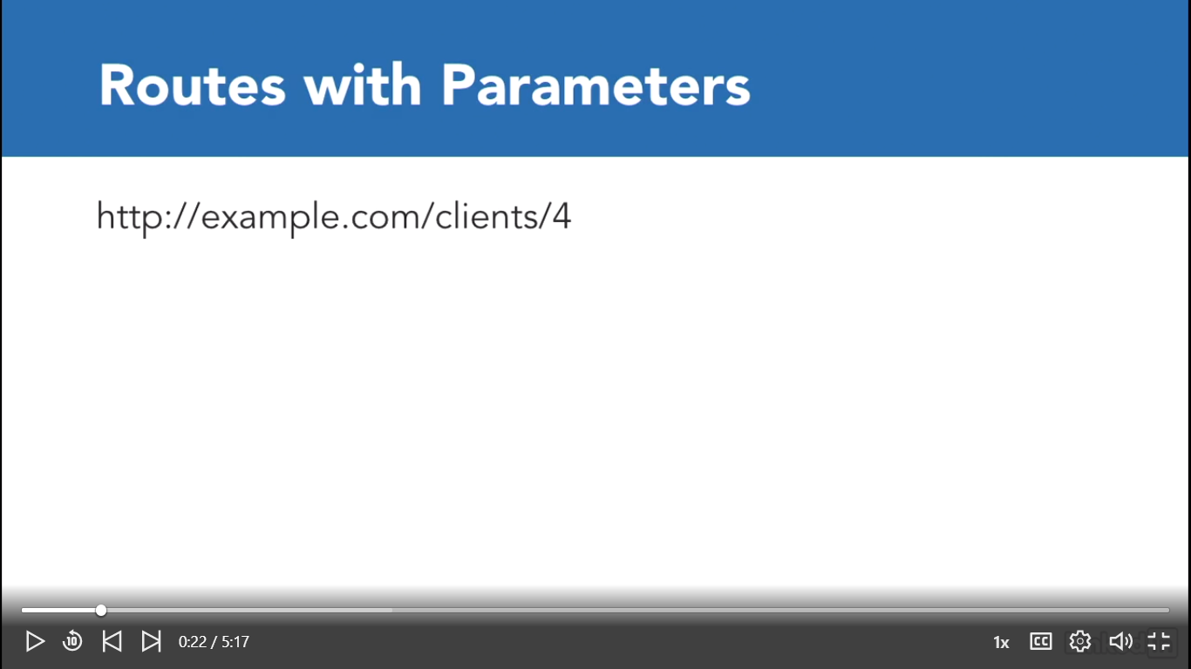

 In the past we would use GET parameters by using the question mark to denote variables. However, in the context of Frameworks, we can now pass parameters separated by the slash symbol. So for example, to get the details of a client, whose ID is four, we could use the url client slash four.

..clients/4

The way to go is to surround our parameters with curly braces. So let's create a new route for client details and add our client ID.

Så i web.app tilføjer vi:

//Laravel måde til at sende parameter til url´en  
Route::*get*('/clients/{client_id}', 'ClientController@show');

Og laver metoden show() i ClientController.php på den måde;

**public function** show($client_id) {  
 **return** *__METHOD__*.': '.$client_id;  
}

ved at taste I url´en <http://127.0.0.1:8000/clients/4> få vi

App\Http\Controllers\ClientController::show: 4

Loading a View

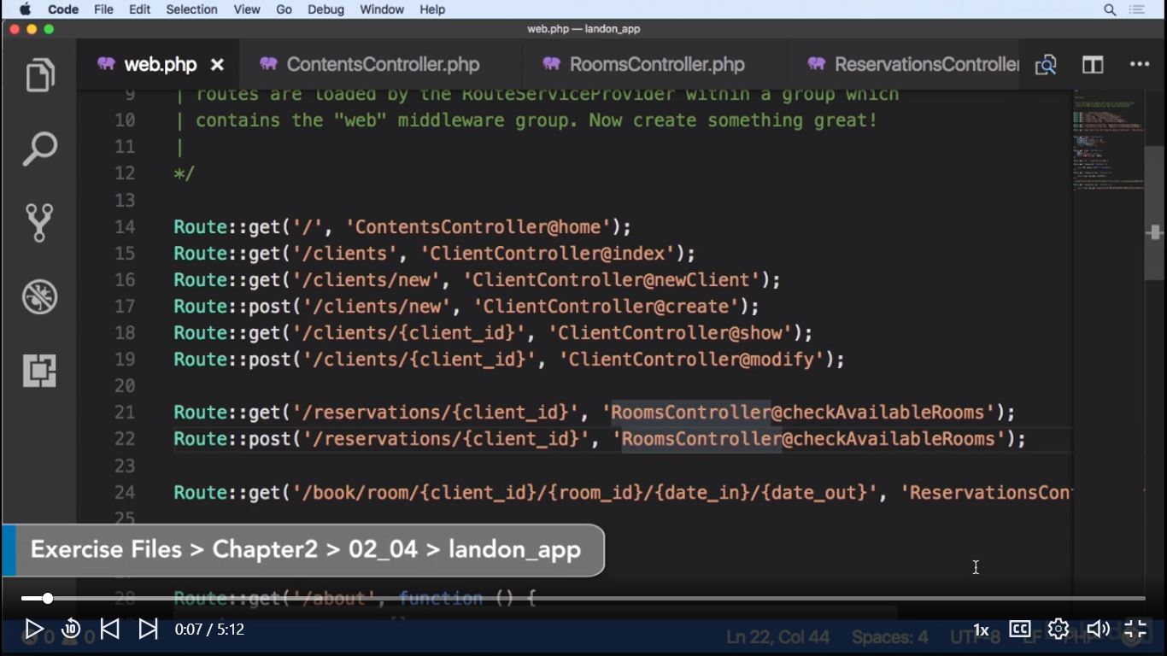

Vi laver en ny mappe med samme navn som metoderne:

C:\xampp\htdocs\landon_app\resources\views\client … som vi har lavet I nedenstående controller

C:\xampp\htdocs\landon_app\resources\views\contents

C:\xampp\htdocs\landon_app\resources\views\reservations

C:\xampp\htdocs\landon_app\resources\views\rooms

ClientController, ContentsController, ReservationsController, checkAvailableRooms

C:\xampp\htdocs\landon_app\resources\views\client\index.blade.php osv.

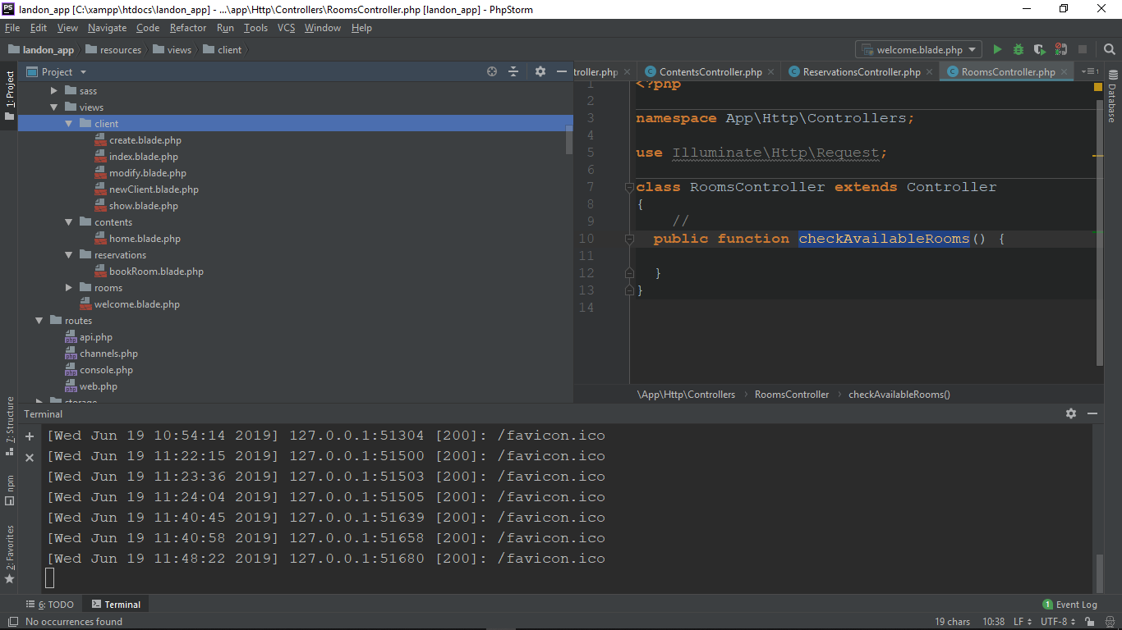

Og ændre metoderne ClientController som nedenfor:

**public function** index() {  
 **return** view('client/index');  
 //return __METHOD__;  
}  
**public function** newClient() {  
 **return** view('client/newClient');  
 //return __METHOD__;  
}  
**public function** create() {  
 **return** view('client/create');  
 //return __METHOD__;  
}  
//hvis i url taster vi i url´en via Get parameter http://127.0.0.1:8000/clients/4  
//får vi i browseren: App\Http\Controllers\ClientController::show: 4  
**public function** show($client_id) {  
 **return** view('client/show');  
 //return __METHOD__.': '.$client_id;  
}

og samme I ContentsController

**class** ContentsController **extends** Controller  
{  
 //  
 **public function** home() {  
  
 **return** view('contents/home');  
 //return __METHOD__;  
 }  
}

og I ReservationsController

**class** ReservationsController **extends** Controller  
{  
 //  
 **public function** bookRoom() {  
 **return** view('reservations/bookRoom');  
 }  
}

og I RoomsController

**class** RoomsController **extends** Controller  
{  
 //  
 **public function** checkAvailableRooms() {  
 **return** view('rooms/checkAvailableRooms');  
 }  
}

Nu ændrer vi I View folder php.filer(f.eks index.blade.php eller homi.blade.php) og skriver noget som vi kan se i browseren

Eksampel:

Trin 1

Under C:\xampp\htdocs\landon_app_03_02\routes\web.php definer vi Route og metoden homi()

//test homi  
Route::*get*('/clients/homi','ClientController@homi')->name('homi_client');

Dvs. i browseren skal vi finde <http://127.0.0.1:8000/clients/homi>

Trin 2

ClientController@homi betyder at vi i filen

C:\xampp\htdocs\landon_app_03_02\app\Http\Controllers\ClientController.php skal laves metoden homi() som nedenfor

**public function** homi() {  
 **return** view('client/homi');  
}

dvs. ClientController nu kalder metoden homi(), som ved eksekvering trigger filen homi.blade.php under view/client

Trin 3

’client/homi’ betyder, der skal laves filen homi.blade.php under views

C:\xampp\htdocs\landon_app_03_02\resources\views\client\homi.blade.php

Hvor indeholder html som nedenfor

<h1>Homi i filen homi.blade.php under view er blevet kaldt via client controlleren</h1>

Og vise i browseren <http://127.0.0.1:8000/clients/homi>

# Homi i filen homi.blade.php under view er blevet kaldt via client controlleren

Create a template and extended views

One of the most useful assets in a framework, is the ability to create layouts. By layouts I mean, reusable parts of the html so we can easily include a header block, a body block and a footer block. We can also include our application's assets: JS, CSS and images. And creating a new view, will become a very simple task.

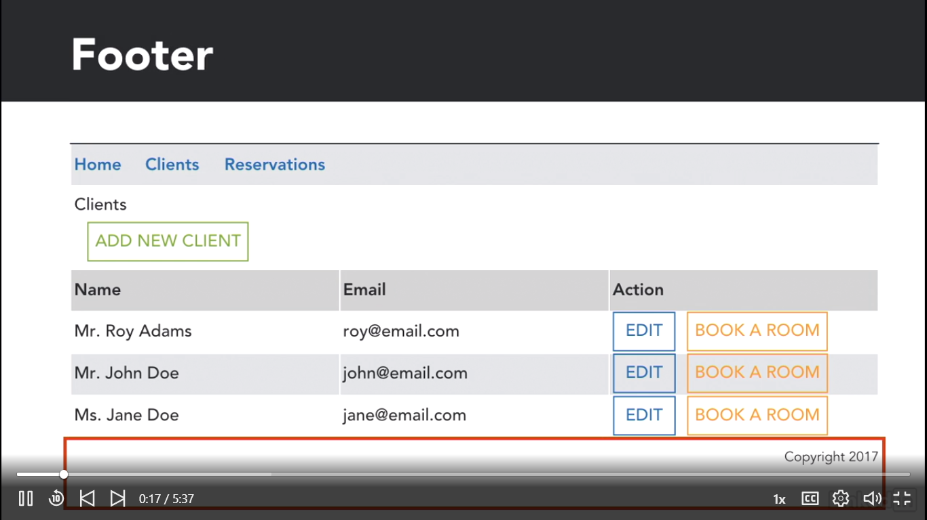

Vi laver en ny mappe layouts under views og laver filen app.blade.php

C:\xampp\htdocs\landon_app\resources\views\layouts\app.blade.php

Fra project resources tage koden fra client.html og kopier indholdet til app.blade.php filen.

Og ændrer vi som nedenfor

<link rel="stylesheet" href="{{asset('css/foundation.css')}}">  
<link rel="stylesheet" href="{{asset('css/app.css')}}">  
<link rel="stylesheet" href="{{asset('pickadate/lib/themes/default.css')}}">  
<link rel="stylesheet" href="{{asset('pickadate/lib/themes/default.date.css')}}"

<script src="{{ asset('js/vendor/jquery.js')}}"></script>  
<script src="{{ asset('js/vendor/what-input.js')}}"></script>  
<script src="{{ asset('js/vendor/foundation.js')}}"></script>  
<script src="{{ asset('js/app.js')}}"></script>  
<script src="{{ asset('pickadate/lib/picker.js') }}"></script>  
<script src="{{ asset('pickadate/lib/picker.date.js') }}"></script>

Nu går vi under [home.blade.php](http://home.blade.php) og ændrer som nedenfor

Let's start by sending some data to the view. For now, let's only send hard coded data. However, let's try to keep this data as similar to the data on the database as possible. Let's start by sending a variable to the view.

Først åbner vi

C:\xampp\htdocs\landon_app_03_02\app\Http\Controllers\ContentsController.php

**class** ContentsController **extends** Controller  
{  
 //  
 **public function** home()  
 {  
 $data = [];  
 $data['version'] = '0.1.2';  
 **return** view('contents/home', $data);  
 }  
}

Nu åbner vi C:\xampp\htdocs\landon_app_03_02\resources\views\contents\home.blade.php

**@section(**'content'**)** <div class="row">  
 <div class="medium-6 columns">  
 <h4>Landon Hotel App v. {{ $version }}</h4>  
 <img class="thumbnail" src="images/attractions.jpg">  
 </div>  
 <div class="medium-6 large-5 columns">  
 <p>The original Landon perseveres after 50 years in the heart of West London. The West End neighborhood has something for everyone—from theater to dining to historic sights.</p>  
 <p>And the not-to-miss Rooftop Cafe is a great place for travelers and locals to engage over drinks, food, and good conversation. </p>  
 <p>To learn more about the Landon Hotel in the West End, browse our website and download our handy information sheet.</p>

Så kan nu via {{ $version }} er variable klar til at læses I view(Browser).

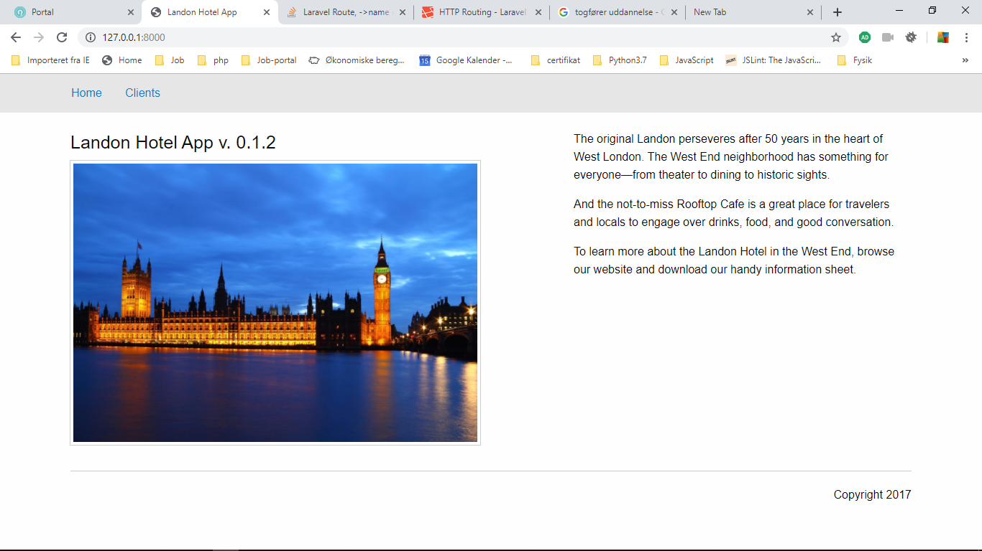

Notice we're adding an associative array. And as easy as that, we have passed data from the controller to the view.

Eksampel:

Først vi går til C:\xampp\htdocs\landon_app_03_02\app\Http\Controllers\ClientController.php

og tilføjer vi to objekter som nedenfor:

**public function** index()  
{  
 $obj = **new** \stdClass;  
 $obj->id = 1;  
 $obj->title = 'mr';  
 $obj->name = 'john';  
 $obj->last_name = 'doe';  
 $obj->email = 'john@domain.com';  
  
  
 $obj = **new** \stdClass;  
 $obj->id = 2;  
 $obj->title = 'ms';  
 $obj->name = 'jane';  
 $obj->last_name = 'doe';  
 $obj->email = 'jane@another-domain.com';  
   
 **return** view('client/index');  
}

Så tilføjer vi 2 objekter I en array som nedenfor

**public function** index()  
{  
 $obj = **new** \stdClass;  
 $obj->id = 1;  
 $obj->title = 'mr';  
 $obj->name = 'john';  
 $obj->last_name = 'doe';  
 $obj->email = 'john@domain.com';  
  
 //vi tiljøjer 2 objekter til en array  
 $data['clients'][]= $obj;  
  
  
 $obj = **new** \stdClass;  
 $obj->id = 2;  
 $obj->title = 'ms';  
 $obj->name = 'jane';  
 $obj->last_name = 'doe';  
 $obj->email = 'jane@another-domain.com';  
  
 //vi tiljøjer 2 objekter til en array  
 $data['clients'][]= $obj;  
  
 **return** view('client/index', $data);  
}

Nu åbner vi index.blade.php under views:

C:\xampp\htdocs\landon_app_03_02\resources\views\client\index.blade.php

Og tilføjer

{{--//for at vise indeholdet da vi allerede oprtettet i ClientController som--}}  
{{--// $data['clients'][]= $obj; med 2 objekter i assoc.array $data[]--}}  
  
 <pre>{{ var_dump($clients) }}</pre>

Og kan se browseren: <http://127.0.0.1:8000/clients>

**array** *(size=2)*

0 =>

**object**(*stdClass*)[*227*]

*public* 'id' => int 1

*public* 'title' => string 'mr' *(length=2)*

*public* 'name' => string 'john' *(length=4)*

*public* 'last_name' => string 'doe' *(length=3)*

*public* 'email' => string 'john@domain.com' *(length=15)*

1 =>

**object**(*stdClass*)[*222*]

*public* 'id' => int 2

*public* 'title' => string 'ms' *(length=2)*

*public* 'name' => string 'jane' *(length=4)*

*public* 'last_name' => string 'doe' *(length=3)*

*public* 'email' => string 'jane@another-domain.com' *(length=23)*

Views and additional Blade functionality

Now that the data is available for the view we can still make blade simplify things for us. For one thing, loops are very useful when handling arrays. Let's use the array we previously created to show data on the table.

C:\xampp\htdocs\landon_app_03_02\resources\views\client\index.blade.php

<tr>  
 <td>Mr. Roy Adams</td>  
 <td>roy@email.com</td>  
 <td>  
 <a class="hollow button" href="./clients_new.html">EDIT</a>  
 <a class="hollow button warning" href="./book_room.html">BOOK A ROOM</a>  
 </td>  
</tr>

Laves om til at få object prop. Fra assoc. Array som nedenfor

**@foreach(**$cliens **as** $client**)** <tr>  
 <td>{{ $client->title }}.{{ $client->name }}</td>  
 <td>{{ $client->email }}</td>  
 <td>  
 <a class="hollow button" href="./clients_new.html">EDIT</a>  
 <a class="hollow button warning" href="./book_room.html">BOOK A ROOM</a>  
 </td>  
 </tr>  
**@endforeach**

Obs: Hvis vi kører så får vi nedenstående problem:

Undefined variable: cliens (View: C:\xampp\htdocs\landon_app_03_02\resources\views\client\index.blade.php)

And this is where it gets slightly tricky. We're about to create dynamic links to other routes but we also have to send parameters to these routes. Let's do that. Let's erase the href content and change it to mustache syntax.

**@foreach(**$clients **as** $client**)** <tr>  
 <td>{{ $client->title }}.{{ $client->name }}</td>  
 <td>{{ $client->email }}</td>  
 <td>  
 <a class="hollow button" href="{{ route('show_client', ['client_id' => $client->id] )}}">EDIT</a>  
 <a class="hollow button warning" href="{{ route('check_room', ['client_id' => $client->id] )}}">BOOK A ROOM</a>  
 </td>  
 </tr>  
**@endforeach**

I browser´en <http://127.0.0.1:8000/clients>

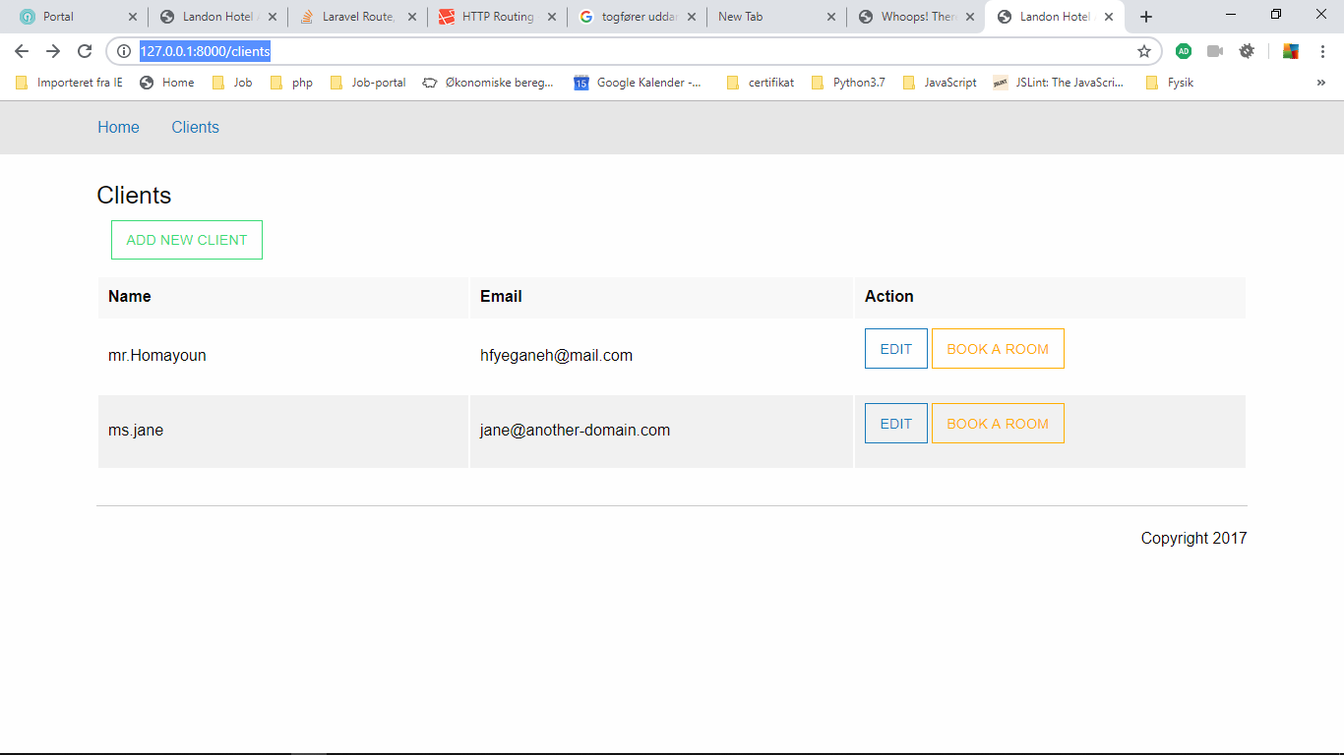

 Titles from the model

Now that we've learned how to parse data to a view, let me give you something to do on your own. Earlier, we created a model for the title's array called titles. Your mission, should you choose to accept it, is to use this model and inject it to the new client form. The model array should populate the select menu. You'll want to start by searching the route by name. The model is already imported in the client controlle.

C:\xampp\htdocs\landon_app_03_02\app\Http\Controllers\ClientController.php

**use** App\Title **as** Title;  
  
**class** ClientController **extends** Controller  
{  
 //  
 **public function** __construct( Title $titles )  
 {  
 $this->titles = $titles->all();  
 }

og passer vi $data I newClient

**public function** newClient()  
{  
 $data = [];  
 $data['titles'] = $this->titles;  
 **return** view('client/newClient', $data);  
}

Så skal vi C:\xampp\htdocs\landon_app_03_02\resources\views\client\newClient.blade.php

<select name="form[title]">  
 <option value="mr" selected="selected">Mr.</option>  
 <option value="ms">Ms.</option>  
 <option value="mrs">Mrs.</option>  
 <option value="dr">Dr.</option>  
 <option value="mx">Mx.</option>  
 </select>

Ændres til:

<select name="form[title]">  
 **@foreach(**$titles **as** $title**)** <option value="{{$title}}" >{{$title}}.</option>  
 **@endforeach** </select>  
</div>

Create forms

Forms are the entry point for data coming from the end user. We must be very careful when handling data from forms, because we can never trust data coming from the users. But for now, let's first get the data.

Først I web.php cheker vi : C:\xampp\htdocs\landon_app_03_02\routes\web.php

Route::*get*('/clients/new', 'ClientController@newClient')->name('new_client');  
Route::*post*('/clients/new', 'ClientController@create')->name('create_client');

The difference will abide in the request. When the form is being shown, it's being sought(søge) by a get request, but when the form is sent, it will be though a post request. So the route should be as such, one for new client, and one for create client.

Så åbner vi:

C:\xampp\htdocs\landon_app_03_02\resources\views\client\newClient.blade.php

Now this will get slightly tricky. While we should use a view for each controller method, we can bend this rule for the sake of code reuse. We want to use the same form for creating a new client, and for modifying an existing client.

Vi laver en copy af indeholdet af newClient.blade.php og sætter ind i en ny fil form.blade.php

Først vi laver tilføjer i ClientController modify data

C:\xampp\htdocs\landon_app_03_02\app\Http\Controllers\ClientController.php

**public function** newClient()  
{  
 $data = [];  
 $data['titles'] = $this->titles;  
 **return** view('client/newClient', $data);  
}

ændres til:

**public function** newClient()  
{  
 $data = [];  
 $data['titles'] = $this->titles;  
 $data['modify'] = 0;  
 **return** view('client/form', $data);  
}

**HUKSK: client/form betyder: client/form.blade.php

**public function** show($client_id)  
{  
 $data = [];  
 $data['titles'] = $this->titles;  
 $data['modify'] = 1;  
 **return** view('client/form, $data);  
}

Så I C:\xampp\htdocs\landon_app_03_02\resources\views\client\form.blade.php

<div class="medium-12 large-12 columns">  
 <h4>{{ $modify == 1 ? 'Modify Client' : 'New Client' }}</h4>  
 <form action="{{ $modify == 1 ? route('update_client', ['client_id' => 1 ]) : route('create_client') }}" method="post">  
 <div class="medium-4 columns">  
 <label>Title</label>  
 <select name="form[title]">  
 **@foreach(**$titles **as** $title**)** <option value="{{$title}}" >{{$title}}.</option>  
 **@endforeach**

Process form data

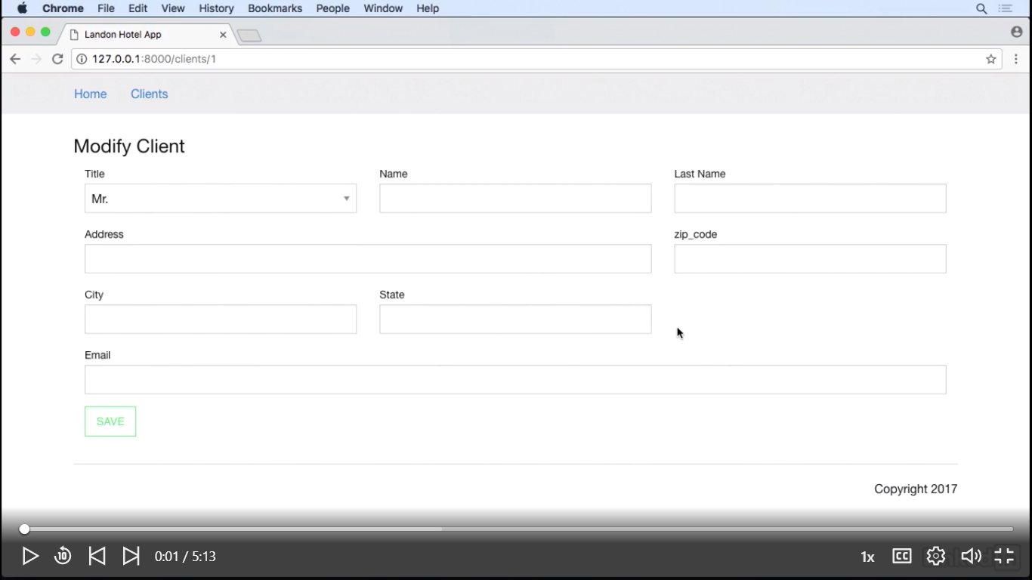

Hvis vi klikke på SAVE button, Laravel comes with a CSRF or Cross-Site Request Forgery protection mechanism. let's open the CSRF middleware file.  type VerifyCsrfToken.php, and on the except array, we'll just add a string with a star on it. This is a wildcardand will disable any CSRF protection for any request. So let's test it. Let's go to the browser, refresh, and now we have a different error.

**class** VerifyCsrfToken **extends** Middleware  
{  
 */**  
 * Indicates whether the XSRF-TOKEN cookie should be set on the response.  
 *  
 \** ***@var*** *bool  
 */* **protected** $addHttpCookie = **true**;  
  
 */**  
 * The URIs that should be excluded from CSRF verification.  
 *  
 \** ***@var*** *array  
 */* **protected** $except = [  
 //  
 '*'  
 ];  
}

This is a wildcard (*)and will disable any CSRF protection for any request.

Vi ånber ClientController.php og ændre i newClient() metode.

**public function** newClient()  
{  
 $data = [];  
 $data['titles'] = $this->titles;  
 $data['modify'] = 0;  
 **return** view('client/form', $data);  
}

til:

**public function** newClient(Request $request)  
{  
 $data = [];  
 $data['title'] = $request->input('title');  
 $data['name'] = $request->input('name');  
 $data['last_name'] = $request->input('last_name');  
 $data['address'] = $request->input('address');  
 $data['zip_code'] = $request->input('zip_code');  
 $data['city'] = $request->input('city');  
 $data['state'] = $request->input('state');  
 $data['email'] = $request->input('email');  
  
 $data['titles'] = $this->titles;  
 $data['modify'] = 0;  
  
 **if** ($request->isMetod('post')) {  
 dd($data);  
 **return** redirect('clients');  
 }  
 **return** view('client/form', $data);  
}

som f.eks $request->input('name');  
svar I html form.blade.php filen:

<div class="medium-4 columns">  
 <label>Name</label>  
 <input name="name" type="text">  
</div>  
<div class="medium-4 columns">  
 <label>Last_name</label>  
 <input name="lastName" type="text">  
</div>

Osv. …

så I web.app

Route::*get*('/clients/new', 'ClientController@newClient')->name('new_client');  
Route::*post*('/clients/new', 'ClientController@create')->name('create_client');

Til:

Route::*get*('/clients/new', 'ClientController@newClient')->name('new_client');  
Route::*post*('/clients/new', 'ClientController@newClient')->name('create_client');

Hvis vi kører uden at skrive noget, får vi

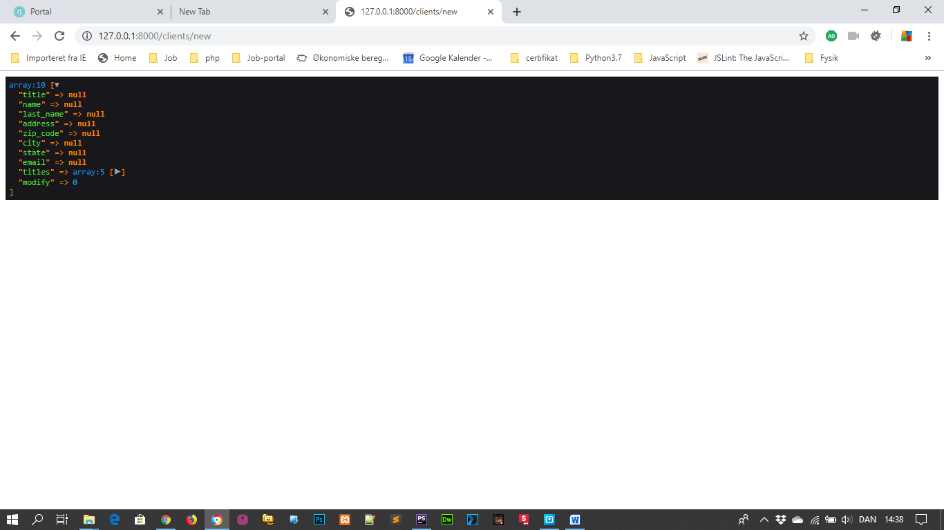

Men hvis vi udfylder post felterne som nedenfor:

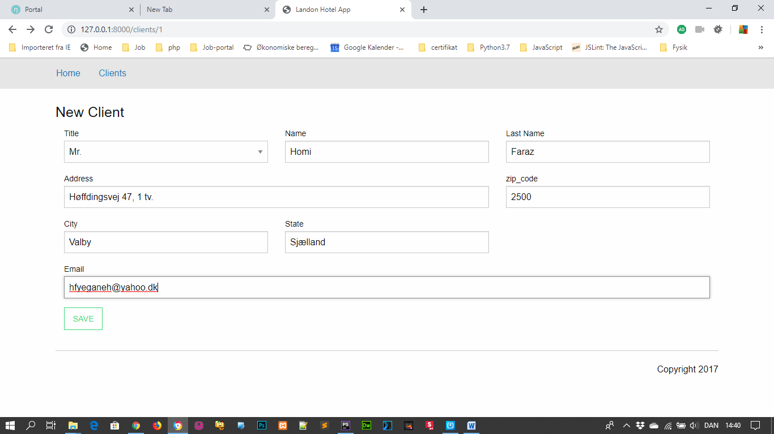

Får vi:

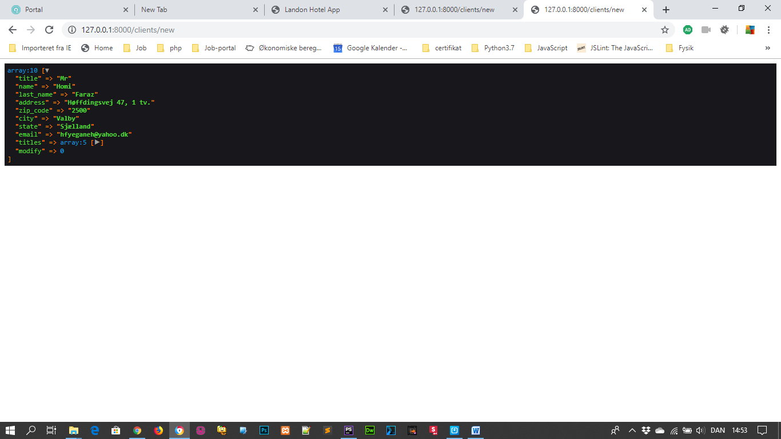

Form validation: Back end

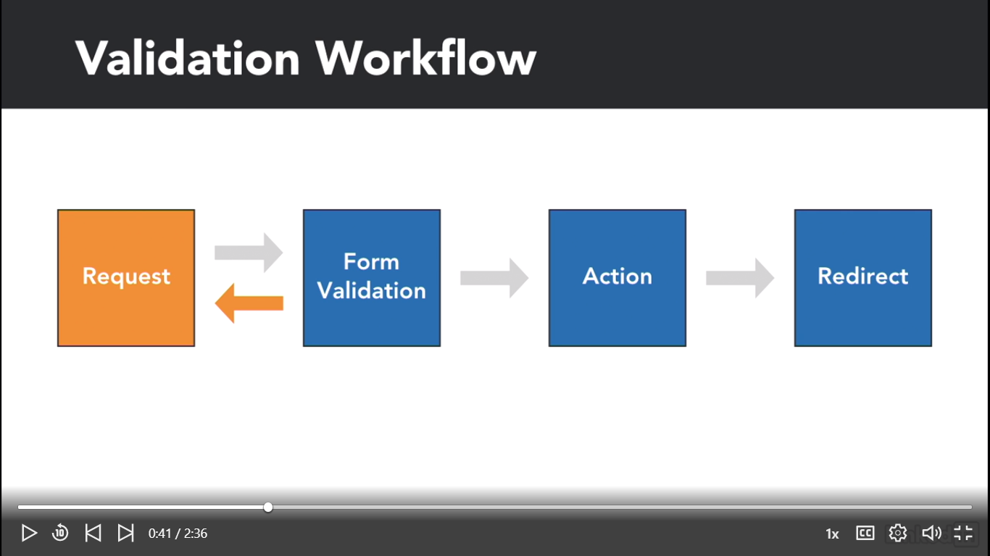

Så valider felterene i: C:\xampp\htdocs\landon_app_03_02\app\Http\Controllers\ClientController.php

**public function** newClient(Request $request)  
{  
 $data = [];  
 $data['title'] = $request->input('title');  
 $data['name'] = $request->input('name');  
 $data['last_name'] = $request->input('last_name');  
 $data['address'] = $request->input('address');  
 $data['zip_code'] = $request->input('zip_code');  
 $data['city'] = $request->input('city');  
 $data['state'] = $request->input('state');  
 $data['email'] = $request->input('email');  
  
 $data['titles'] = $this->titles;  
 $data['modify'] = 0;  
  
 **if** ($request->isMethod('post')) {  
 //dd($data);  
 //validation starts here  
 $this->validate($request,  
 [  
 'name'=>'required',  
 'last_name'=>'required',  
 'address'=>'required',  
 'zip_code'=>'required',  
 'city'=>'required',  
 'state'=>'required',  
 'email'=>'required'  
 ]);  
 **return** redirect('clients');  
 }  
 **return** view('client/form', $data);  
}

Form validation: Front end

Open

C:\xampp\htdocs\landon_app_03_02\public\css\app.cssand we're going to add the following style sheet rule. Dot error, curly bracesand we're just going to type color, colon, red.

.error { color: red;}

Then open C:\xampp\htdocs\landon_app_03_02\resources\views\client\form.blade.php

<div class="medium-4 columns">  
 <label>Name</label>  
 <input name="name" type="text">  
 <small class="error">{{ $errors->first('name') }}</small>  
</div>

Og ændre for alle felterne I formen:

<div class="medium-4 columns">  
 <label>Last_name</label>  
 <input name="last_name" type="text">  
 <small class="error">{{ $errors->first('last_name') }}</small>  
</div>  
<div class="medium-8 columns">  
 <label>Address</label>  
 <input name="address" type="text">  
 <small class="error">{{ $errors->first('address') }}</small>  
</div>  
<div class="medium-4 columns">  
 <label>zip_code</label>  
 <input name="zip_code" type="text">  
 <small class="error">{{ $errors->first('zip_code') }}</small>  
</div>  
<div class="medium-4 columns">  
 <label>City</label>  
 <input name="city" type="text">  
 <small class="error">{{ $errors->first('city') }}</small>  
</div>  
<div class="medium-4 columns">  
 <label>State</label>  
 <input name="state" type="text">  
 <small class="error">{{ $errors->first('state') }}</small>  
</div>  
<div class="medium-12 columns">  
 <label>Email</label>  
 <input name="email" type="text">  
 <small class="error">{{ $errors->first('email') }}</small>  
</div>

Nu kører vi igen uden at udfylde og klikke på SAVE knappen:

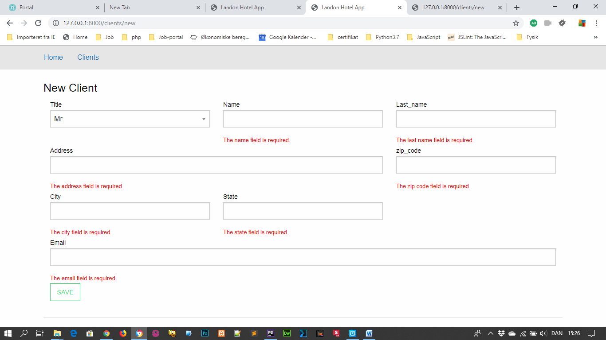

However there's one last thing we need to fix. We're sending an empty field, but if we were not, the form data would be lost. This would be extremely frustrating for the end user. How many times have we seen long forms cleared out without any indication as to what went wrong?

Vi åbner igen open C:\xampp\htdocs\landon_app_03_02\resources\views\client\form.blade.php

Og tilføjer old I html´en:

<div class="medium-4 columns">  
 <label>Name</label>  
 <input name="name" type="text" value="{{ old('name') }}">  
 <small class="error">{{ $errors->first('name') }}</small>  
</div>

Og det samme for alle andre ferlter som nedenfor:

<div class="medium-4 columns">  
 <label>Last_name</label>  
 <input name="last_name" type="text" value="{{ old('last_name') }}">  
 <small class="error">{{ $errors->first('last_name') }}</small>  
</div>  
<div class="medium-8 columns">  
 <label>Address</label>  
 <input name="address" type="text" value="{{ old('address') }}">  
 <small class="error">{{ $errors->first('address') }}</small>  
</div>  
<div class="medium-4 columns">  
 <label>zip_code</label>  
 <input name="zip_code" type="text" value="{{ old('zip_code') }}">  
 <small class="error">{{ $errors->first('zip_code') }}</small>  
</div>  
<div class="medium-4 columns">  
 <label>City</label>  
 <input name="city" type="text" value="{{ old('city') }}">  
 <small class="error">{{ $errors->first('city') }}</small>  
</div>  
<div class="medium-4 columns">  
 <label>State</label>  
 <input name="state" type="text" value="{{ old('state') }}">  
 <small class="error">{{ $errors->first('state') }}</small>  
</div>  
<div class="medium-12 columns">  
 <label>Email</label>  
 <input name="email" type="text" value="{{ old('state') }}">  
 <small class="error">{{ $errors->first('email') }}</small>  
</div>

Besides being required, let's also add an addition validation which will be a minimum character requirement. Let's type pipe, min, colon, five. Let's go back to our browser and let's send the form again. Now let's send a name, Be, and now the error message changes. If, however, we fill out the whole form and let's try to send our form again.

C:\xampp\htdocs\landon_app_03_02\app\Http\Controllers\ClientController.php

**public function** newClient(Request $request)  
{  
 $data = [];  
 $data['title'] = $request->input('title');  
 $data['name'] = $request->input('name');  
 $data['last_name'] = $request->input('last_name');  
 $data['address'] = $request->input('address');  
 $data['zip_code'] = $request->input('zip_code');  
 $data['city'] = $request->input('city');  
 $data['state'] = $request->input('state');  
 $data['email'] = $request->input('email');  
  
 $data['titles'] = $this->titles;  
 $data['modify'] = 0;  
  
 **if** ($request->isMethod('post')) {  
 //dd($data);  
 //validation starts here  
 $this->validate($request,  
 [  
 'name'=>'required|min:5',  
 'last_name'=>'required',  
 'address'=>'required',  
 'zip_code'=>'required',  
 'city'=>'required',  
 'state'=>'required',  
 'email'=>'required'  
 ]);  
 **return** redirect('clients');  
 }  
 **return** view('client/form', $data);  
}

'name'=>'required|min:5’; betyder at antal karakterer skal ikke være mindre end 5

Test:

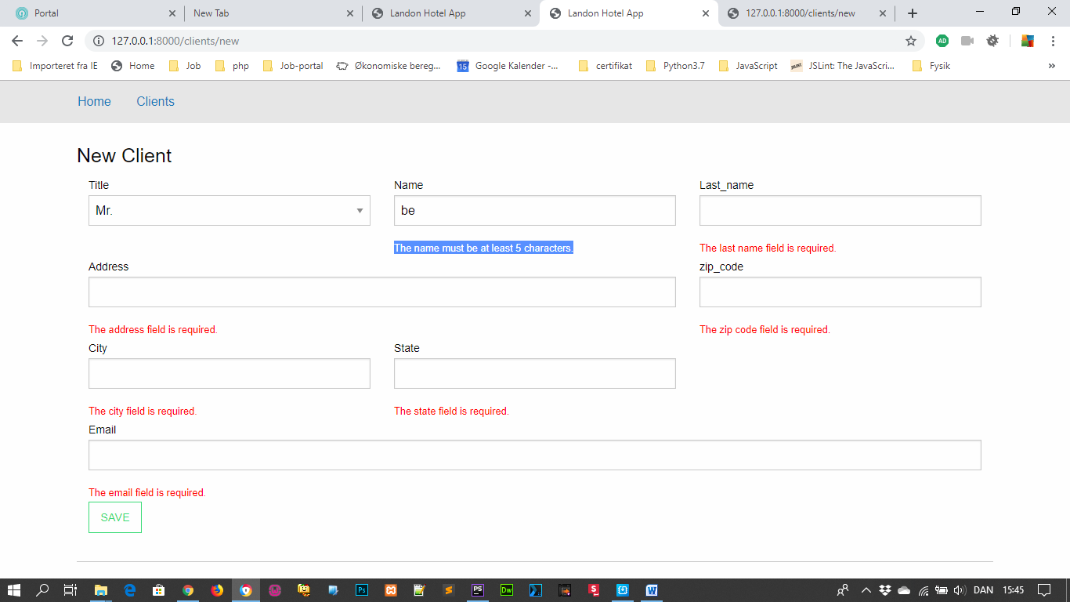

Introduction to Eloquent

Frameworks were built upon the DRY premise, or Do not Repeat Yourself. And frameworks, just like design patterns, were created to solve issues that developers encounter, again and again. And database handling is not the exception. Laravel comes with an already-packaged and ready to use ORM, called Eloquent. But before getting into Eloquent, let's dip into what an ORM is. An ORM is an object-relational mapper, which is an abstraction of database table structure and actions. The ORM helps us execute database actions without having to write SQL queries.

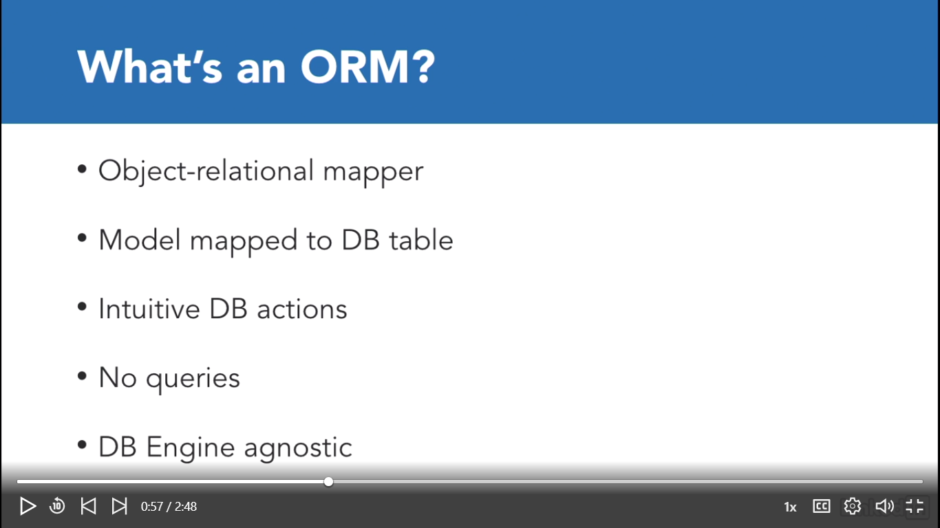

It's also database-agnostic, that is, it will help us use different databases without us having to worry about the SQL flavor. Should we ever have the need to change the database engines, an ORM would help us do the switch seamlessly. There are different ORMs for different technologies. For example, ActiveRecord is the ORM that is normally used with Ruby on Rails. And Symphony already comes with Doctrine out of the box. While it may not be suitable for small projects, Doctrine makes perfect sense for large projects, with its own DQL or Doctrine Query Language. Laravel is not the exception and comes with an ORM called Eloquent. While you may configure Laravel to use other ORMs, most examples and the documentation are heavily basedon the assumption that we'll use Eloquent. So for now, let's use Eloquent. Eloquent is an ORM based on the ActiveRecord design pattern. Named by Martin Fowler, the ActiveRecord pattern wraps a database table into a class, and an instance of that class to a single row. Any action performed on that object will be reflected on the database. Lastly, Foreign Keys relationships are exposed as separate instances. While Eloquent does have its own implementation of the ActiveRecord pattern, once you use it, you realize the astonishing resemblance with the ActiveRecord ORM for Rails. Propel is another great choice for an ORM, which also implements the ActiveRecord pattern. It's simple to learn and, since it uses PDOs, it supports a large number of databases. RedBean PHP is another great way to go, as far as ORM selection is concerned. It employs an awesome strategy of zero configuration and it's great for prototyping. The downfall is that it may not be suitable for large projects that have already been designed.

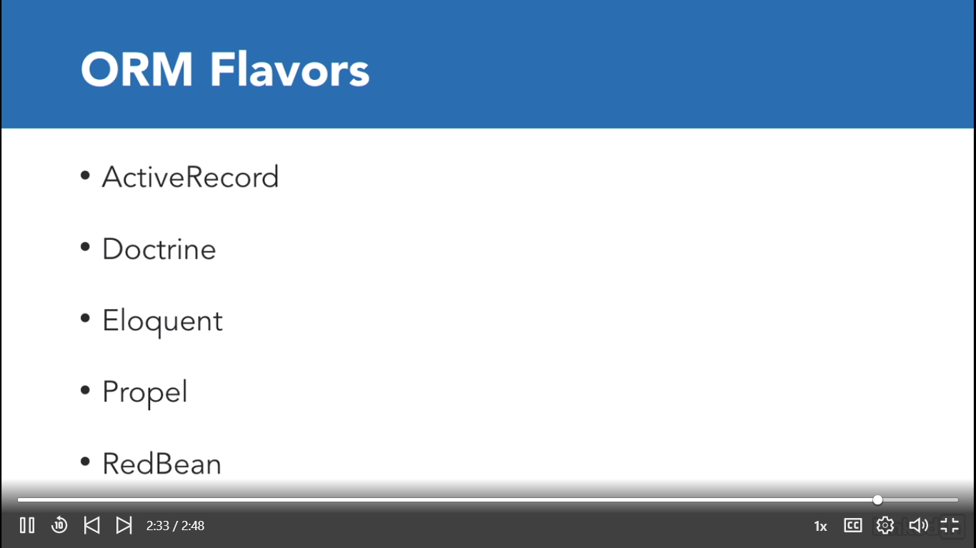

Set up a database

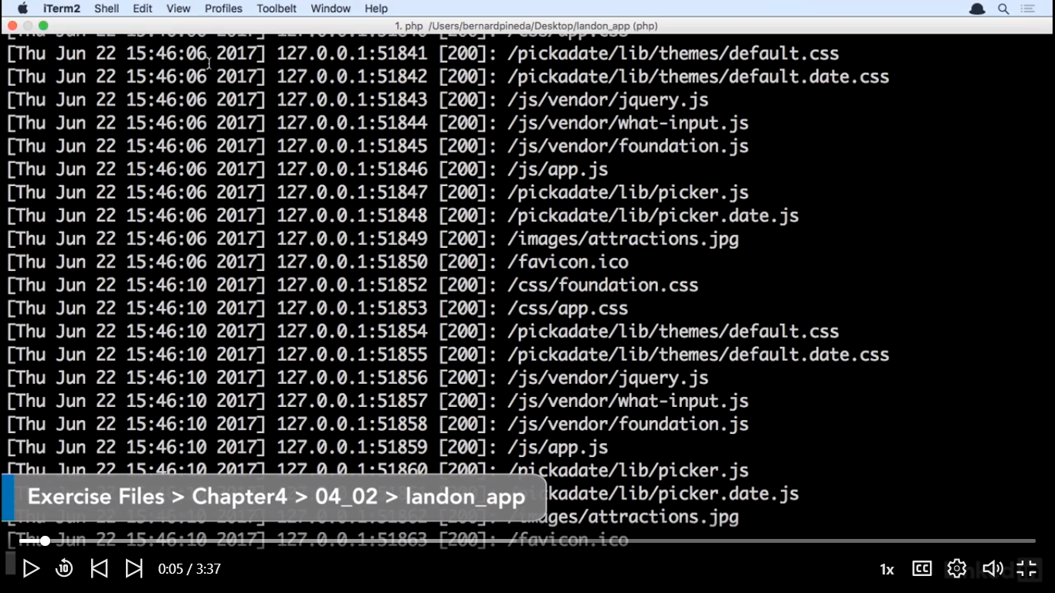

Database Connection:

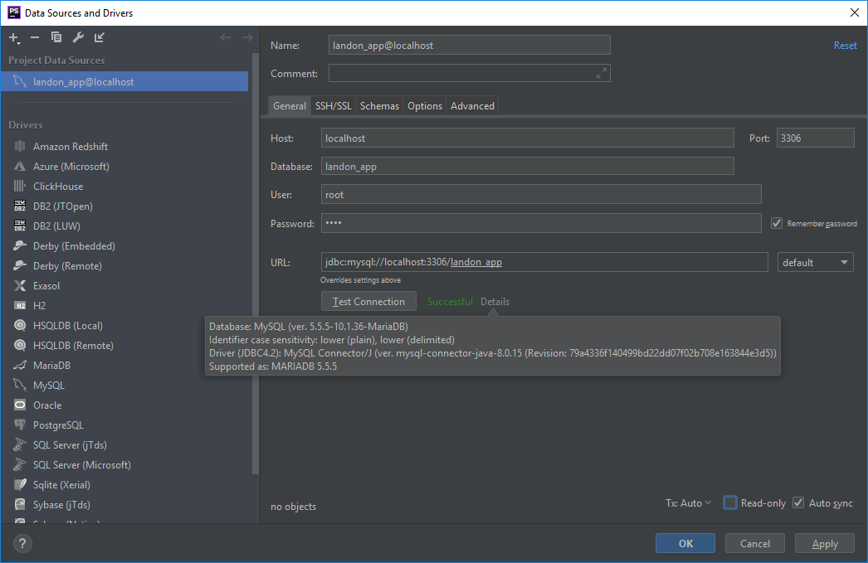

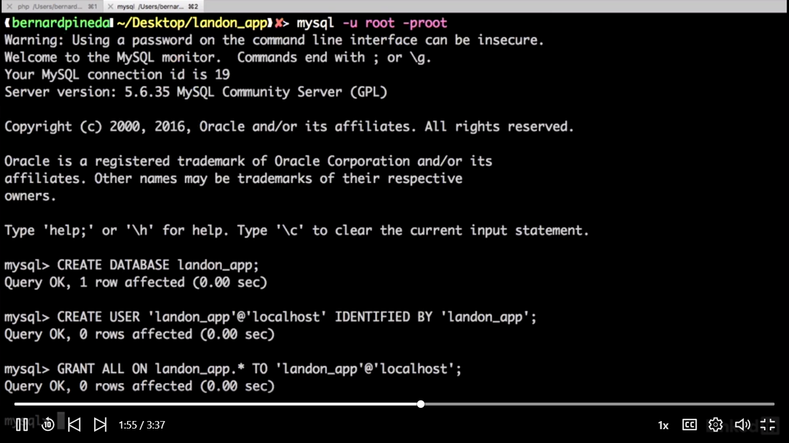

Så åbner vi filen C:\xampp\htdocs\landon_app_database\.env og ændre

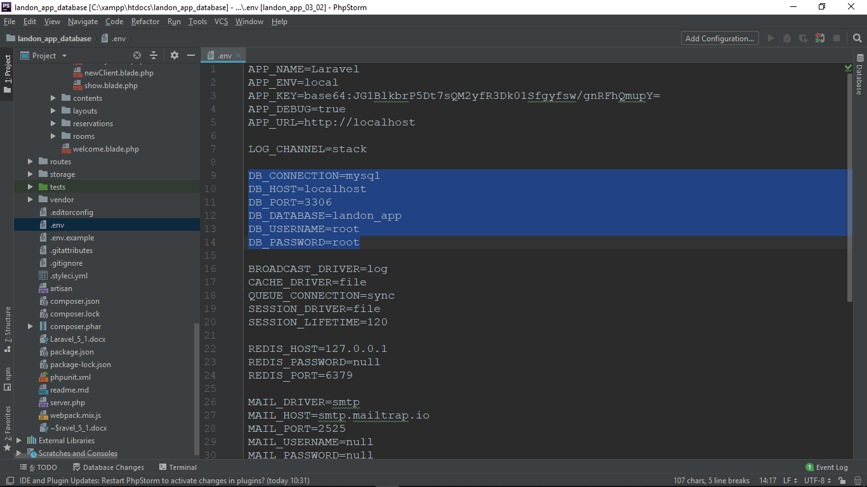

Til:

DB_HOST=localhost

small bug depending on your mysql version. In this setup we're using mysql 5.6 and we need to fix this bug, so let's open our App Services Provider file with Command P or Control P, AppServiceProvider.php.

under C:\xampp\htdocs\landon_app_database\app\Providers\AppServiceProvider.php

tilføjer vi denne linie:

**use** Illuminate\Support\Facades\Schema;

samt ændre vi boot til:

**public function** boot()  
{  
 //  
 Schema::*defaultStringLength*(191);  
  
}

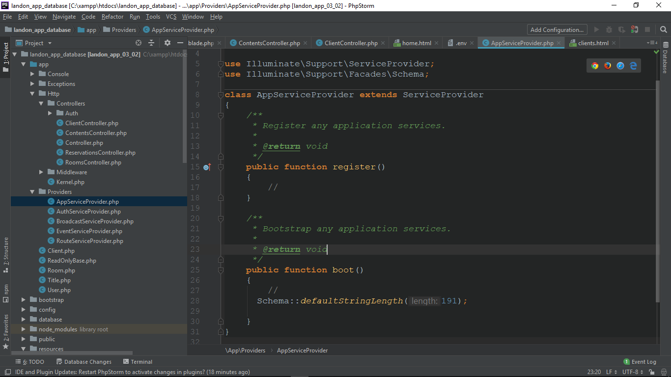

Database migrations

Database migrations are a very useful tool provided by Laravel. A database migration simply put is a set of instructions to create a database structure. You will need a migration that will define each table to be created, as well as columns for that table. However, migrations also let us modify an existing database. We can delete fields, create new ones, or even delete whole tables. The idea behind this is that in the course of development once the application is deployed with every new deployment code is updated, migrations run, assets rebuilt, and cache is cleared. And every developer can have the same structure of the database.

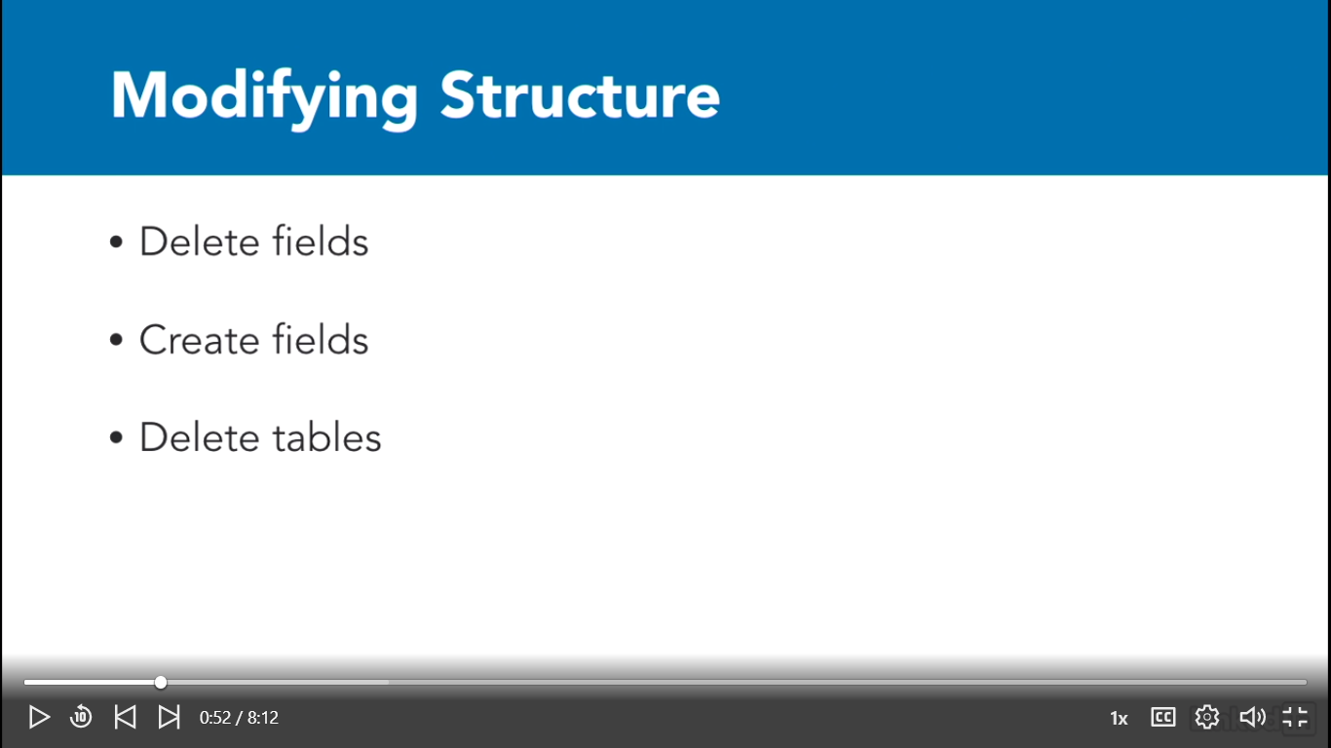

Vi laver vores table via:

C:\xampp\htdocs\landon_app_database>php artisan make:migration create_rooms_table --create=rooms

Created Migration: 2019_06_27_085632_create_rooms_table

Så er blevet nu tabel instruction under C:\xampp\htdocs\landon_app_database\database\migrations\2019_06_27_085632_create_rooms_table.php

Nu laver vi en ny tabel via:

C:\xampp\htdocs\landon_app_database>php artisan make:migration create_clients_table --create=clients

Created Migration: 2019_06_27_090535_create_clients_table

C:\xampp\htdocs\landon_app_database>php artisan make:migration create_reservations_table --create=reservations

Created Migration: 2019_06_27_090850_create_reservations_table

Så Vi har vores tabeler som nedenfor:

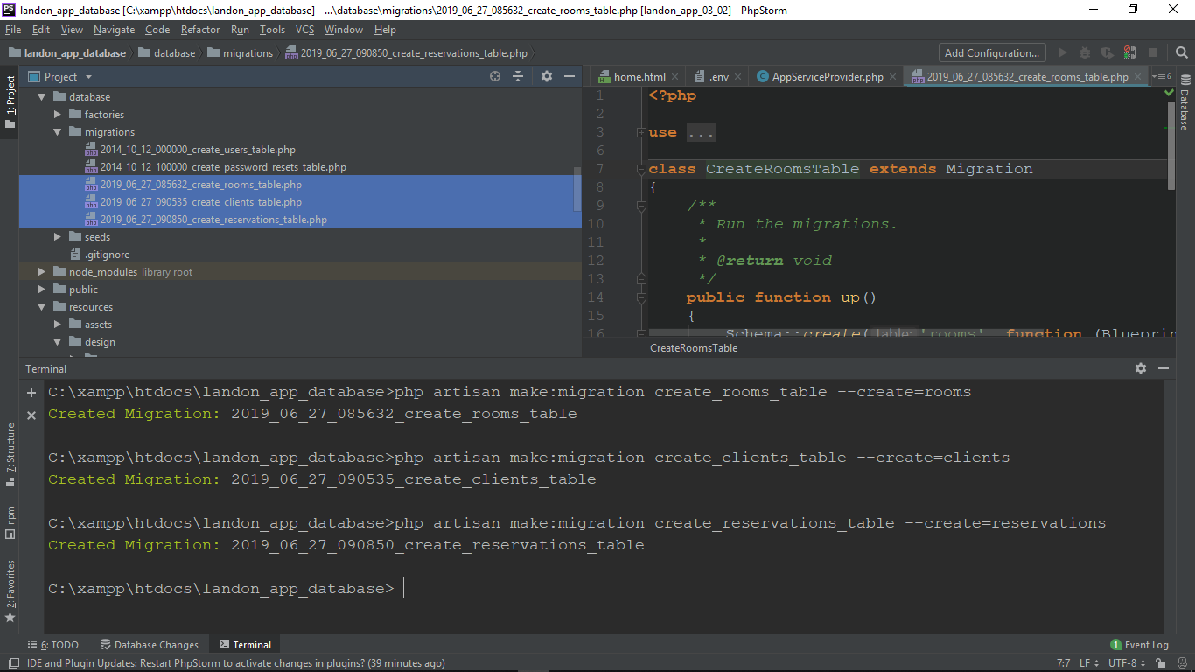

Migrations are eventually going to create a table structure, so let's say for argument's sake we created the reservations migration first. If we had data constraints, such as we defined that the clients and rooms inside the reservations table had to exist, then we would get a bunch of errors trying to relate elements that do not exist. Migrations serve the purpose of modifying our table structure before, during, and after we have started working with databases. So now let's define our database structure.

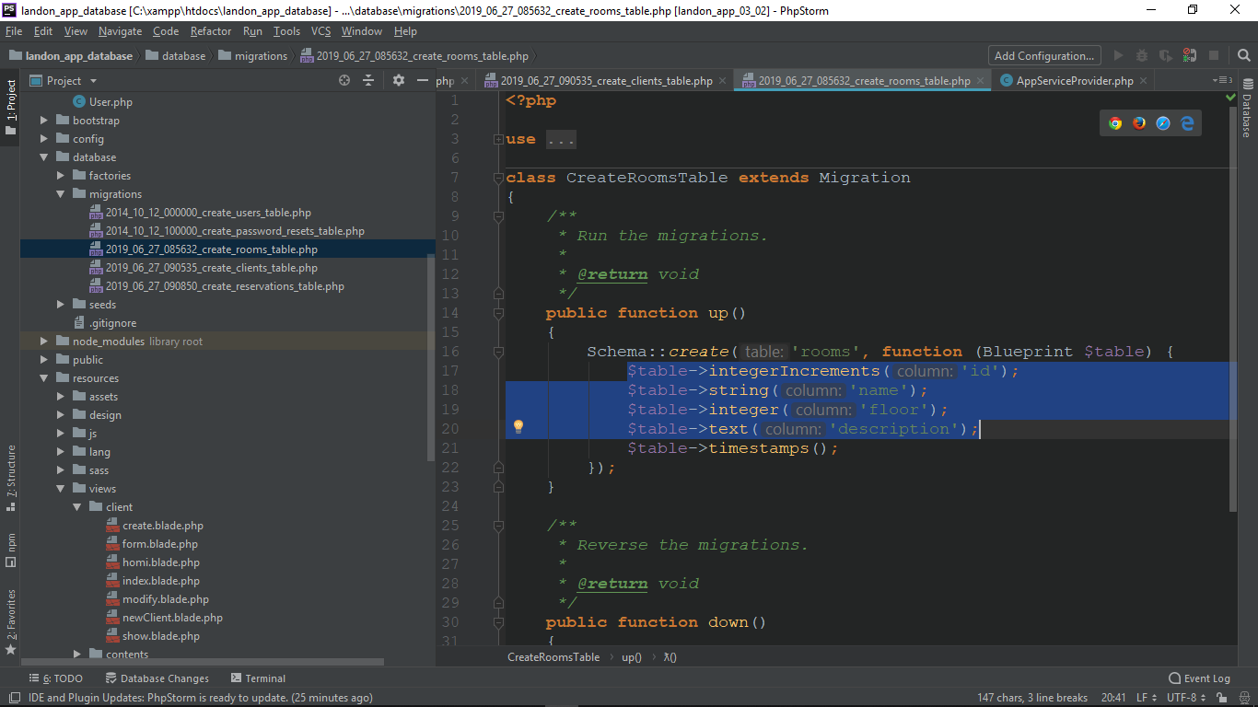

Obs: Husk datatype for id skal være integerIncrements, da skal laves foriegn key med datatype room_id og client_id i henholdsvis rooms og clients tabel.

For clients tabel tilføjer vi: C:\xampp\htdocs\landon_app_database\database\migrations\2019_06_27_090535_create_clients_table.php

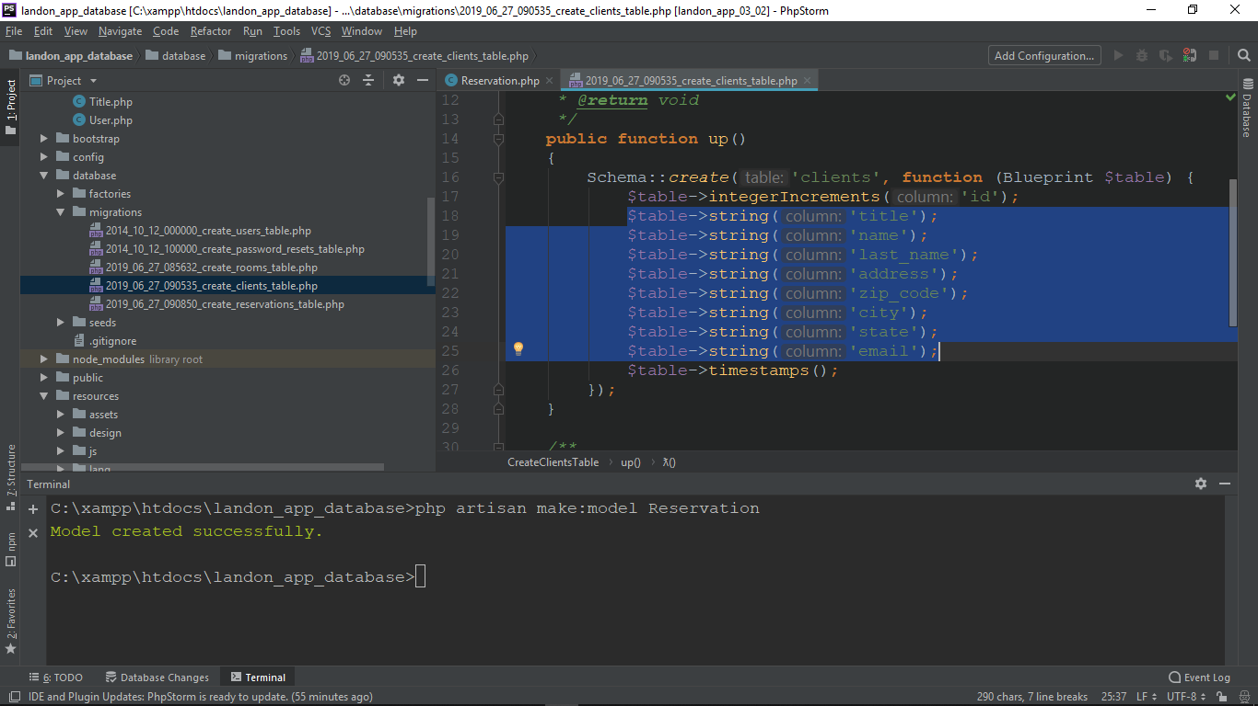

Og til sidst rooms tabel: C:\xampp\htdocs\landon_app_database\database\migrations\2019_06_27_090850_create_reservations_table.php

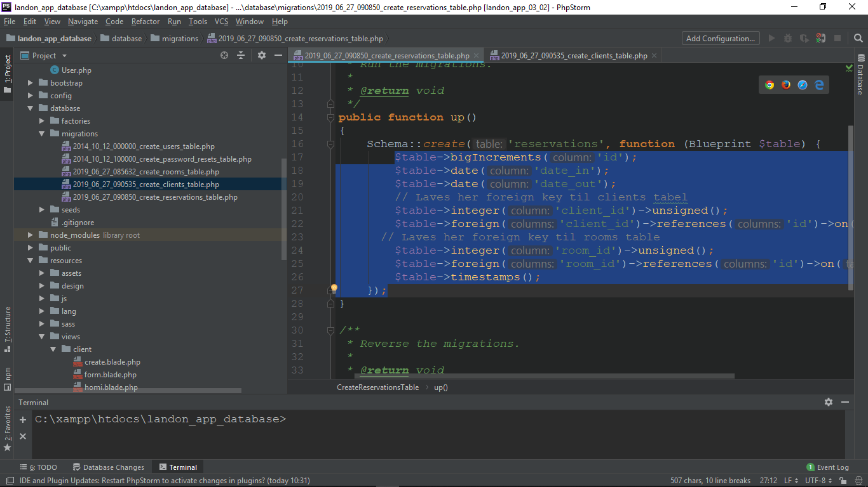

Nu til sidst skal vi kører migration command : C:\xampp\htdocs\landon_app_database>php artisan migrate

C:\xampp\htdocs\landon_app_database>php artisan migrate

Migration table created successfully.

Migrating: 2014_10_12_000000_create_users_table

Migrated: 2014_10_12_000000_create_users_table

Migrating: 2014_10_12_100000_create_password_resets_table

Migrated: 2014_10_12_100000_create_password_resets_table

Migrating: 2019_06_27_085632_create_rooms_table

Migrated: 2019_06_27_085632_create_rooms_table

Migrating: 2019_06_27_090535_create_clients_table

Migrated: 2019_06_27_090535_create_clients_table

Migrating: 2019_06_27_090850_create_reservations_table

Migrated: 2019_06_27_090850_create_reservations_table

Obs: Husk i phpstorm skal database user og adgang for localhost skal testes og Applyes som nedenfor:

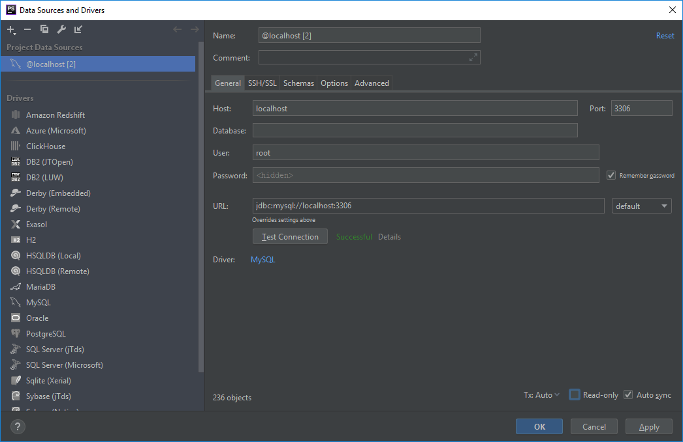

Models in Laravel

In the context of Laravel and the MVC paradigm, we need a data and business layer,which should be implemented in the model. Also, the model connects as data repositories. Normally, the business layer accesses the data in the form of a database. However, this is not the only option. Another option could be that the model accesses an API. While we could access these types of data repositories using the controller, this would be breaking the MVC workflow.

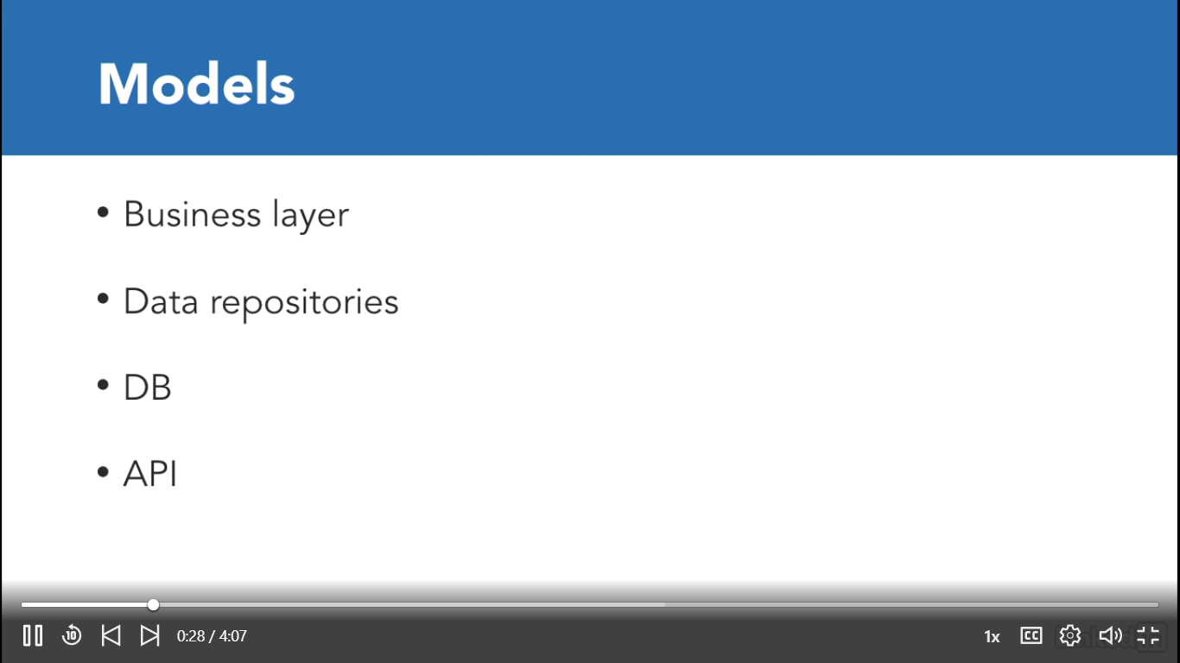

Først laver vi vores Reservation model via:

C:\xampp\htdocs\landon_app_database>php artisan make:model Reservation

Model created successfully.

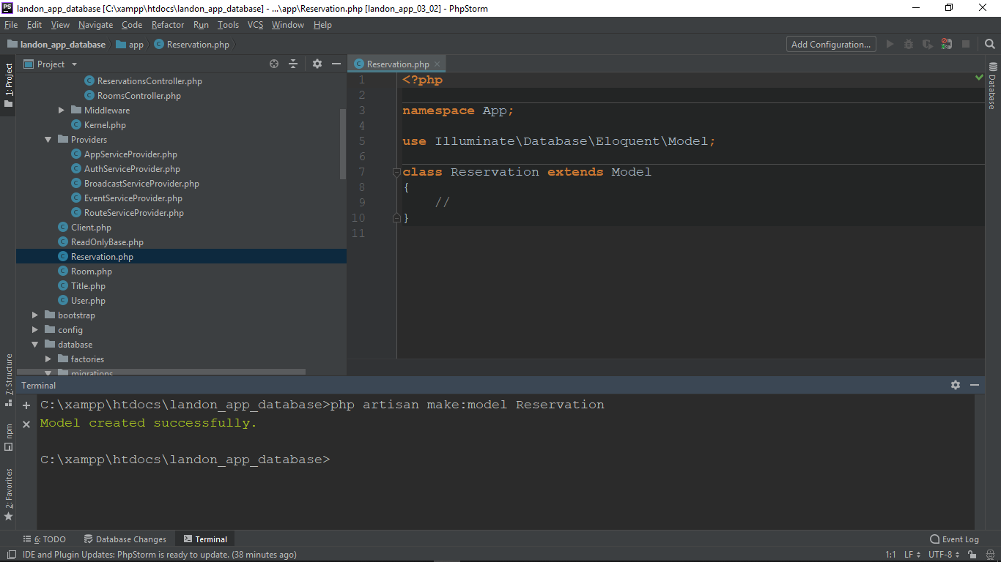

Nu kan vi import Data til vores database: Man kan gøre via termianl som nedenfor:[/resources/db/landon_app.sql] som ligger under:

C:\xampp\htdocs\laravel_5_Ess_1_Basics\Resources\db\landon_app.sql

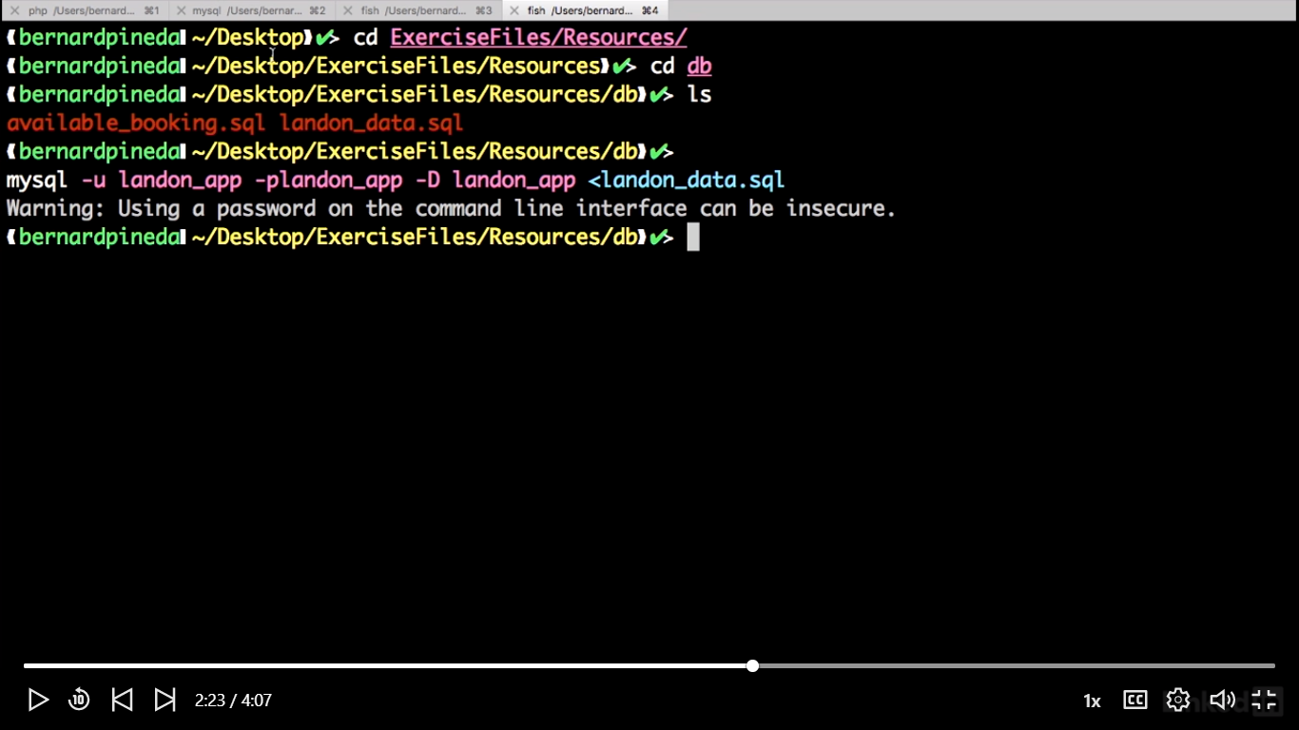

INSERT INTO rooms (name, floor, description) VALUES ( '101', 1, '');

INSERT INTO rooms (name, floor, description) VALUES ( '102', 1, '');

INSERT INTO rooms (name, floor, description) VALUES ( '201', 2, '');

INSERT INTO rooms (name, floor, description) VALUES ( '202', 2, '');

INSERT INTO clients (title, name, last_name, address, zip_code, city, state, email)

VALUES

('mr', 'Vincent', 'Vega', 'Fake Street 123', '11820', 'Tulsa', 'OK', 'john@email.com');

INSERT INTO clients (title, name, last_name, address, zip_code, city, state, email)

VALUES

('mrs', 'Mia', 'Wallace', 'Another Fake Street 234', '06030', 'McAlester', 'OK', 'jane@email.com');

-- Table reservations har foreign keys to Clients og Rooms tables

INSERT INTO reservations ( date_in, date_out, client_id, room_id )

VALUES

( '2017-01-01', '2017-01-05', (SELECT id FROM clients LIMIT 1), (SELECT id FROM rooms LIMIT 1) )

Now let's test to see if our models work. Fortunately, Laravel comes with a nice integrated tool,to test if our application works, called ‘Tinker’. Let's run it and see some magic. Let's open this one. And on the same folder as our application, let's run php artisantinker. Now let's add the ApplicationContext with namespace App semicolon. For at anvende tinker:

C:\xampp\htdocs\landon_app_database>php artisan tinker

Psy Shell v0.9.9 (PHP 7.2.10 — cli) by Justin Hileman

>>> namespace App;

>>> $client = new Client();

=> App\Client {#2978}

>>> $client->all();

>>> $client->all();

=> Illuminate\Database\Eloquent\Collection {#2988

all: [

App\Client {#2989

id: 1,

title: "mr",

name: "Vincent",

last_name: "Vega",

address: "Fake Street 123",

zip_code: "11820",

city: "Tulsa",

state: "OK",

email: "john@email.com",

created_at: null,

updated_at: null,

},

App\Client {#2990

id: 2,

title: "mrs",

name: "Mia",

last_name: "Wallace",

address: "Another Fake Street 234",

zip_code: "06030",

city: "McAlester",

state: "OK",

email: "jane@email.com",

created_at: null,

updated_at: null,

},

],

}

DVS. alt data fra databasen vises ved at kalde metoden all().

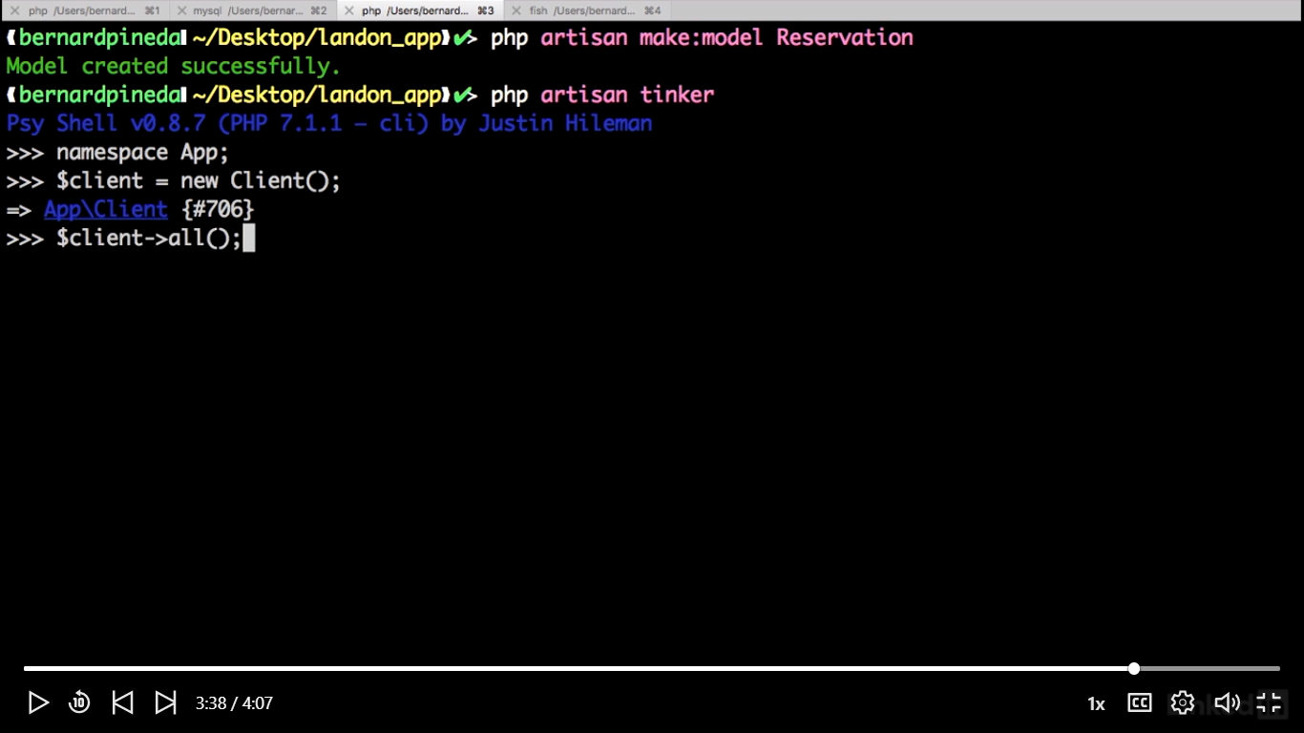

Man kan få en række fra Client tabel fra databasen via:

>>> $client->where('id',1)->get();

=> Illuminate\Database\Eloquent\Collection {#2989

all: [

App\Client {#2993

id: 1,

title: "mr",

name: "Vincent",

last_name: "Vega",

address: "Fake Street 123",

zip_code: "11820",

city: "Tulsa",

state: "OK",

email: "john@email.com",

created_at: null,

updated_at: null,

},

],

}

Samme som >>> $rooms = new Room();

=> App\Room {#2995}

=>$rooms->all(); Får vi alle data fra Room tabel i databasen.

Add data with Eloquent

Vi kan lave en array og tilføje data i databasen:

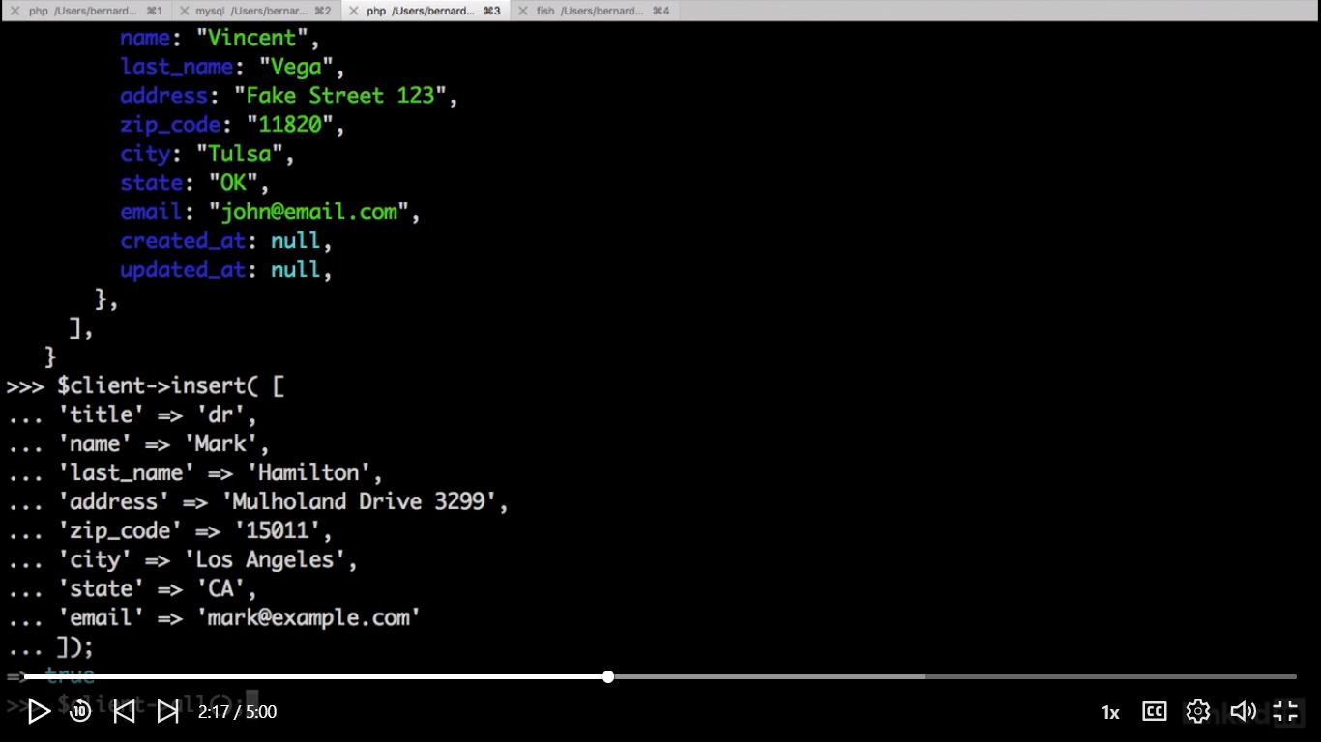

Obs: =>true

Og se den added data via $client->all();

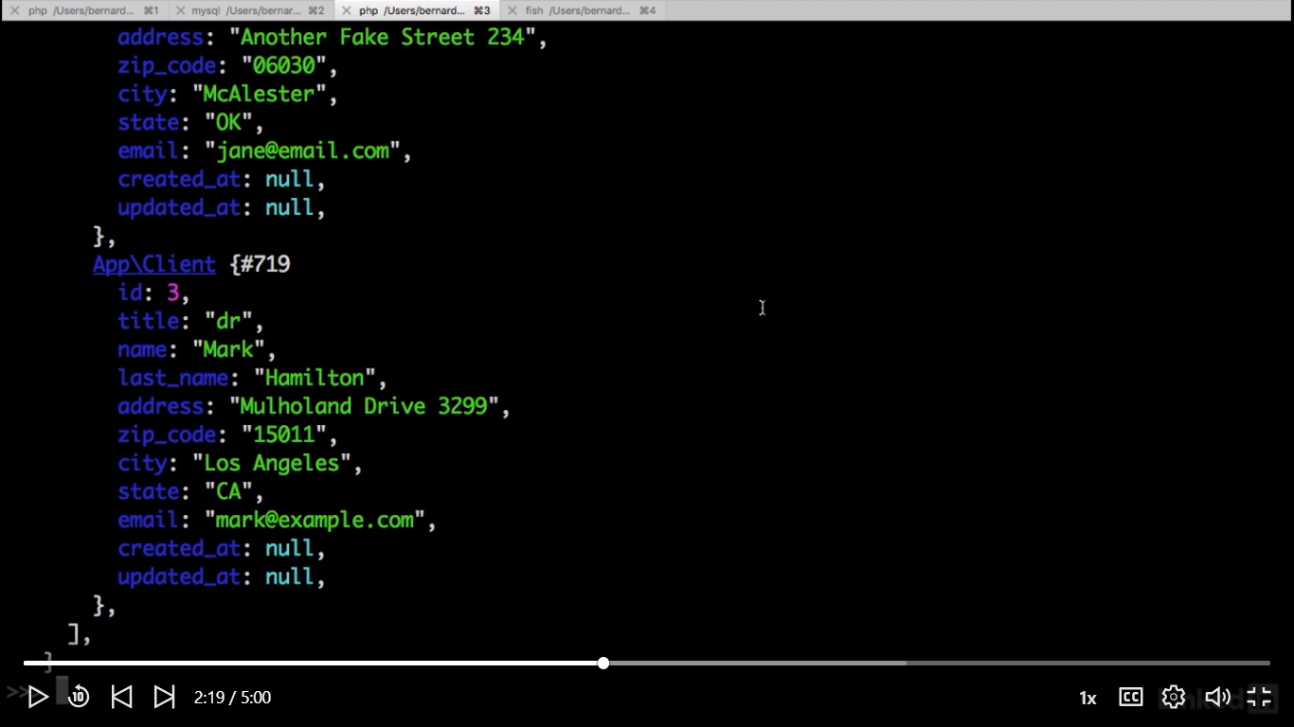

Now let's do this in our application by opening our new client method in our client controller.

Model in the ClientController.php

//Add Model to ClientController  
**use** App\Title **as** Title;  
**use** App\Client **as** Client;

**public function** newClient(Request $request, Client $client)  
{  
 $data = [];  
 $data['title'] = $request->input('title');  
 $data['name'] = $request->input('name');  
 $data['last_name'] = $request->input('last_name');  
 $data['address'] = $request->input('address');  
 $data['zip_code'] = $request->input('zip_code');  
 $data['city'] = $request->input('city');  
 $data['state'] = $request->input('state');  
 $data['email'] = $request->input('email');  
  
 //"titles" => array:5 [▼  
 // 0 => "Mr"  
 // 1 => "Mrs"  
 // 2 => "Ms"  
 // 3 => "Dr"  
 // 4 => "Mx"  
  
  
  
  
 **if** ($request->isMethod('post')) {  
 //dd($data);  
 //validation starts here  
 $this->validate($request,  
 [  
 'name'=>'required|min:2|max:20',  
 'last_name'=>'required|min:5',  
 'address'=>'required',  
 'zip_code'=>'required',  
 'city'=>'required',  
 'state'=>'required',  
 'email'=>'required'  
 ]);  
  
 **//insert the data  
 $client->insert($data);**  
 //http://127.0.0.1:8000/clients **form is submitted  
 **return** redirect('clients');  
  
 }  
 //http://127.0.0.1:8000/clients/new **form is not submitted  
 //back to same place with data  
 $data['titles'] = $this->titles;  
 $data['modify'] = 0;  
  
 **return** view('client/form', $data);  
}

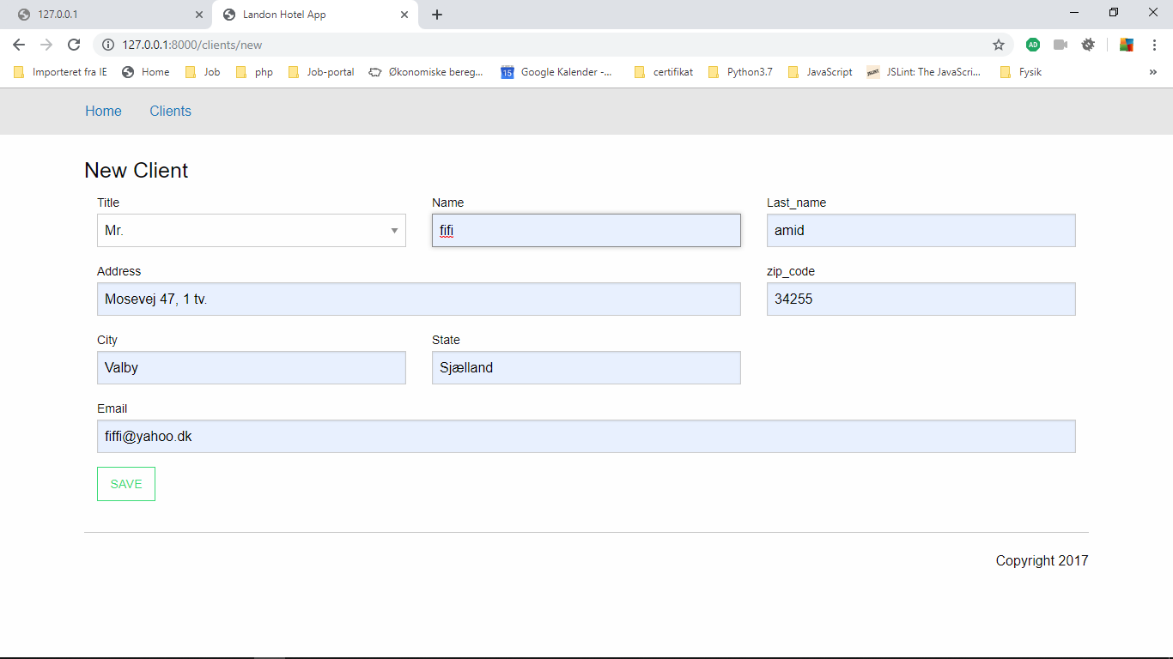

Og vi kan gemme Data i databasen ved at klikke på SAVE kanppen.

Select data with Eloquent

Let's open our ClientController and go to our constructor method, and let's use dependency injection to inject our client model.

**class** ClientController **extends** Controller  
{  
 //MOdel Title class læses automatisk her 'Mr', 'Mrs', 'Ms', 'Dr', 'Mx'  
 **public function** __construct( Title $titles, Client $client )  
 {  
 $this->titles = $titles->all();  
 $this->client =$client;  
 }

**public function** index()  
{  
 $data = [];  
 $data['clients'] = $this->client->all();  
   
 **return** view('client/index', $data);  
}

og nu kan vi se alle recoder i browseren som nedenfor

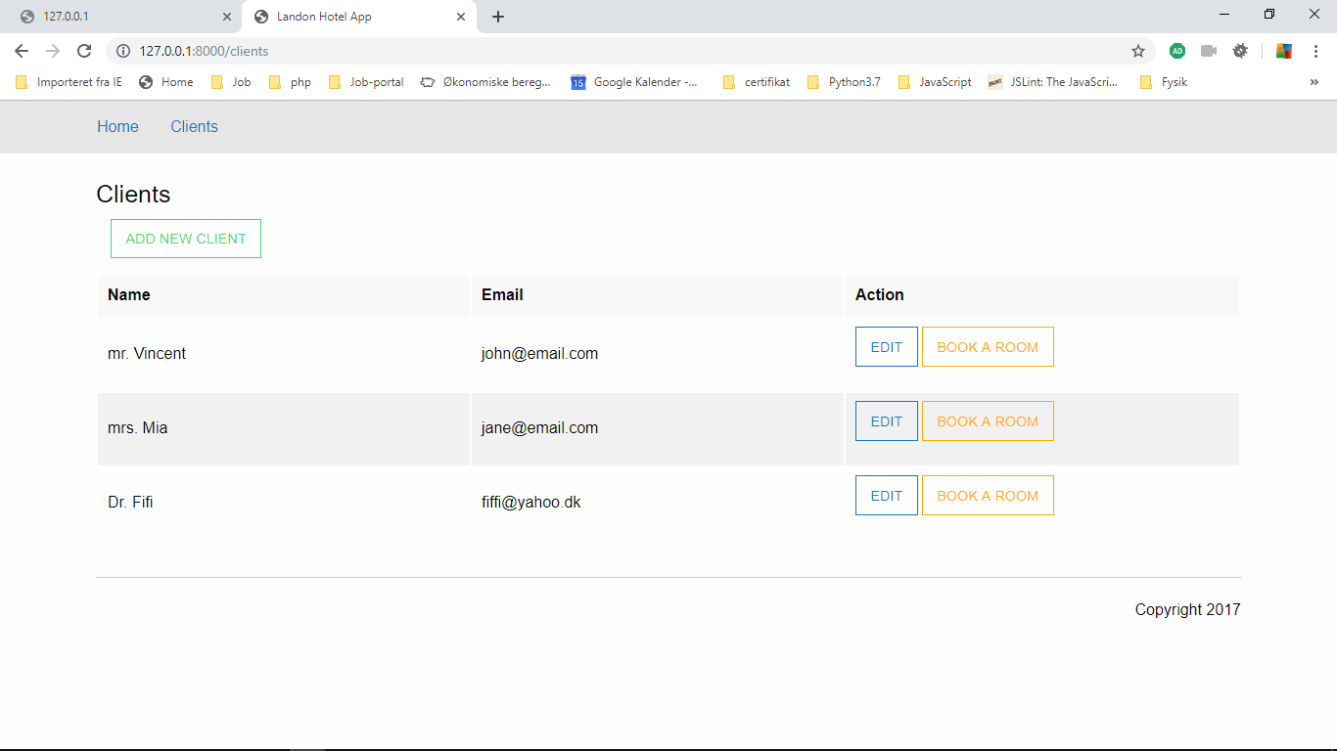

Now let's filter our data. Let's open up our show method.

**public function** show($client_id)  
{  
 $data = [];  
 $data['titles'] = $this->titles;  
 $data['modify'] = 1;  
 **return** view('client/show', $data);  
}

**til:**

**\*\*\*** Since methods where, latest, find, findOrFail and others does not exist in Model class, but in Builder and are loaded via magic methods, the IDE can not detect these.

**C:\xampp\htdocs\landon_app_database\vendor\laravel\framework\src\Illuminate\Database\Eloquent\Builder.php**

**public function** show($client_id)  
{  
 $data = [];  
 $data['titles'] = $this->titles;  
 $data['modify'] = 1;  
  
 $client_data = $this->client->find($client_id);  
 $data['name'] = $client_data->name;  
 $data['last_name'] = $client_data->last_name;  
 $data['title'] = $client_data->title;  
 $data['address'] = $client_data->address;  
 $data['zip_code'] = $client_data->zip_code;  
 $data['city'] = $client_data->city;  
 $data['state'] = $client_data->state;  
 $data['email'] = $client_data->email;  
  
 **return** view('client/show', $data);  
}

Nu åbner vi form.blade.php og ændrer fra:

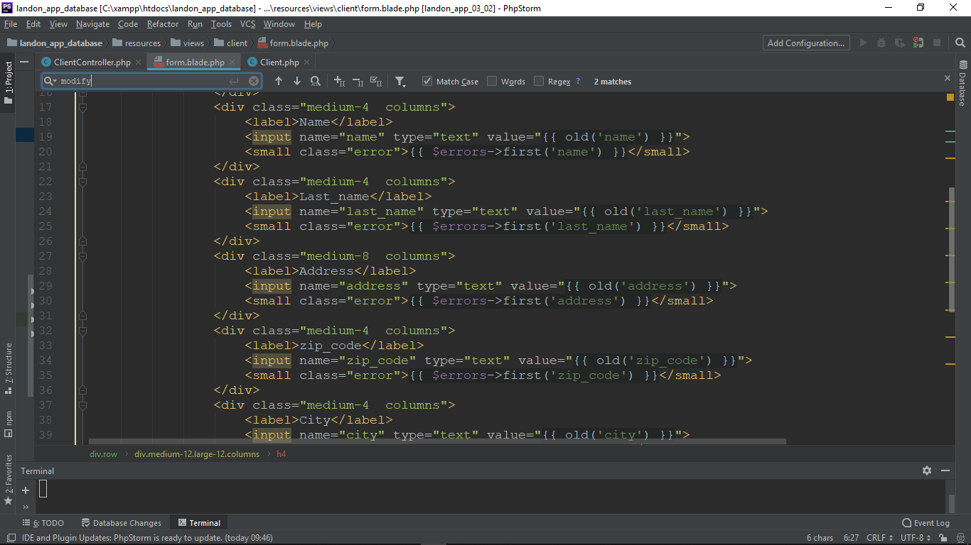

Til:

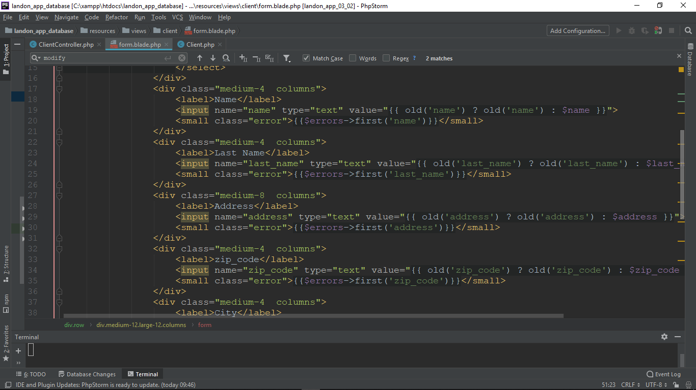

Nu kan vi refreshe browseren få data igen.

Modify data with Eloquent

Først laver vi vores modify() method i ClientController.php

**public function** modify(Request $request, $client_id, Client $client)  
{  
 $data = [];  
 $data['title'] = $request->input('title');  
 $data['name'] = $request->input('name');  
 $data['last_name'] = $request->input('last_name');  
 $data['address'] = $request->input('address');  
 $data['zip_code'] = $request->input('zip_code');  
 $data['city'] = $request->input('city');  
 $data['state'] = $request->input('state');  
 $data['email'] = $request->input('email');  
  
 //"titles" => array:5 [▼  
 // 0 => "Mr"  
 // 1 => "Mrs"  
 // 2 => "Ms"  
 // 3 => "Dr"  
 // 4 => "Mx"  
  
  
  
  
 **if** ($request->isMethod('post')) {  
 //dd($data);  
 //validation starts here  
 $this->validate($request,  
 [  
 'name'=>'required|min:2|max:20',  
 'last_name'=>'required|min:5',  
 'address'=>'required',  
 'zip_code'=>'required',  
 'city'=>'required',  
 'state'=>'required',  
 'email'=>'required'  
 ]);  
  
 //dd($data);  
 //update the data  
 $client_data = $this->client->find($client_id);  
  
 $client_data->title = $request->input('title');  
 $client_data->name = $request->input('name');  
 $client_data->last_name = $request->input('last_name');  
 $client_data->address = $request->input('address');  
 $client_data->zip_code = $request->input('zip_code');  
 $client_data->city = $request->input('city');  
 $client_data->state = $request->input('state');  
 $client_data->email = $request->input('email');  
  
 //modify the client  
 $client_data->save();  
  
 //http://127.0.0.1:8000/clients **form is submitted  
 **return** redirect('clients');  
  
 }  
 //http://127.0.0.1:8000/clients/new **form is not submitted  
 //back to same place with data  
 $data['titles'] = $this->titles;  
 $data['modify'] = 0;  
  
 **return** view('client/form', $data);  
}

og bagefter sletter vi I hardcoded i form.blade.php som nedenfor

fra:

<form action="{{ $modify == 1 ? route('update_client', ['client_id' => 1 ]) : route('create_client') }}" method="post">

Til:

<form action="{{ $modify == 1 ? route('update_client', ['client_id' => $client_id ]) : route('create_client') }}" method="post">

Og til sidst I show() metod I ClientController tilføjer vi

**public function** show($client_id)  
{  
 $data = [];  
 $data['client_id'] = $client_id;  
 $data['titles'] = $this->titles;  
 $data['modify'] = 1;  
  
 $client_data = $this->client->find($client_id);  
 $data['name'] = $client_data->name;  
 $data['last_name'] = $client_data->last_name;  
 $data['title'] = $client_data->title;  
 $data['address'] = $client_data->address;  
 $data['zip_code'] = $client_data->zip_code;  
 $data['city'] = $client_data->city;  
 $data['state'] = $client_data->state;  
 $data['email'] = $client_data->email;  
  
 **return** view('client/show', $data);  
}

Relations in Eloquent

Relational data is one of the advantages of using Eloquent SR ORM. Eloquent handles our relationships as relationships between objects and not as database tables. So forget about foreign keys. There are many types of relationships defined in Eloquent. We are going to use a hasMany relationship whenever an entity may have many objects related to it. For example, a client will have many reservations. The hasOne relationship will define an entity that has one and only one object related to it. An example of this would be a house and an address. A house may only have one address. belongsTo is a type of relationship that counterparts the hasMany relationship. If a client has many reservations, each reservation belongs to a client.

<https://laravel.com/docs/5.8/eloquent-relationships>

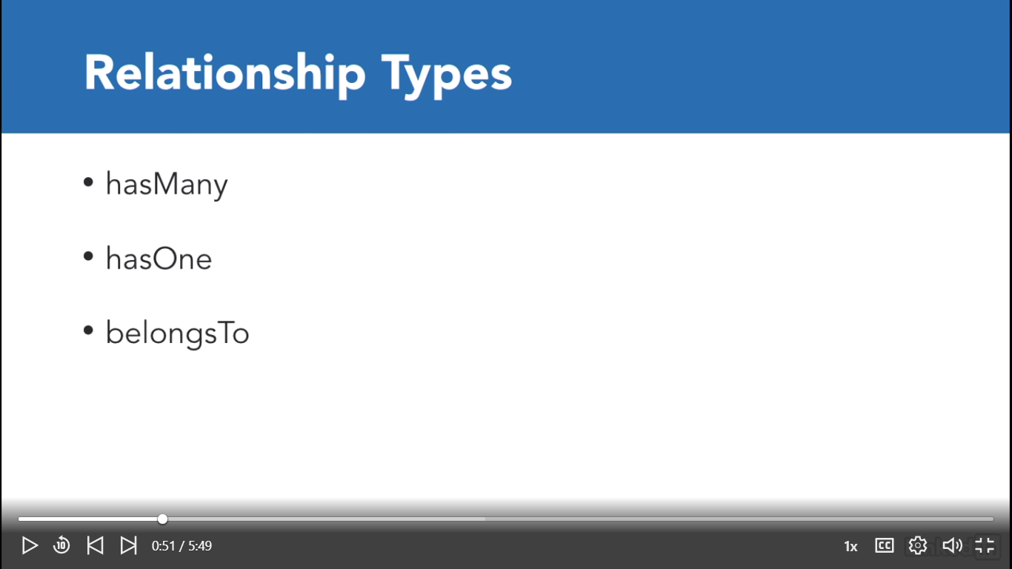

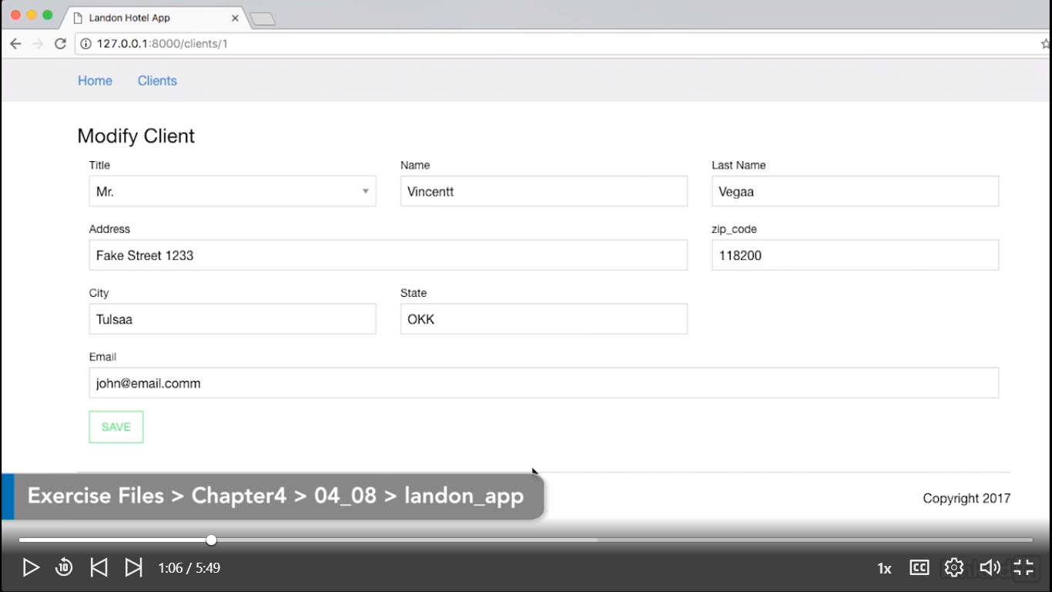

Så finder vi Client Model under: C:\xampp\htdocs\landon_app_database\app\Client.php

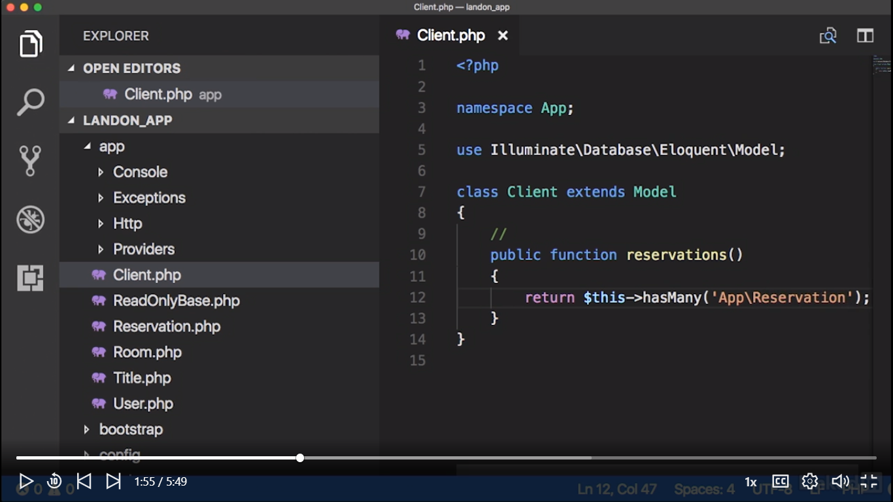

Så åbner vi ‘tinker’

Let's let our client's reservation with selected client reservations. As we can see, we have a hasMany object. However, we may treat it as a collection. Selected client reservations, get, and we're obtaining the first reservation of that client.

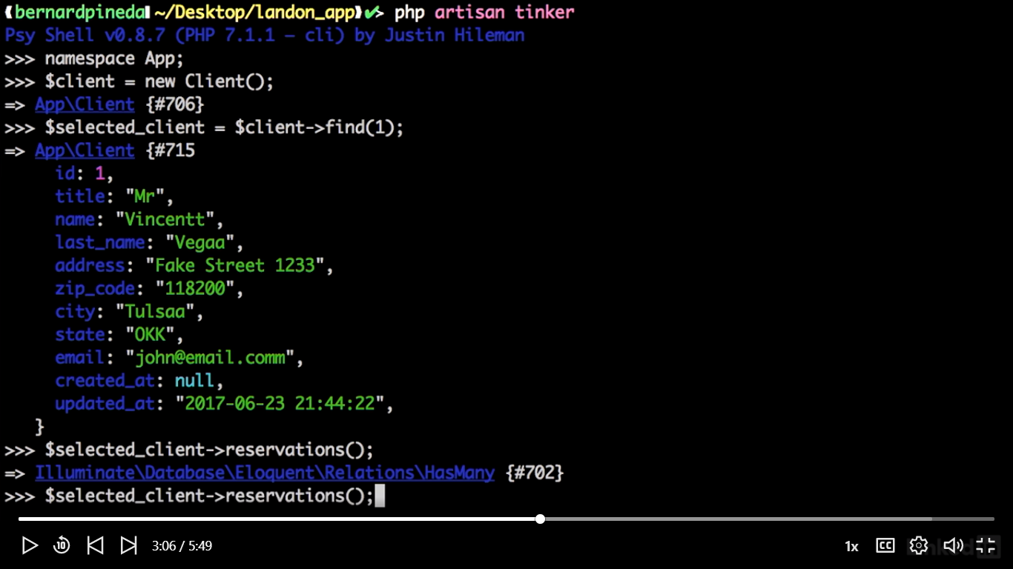

We could also get all the reservations related to the client. Selected client reservations get. Since this client only has one reservation, it will return a collection of one element.

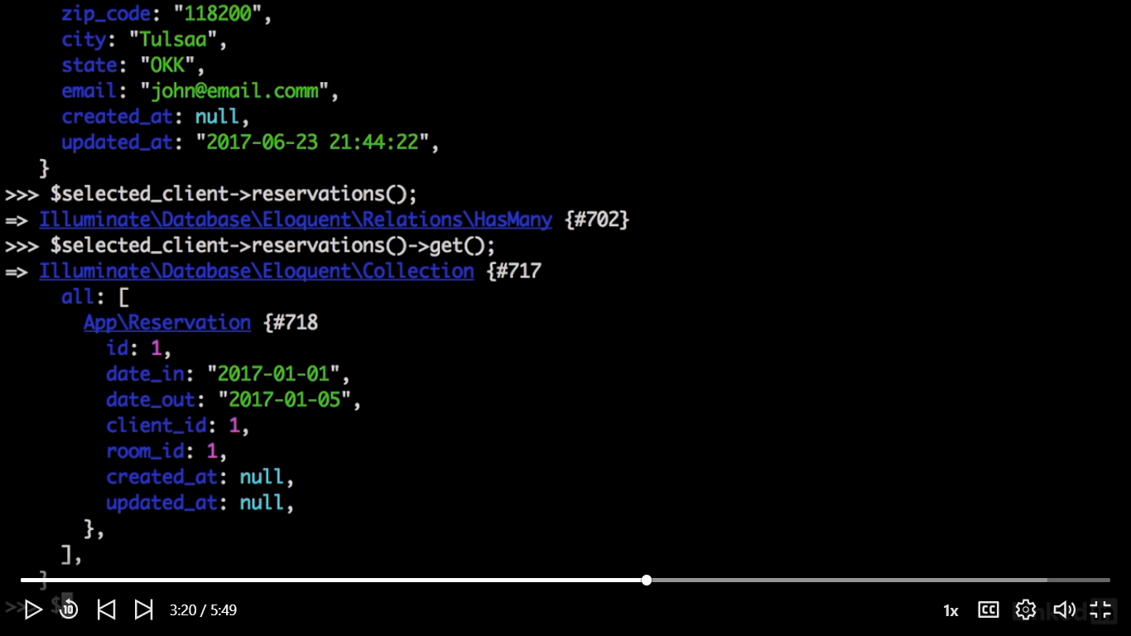

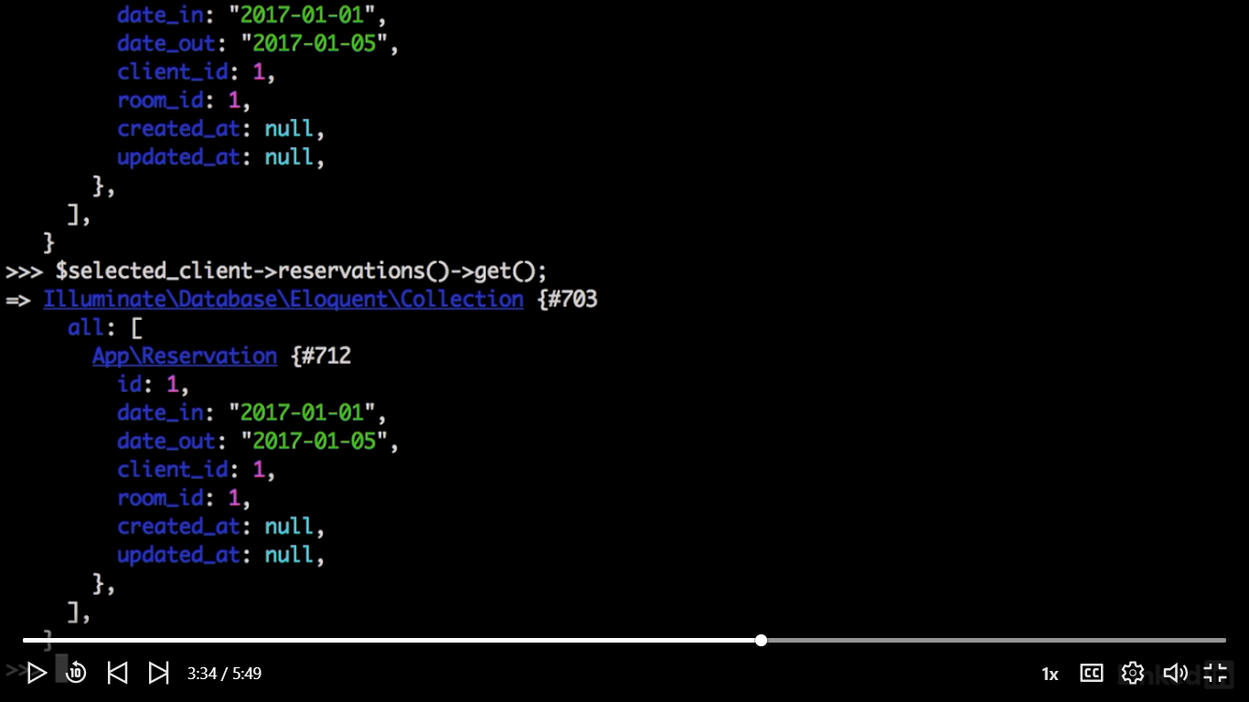

Så definer vi client() function I Reservation.php som nedenfor:

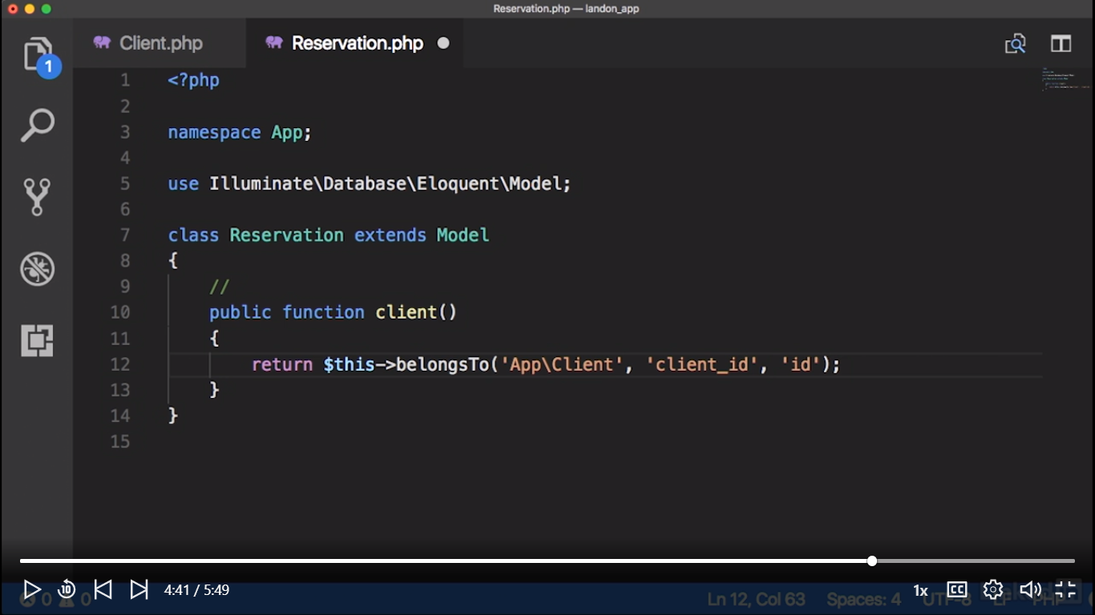

Og burger vi igen ‘tinker’

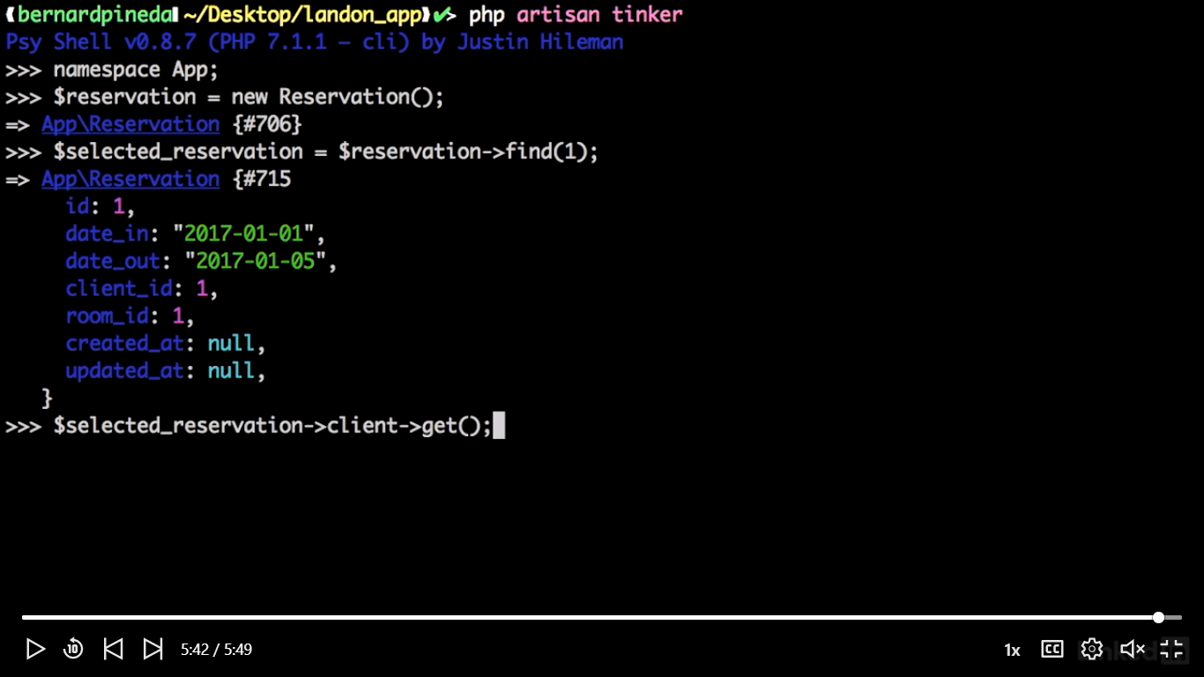

Now let's test our method. Selected reservation, client, get(). And there we have it. We have successfully added add belongs to relationship.

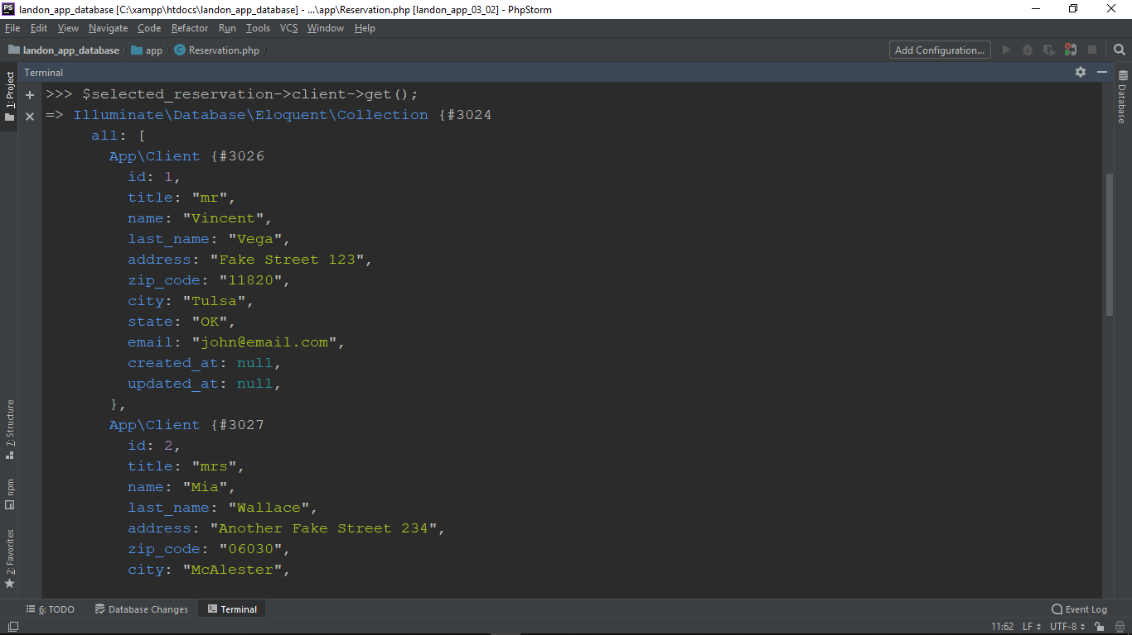

Select data with raw queries

While Laravel query builder makes our life easier by creating queries for us, sometimes we just need a good old-fashioned raw query. Fortunately, Laravel gives us the flexibility to be able to feed eloquent raw queries. Raw queries should be used to execute complex SQL statements, because trying to get the eloquent query builder to do it for us may become cumbersome. Let's still check out an example of raw queries for the complicated situation where we want to get available rooms within a date range. So we first SELECT by a date range and rooms that have been booked within those dates. To get the available rooms we need to get the rooms that are not in the first query. And finally, we need to ORDER BY id. This last one is optional. So now let's do the same query, but on Laravel.

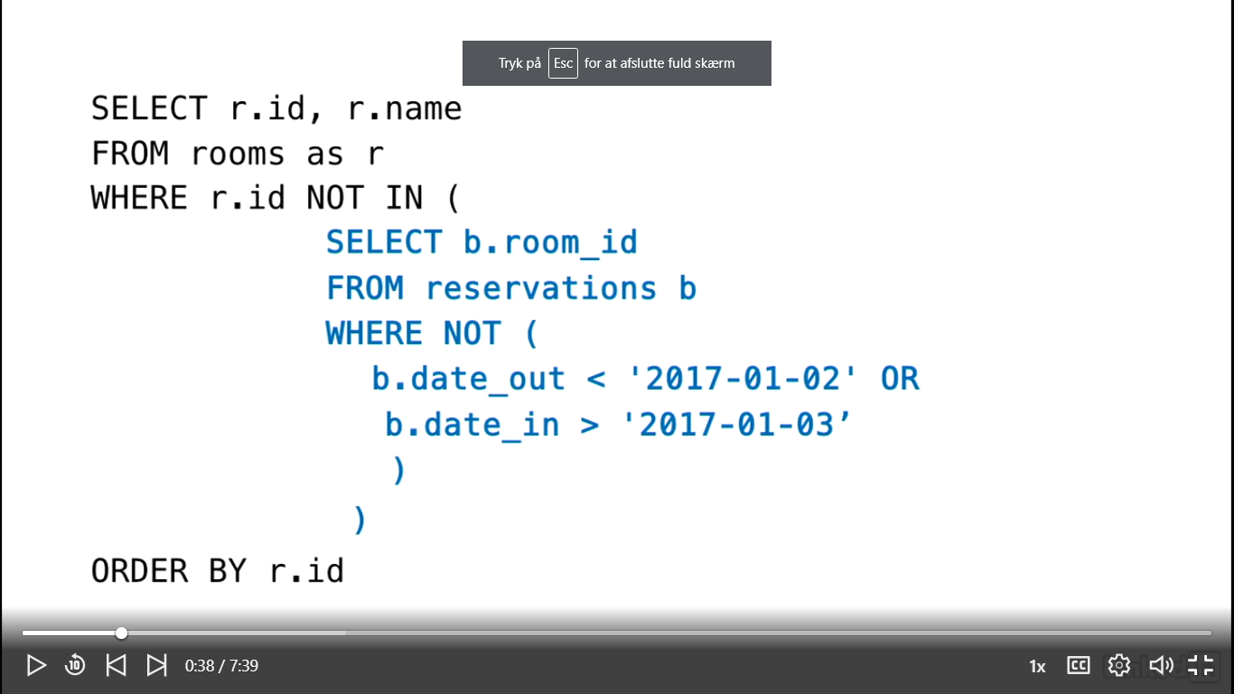

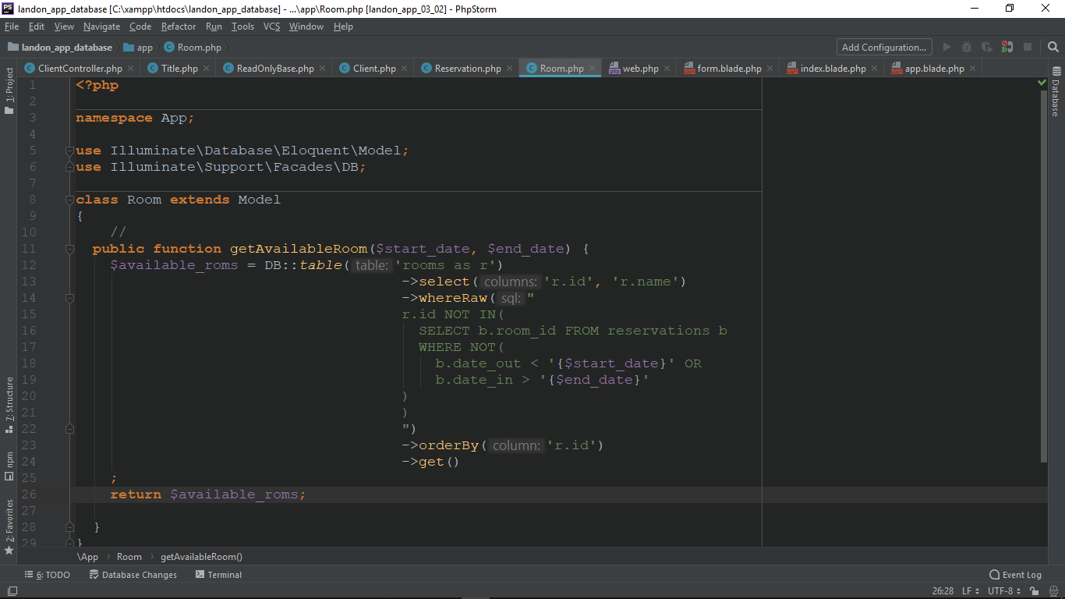

Nu åbner vi C:\xampp\htdocs\landon_app_database\app\Http\Controllers\RoomsController.php

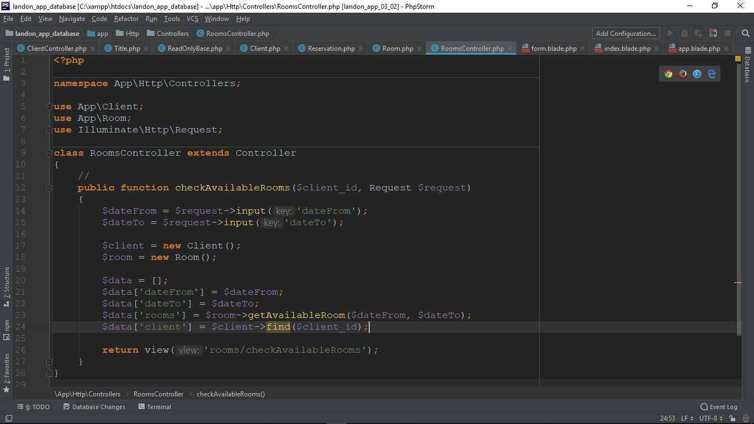

Return data to the view

Now let's add all the functionality to our views.

C:\xampp\htdocs\landon_app_database\resources\views\rooms\checkAvailableRooms.blade.php

Tilføjer

<div class="row">  
 <div class="medium-12 large-12 columns">  
 <h4>Clients/Booking</h4>  
 <div class="medium-2 columns">BOOKING FOR:</div>  
 <div class="medium-2 columns">  
 <b>  
 {{$client->title}}  
 {{$client->name}}  
 {{$client->last_name}}  
 </b>  
 </div>

Og

**@foreach(**$rooms **as** $room**)** <tr>  
 <td>101</td>  
 <td>  
 <div class="callout success">  
 <h7>Available</h7>  
 </div>  
 </td>  
 <td>  
 <a class="hollow button warning" href="./clients.html">BOOK NOW</a>  
 </td>  
 </tr>  
 **@endforeach**

Så åbner vi C:\xampp\htdocs\landon_app_database\app\Http\Controllers\RoomsController.php

**use** App\Room;  
**use** Illuminate\Http\Request;

og

**class** RoomsController **extends** Controller  
{  
 //  
 **public function** checkAvailableRooms($client_id, Request $request)  
 {  
 $dateFrom = $request->input('dateFrom');  
 $dateTo = $request->input('dateTo');  
  
 $client = **new** Client();  
 $room = **new** Room();  
  
 $data = [];  
 $data['dateFrom'] = $dateFrom;  
 $data['dateTo'] = $dateTo;  
 $data['rooms'] = $room->getAvailableRoom($dateFrom, $dateTo);  
 $data['client'] = $client->find($client_id);  
  
 **return** view('rooms/checkAvailableRooms', $data);  
 }  
}

Nu vi kan teste i browseren:

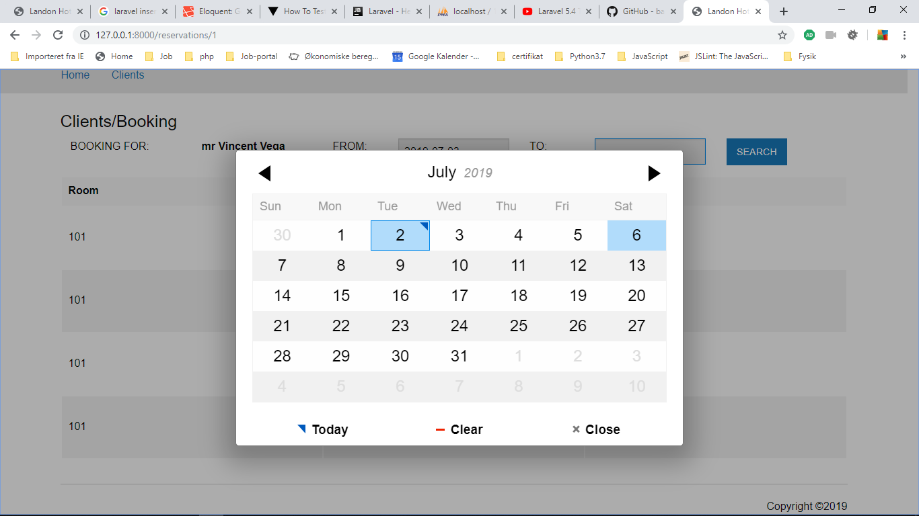

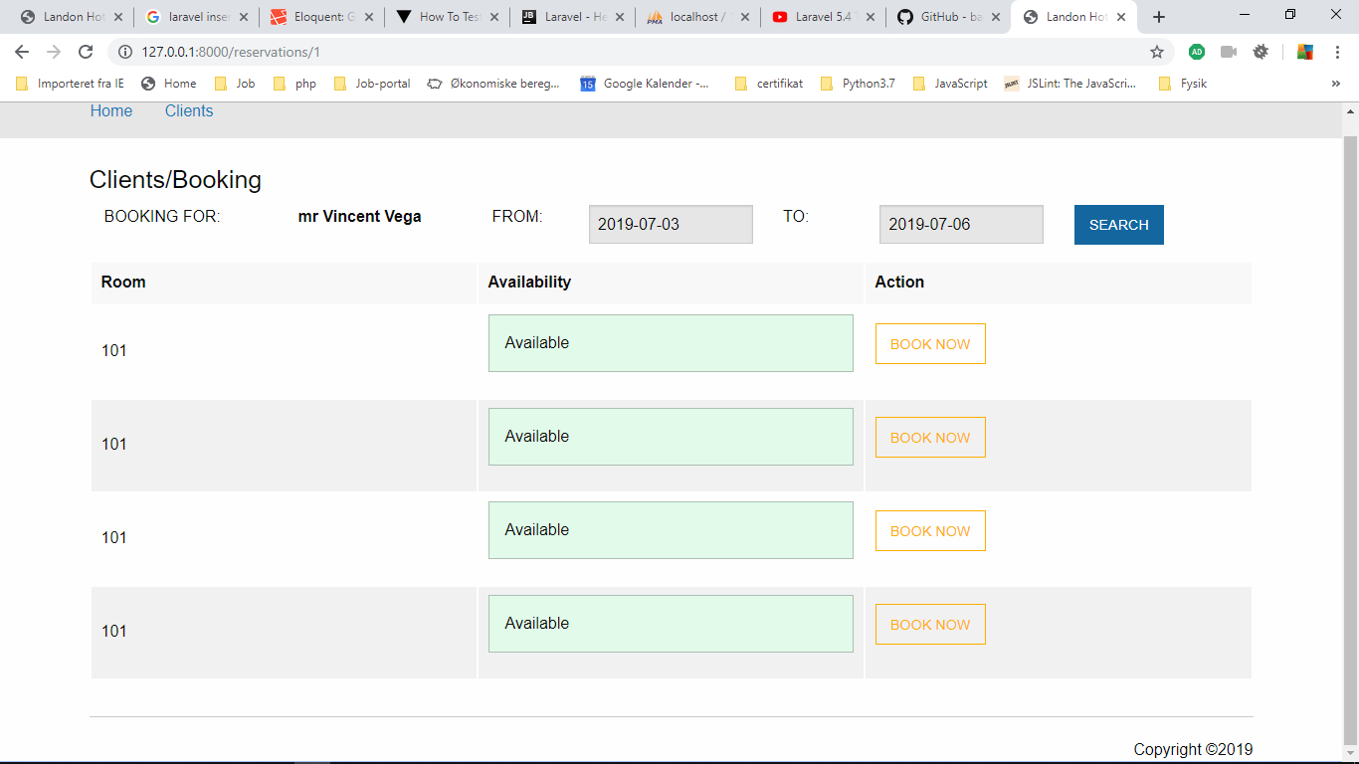

Så åbner vi igan: C:\xampp\htdocs\landon_app_database\resources\views\rooms\checkAvailableRooms.blade.php

**@unless( empty**($dateFrom) || **empty**($dateTo)**)  
@foreach(**$rooms **as** $room**)** <tr>  
 <td>{{$room->name}}</td>  
 <td>  
 <div class="callout success">  
 <h7>Available</h7>  
 </div>  
 </td>  
 <td>  
 <a class="hollow button warning" href="{{  
 route('book_room'),  
 ['client_id'=>$client->id,  
 'room_id'=>$room->id,  
 'date_in'=>$dateFrom,  
 'date_out'=>$dateTo  
 ]  
 }}">BOOK NOW</a>  
 </td>  
 </tr>  
 **@endforeach  
 @endunless**

<form action="" method="post">  
<input type="hidden" name="_token" value="qbuQgVOYJ0tkLX6OPq5gYGJXqPG0Pke7VfuRXF53">  
 <div class="medium-1 columns">FROM:</div>  
 <div class="medium-2 columns"><input name="dateFrom" value="{{ $dateFrom }}" type="text" class="datepicker" /></div>  
 <div class="medium-1 columns">TO:</div>  
 <div class="medium-2 columns"><input name="dateTo" value="{{ $dateTo }}" type="text" class="datepicker" /></div>  
 <div class="medium-2 columns"><input class="button" type="submit" value="SEARCH" /></div>  
</form>

<a class="hollow button warning" href="{{  
route('book_room'),  
['client_id'=>$client->id,  
 'room_id'=>$room->id,  
 'date_in'=>$dateFrom,  
 'date_out'=>$dateTo  
]  
}}">BOOK NOW</a>

Så tester vi I browseren:

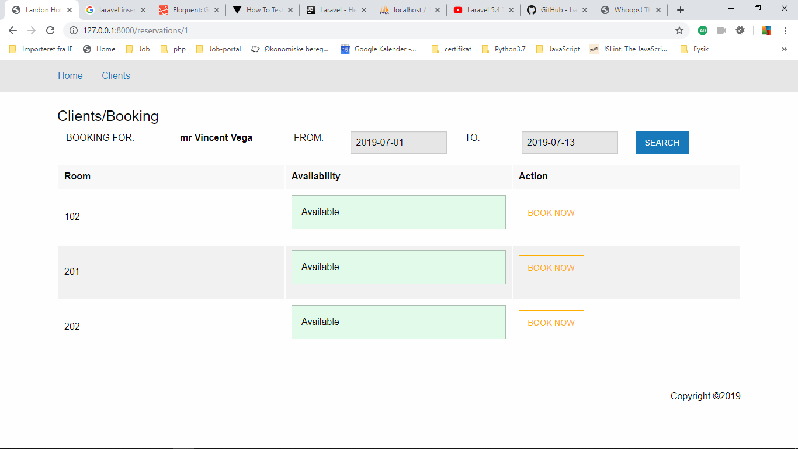

Add relational data

So for our last trick we need to book the room. Let's use the belongs to relationship to add a new reservation.

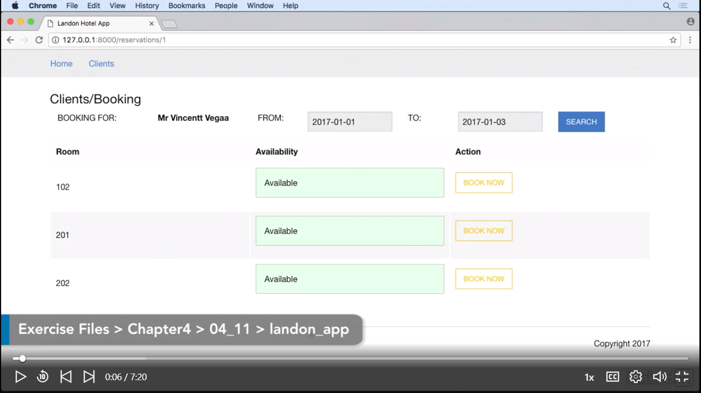

Så åbner vi vores model Reservation

C:\xampp\htdocs\landon_app_database\app\Reservation.php

Tilføjer room() function

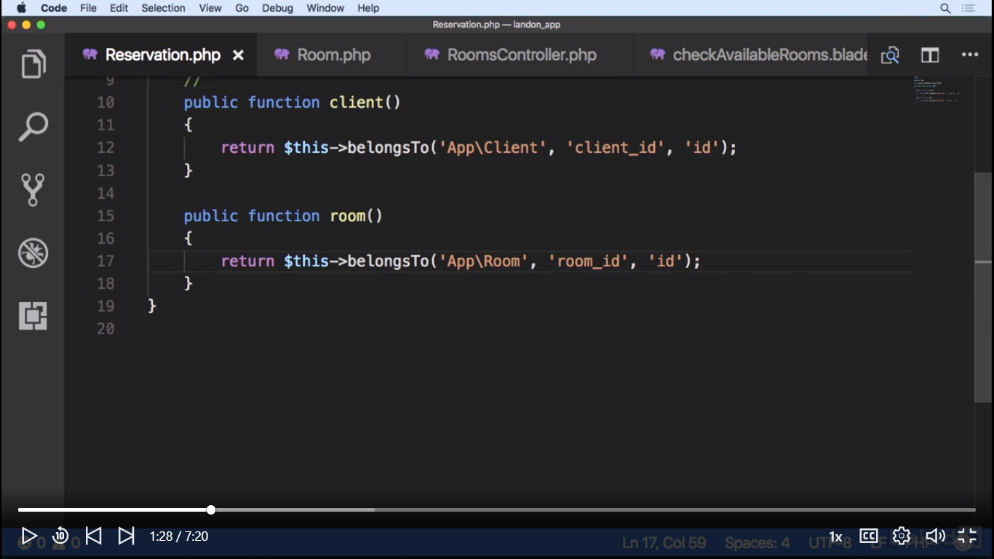

Så åbner vi C:\xampp\htdocs\landon_app_database\app\Http\Controllers\ReservationsController.php

**<?php  
  
namespace** App\Http\Controllers;  
  
**use** App\Client **as** Client;  
**use** App\Room **as** Room;  
**use** App\Reservation **as** Reservation;  
  
**use** Illuminate\Http\Request;  
  
**class** ReservationsController **extends** Controller  
{  
 //  
 **public function** bookRoom($client_id, $room_id, $date_in, $date_out)  
 {  
 $reservation = **new** Reservation();  
 $client_instance = **new** Client();  
 $room_instance = **new** Room();  
  
 $client = $client_instance->find($client_id);  
 $room = $room_instance->find($room_id);  
 $reservation->date_in = $date_in;  
 $reservation->date_out = $date_out;  
  
 //Finally for the magic part for this to work we need to tell the reservation  
 // to associate the room and the client and we do it this way.  
 // Reservation we call room and then we call associate with the object,  
 // room. We do the same for the client, reservation, client, associate but now with the client. The last thing we need to do is to save the reservation.  
 $reservation->room()->associate($room);  
 $reservation->client()->associate($client);  
  
 $reservation->save();  
 //for just test reasen  
 //return redirect()->route('clients');  
  
 **return** view('reservations/bookRoom');  
 }  
}

Concurrent connections

So the people at Landon Hotel have started using the application. However, they have reported that they still have the error that the application was supposed to fix and they're not happy about it.

Hvis kunder klikke to gange på book, så i databasen forekommer 2 gange på det samme dato som nedenfor

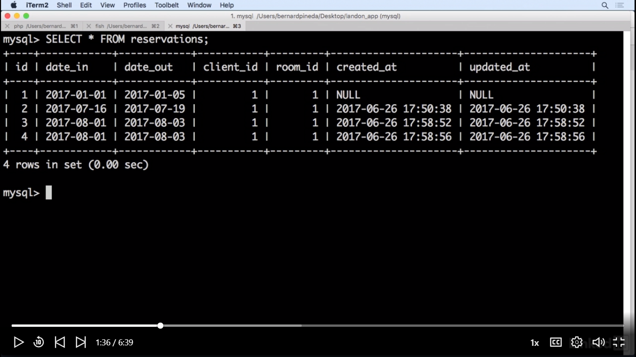

For at løse problemet laver vi en ny methode i room modelen:

C:\xampp\htdocs\landon_app_database\app\Room.php

**public function** isRoomBooked($room_id, $start_date, $end_date) {  
 $available_rooms = DB::table('reservations')  
 ->whereRaw("  
 NOT(  
 date_out < '{$start_date}' OR  
 date_in > '{$end_date}'  
 )  
   
 ")  
 ->where('room_id', $room_id)  
 ->count()  
 ;  
 **return** $available_rooms;  
}

Nu i ReservationController bruger vi metoden:

C:\xampp\htdocs\landon_app_database\app\Http\Controllers\ReservationsController.php

**class** ReservationsController **extends** Controller  
{  
 //  
 **public function** bookRoom($client_id, $room_id, $date_in, $date_out)  
 {  
 $reservation = **new** Reservation();  
 $client_instance = **new** Client();  
 $room_instance = **new** Room();  
  
 $client = $client_instance->find($client_id);  
 $room = $room_instance->find($room_id);  
 $reservation->date_in = $date_in;  
 $reservation->date_out = $date_out;  
  
 //Finally for the magic part for this to work we need to tell the reservation  
 // to associate the room and the client and we do it this way.  
 // Reservation we call room and then we call associate with the object,  
 // room. We do the same for the client, reservation, client, associate but now with the client. The last thing we need to do is to save the reservation.  
 $reservation->room()->associate($room);  
 $reservation->client()->associate($client);  
  
 //anvender vi metoden isRoomBooked($room_id, $start_date, $end_date)  
 //som ligger i Room modellen  
 **if** ($room_instance->isRoomBooked($room_id, $date_in, $date_out)) {  
 abort(405, 'Trying to book an already booked room');  
 }  
 $reservation->save();  
 //for just test reasen  
 //return redirect()->route('clients');  
  
 **return** view('reservations/bookRoom');  
 }  
}

The TDD paradigm

The TDD Paradigm, or Test-Driven Development is a way of developing software based on tests or test suites. It relies on testing tools to develop features that are tested from their conception. Requirements are written as test cases. Even if tests aren't passed, this is part of the paradigm. Tests are written before any code of the application. It might seem strange, but we could have a whole testing suite written prior to having any application code. In TDD, we strive to test if not all, most of our code. There are tools such as PHP units, code coverage, which gives us an estimate as to the percentage of tested code. The whole idea is that once we have the test or test suite, we write code to have these tests.

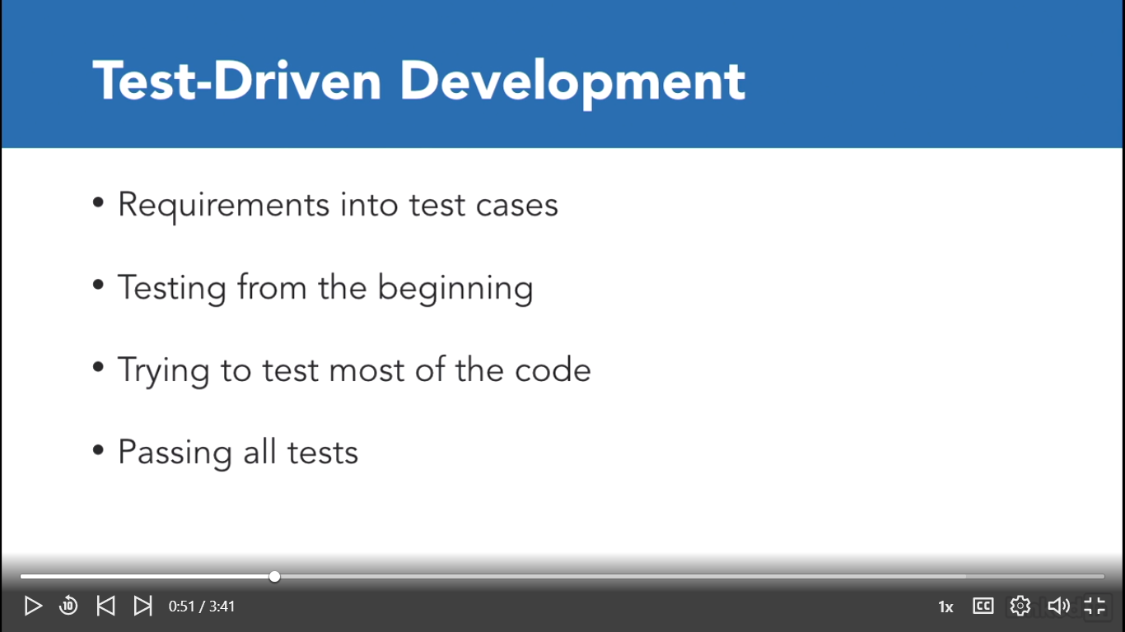

But now, let's take a look into the TDD Workflow. We will take a feature and abstract it into our software. Once we know what a feature is supposed to solve, then we write a test for that feature. We will run the test knowing it will not pass, since we haven't written a test to pass it. Once we confirm our testing mechanism is working correctly, we will write code to pass the test. Once the test has passed, we run the rest of the tests. Sometimes we may pass an individual test, but we may have broken something somewhere else. Once all tests have passed, we start improving our test to be more efficient. We refactor it.

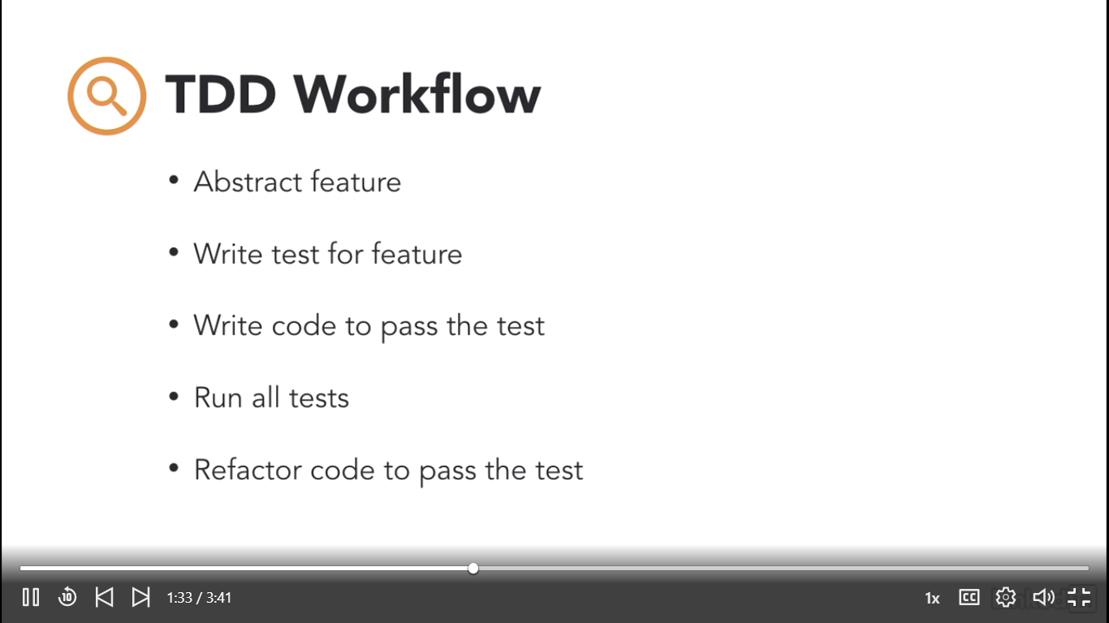

We will be using two types of testing. Unit testing refers to isolating a component and testing a component's functionality. With this type of testing, we may test a model away from the MBC context and determine if it works correctly. Functional testing refers to testing a feature with the whole context of the application.

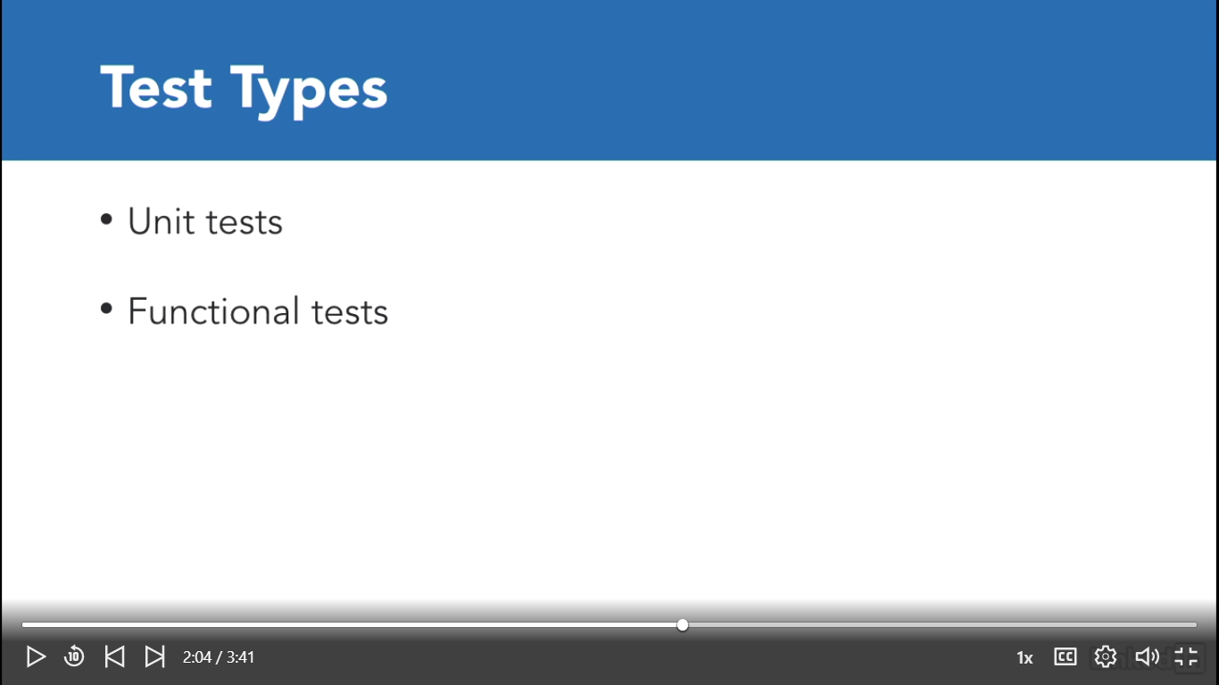

While there are more types of tests, we will only be seeing these two. In PHP, we have several tools we can use to implement TDD. As of now, PHPUnit is practically the most popular TDD tool there is in the market. It helps us with the creation of unit tests. PHPSpec is a testing tool to make behavior driven development tests. Tests are written more like a story than a test. Codeception is a tool set to write unit functional and acceptance tests. You may test a single class or framework component or a page. Selenium is a browser automation tool. It has a WebDriver API of its own to create browser automated tests. It is possible to test an entire web application as if it were a user on a web browser. Behat is an open source behavior driven development framework of PHP. It's heavily based on Symfony's components. And lastly, let's take a quick look at TDD Deployment Workflow. A staging environment will be an environment just like production, but without real customer data on the database. CircleCI can help us have this environment. We will also need the same test suite we used locally on this environment.  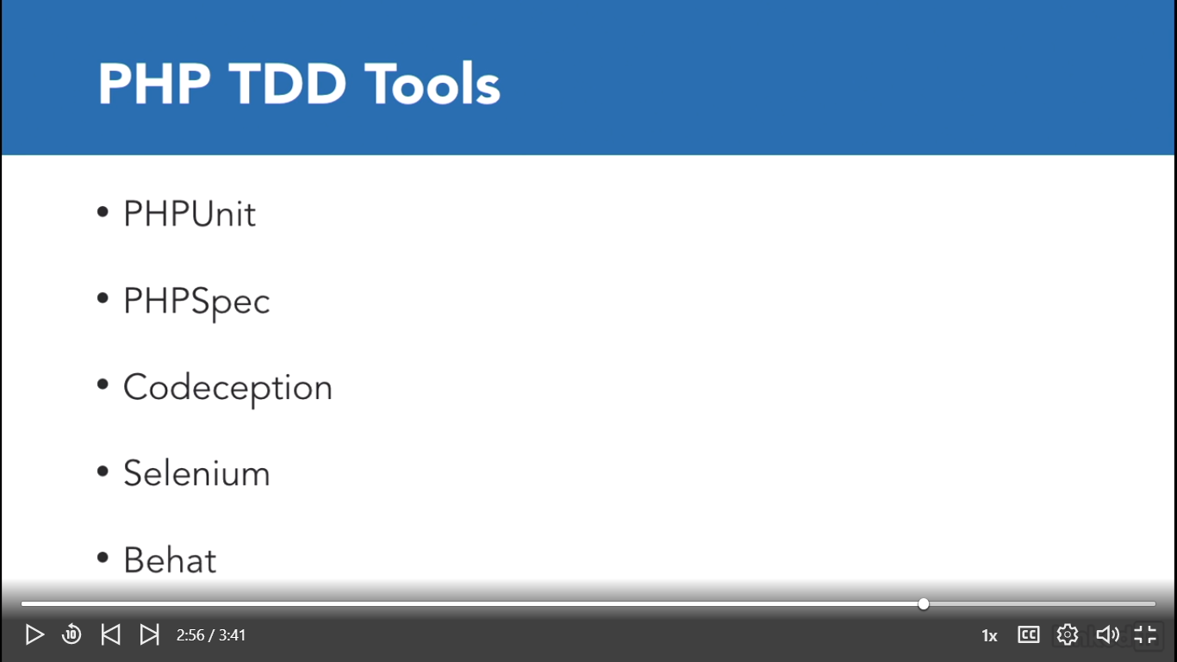

A possible scenario is the following: We develop a new feature, we test locally,  all of our tests pass so we now launch into staging. Staging will run the test again. And only if these tests pass on this environment, our code will be merged into our base code.

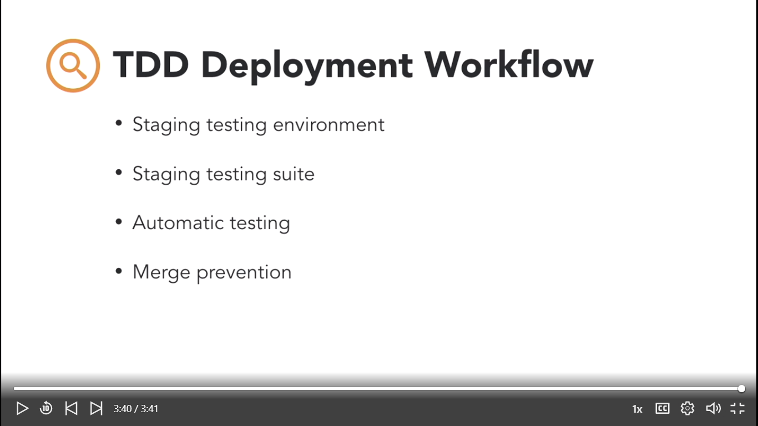

Build features with unit tests

So, the people at the Landon Hotel will be hosting a small get together, and one of the guests is a university professor. And the owner of the Landon Hotel wants to make a good impression with the professor. So, we've been asked to add a new title name, professor, to our select button on our client form. So, let's do a little TDD with this small new feature. 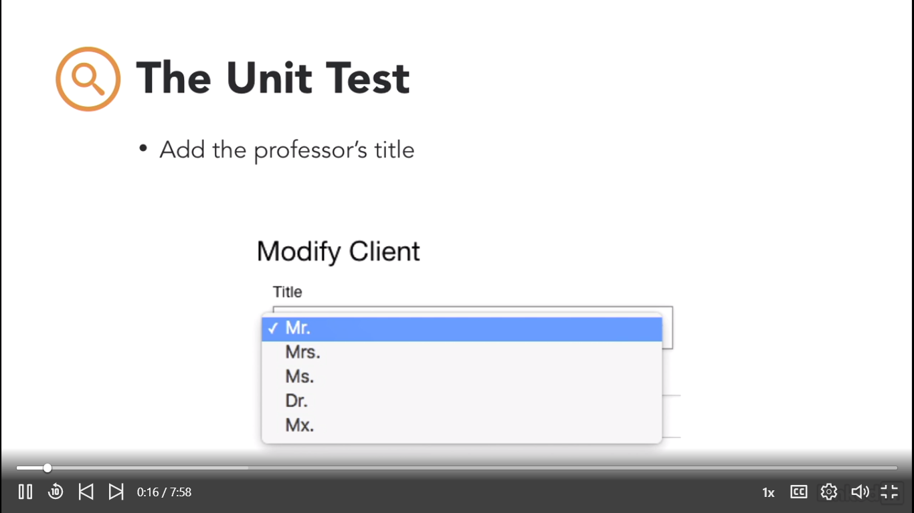

The workflow will be the following. We first write the test. We make sure the test works. And finally, we write the code to pass the test.

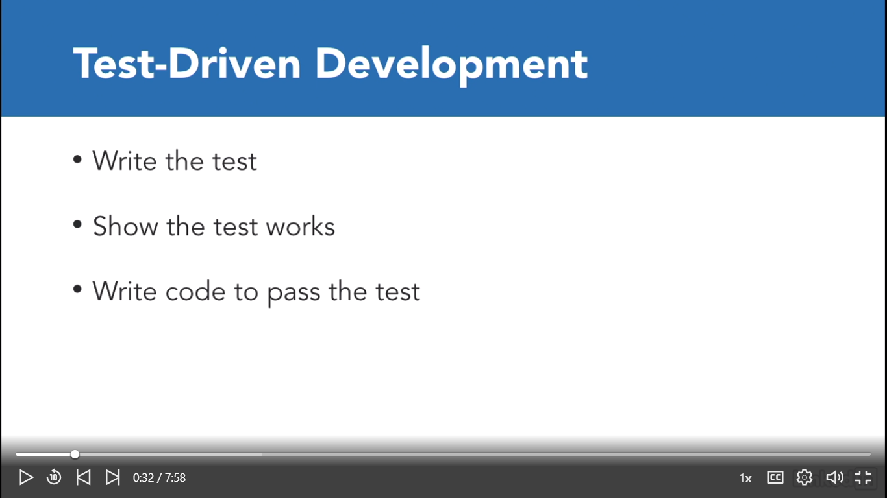

So we open the ExampleTest.php fil under:

C:\xampp\htdocs\landon_app_database\tests\Unit\ExampleTest.php

We add a new function called:

**<?php  
  
namespace** Tests\Unit;  
  
**use** Tests\TestCase;  
**use** Illuminate\Foundation\Testing\RefreshDatabase;  
  
**class** ExampleTest **extends** TestCase  
{  
 */**  
 * A basic test example.  
 *  
 \** ***@return*** *void  
 */* **public function** testBasicTest()  
 {  
 $this->assertTrue(**true**);  
 }  
  
 **public function** testTitlesModelCount() {  
 $value = 2;  
 $this->assertTrue( 1 === $value, 'Value should be 1');  
 }  
}

We open our termainal:

Application Security

### Handle volatile data with sessions

Sometimes our applications may need to use volatile data that we don't want to store in a database such as shopping cart contents or an access token.  It's information we may need now but not in the future.

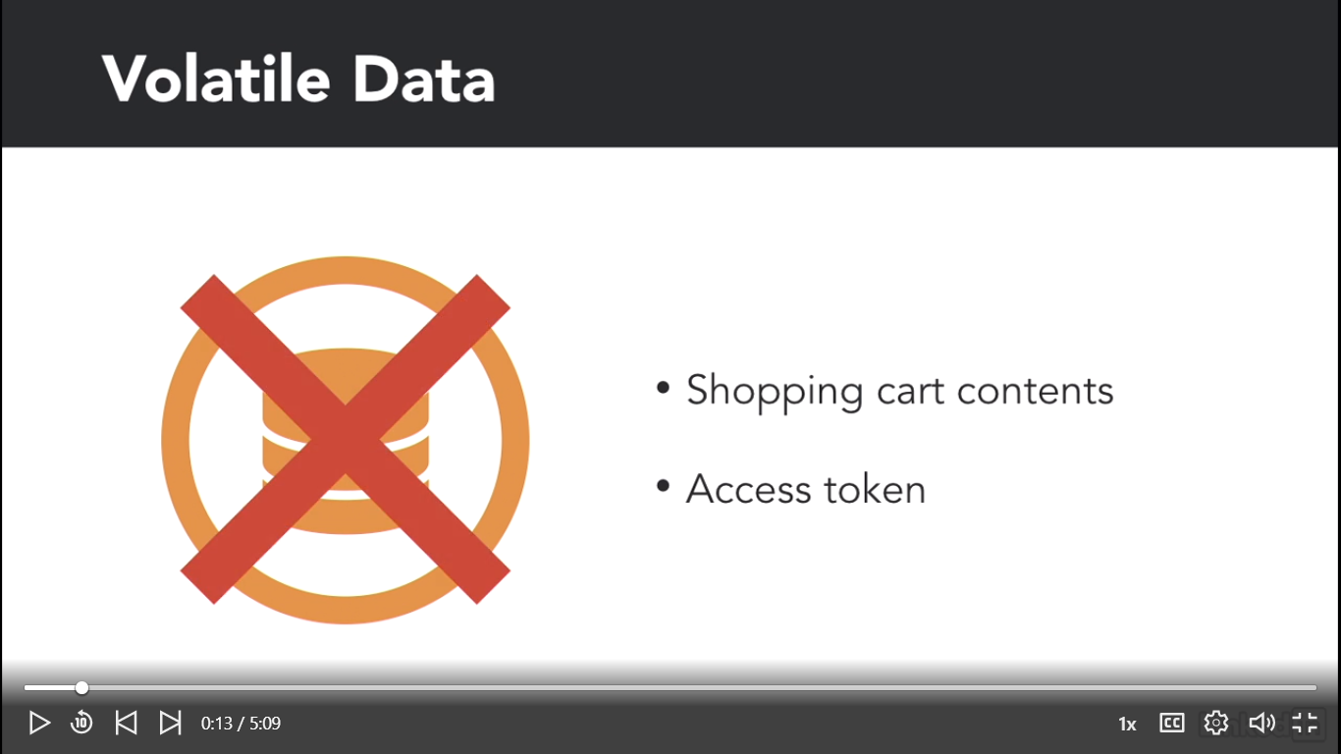

Not to worry people, sessions have come to the rescue by easily saving temporary data. We just need to keep in mind that the data is based on a cookie, so if cookies are disabled, we won't be able to use sessions. We are going to assume cookies will be enabled for the time being.

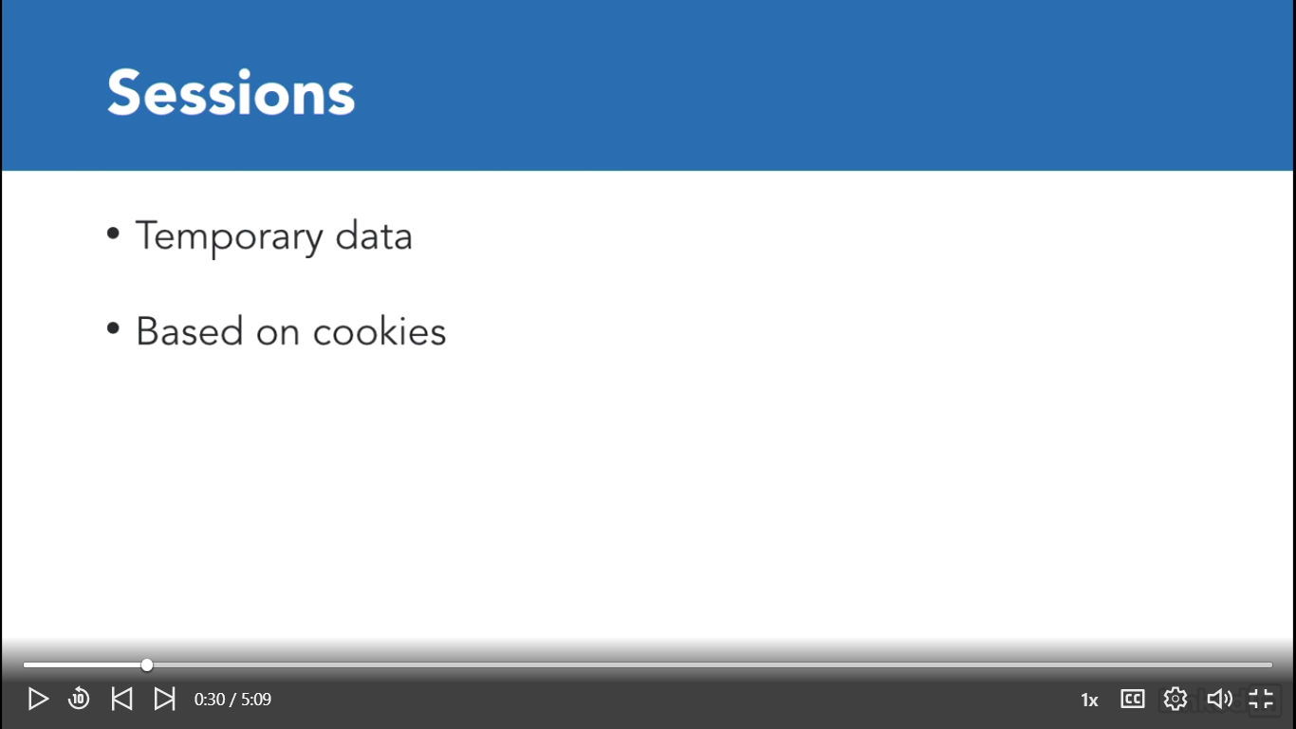

Let's open up visual studio code. Let's open the sidebar with command b or control b and let's close these files with right click and close all. And let's open our details page on our controllers on app, http, controllers, client controller.

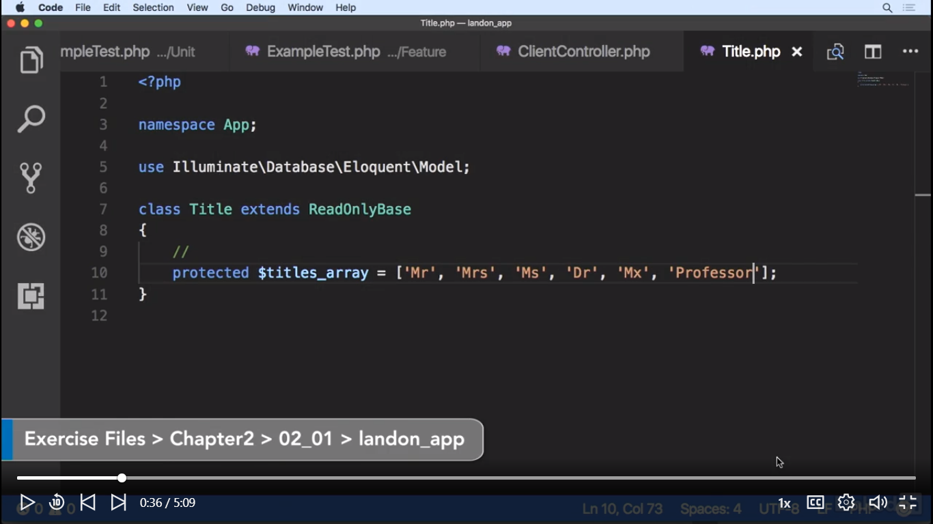

Let's close our sidebar with command b or control b. And on the show method, look for the show method on line 77 and now let's start using sessions with request, session, open and close parentheses and we're going to chain put, and let's add an index for this called last updated comma and let's get the name and the last name. So let's copy client data name. It's pasted on line 92. Concatenate with a space and concatenate with press enter here and let's copy and paste last name. And we save. With this we have told Laravel to store the first and last name of the updated client inside the session variables.

**public function** show($client_id, Request $request)  
{  
 $data = []; $data['client_id'] = $client_id;  
 $data['titles'] = $this->titles;  
 $data['modify'] = 1;  
 $client_data = $this->client->find($client_id);  
 $data['name'] = $client_data->name;  
 $data['last_name'] = $client_data->last_name;  
 $data['title'] = $client_data->title;  
 $data['address'] = $client_data->address;  
 $data['zip_code'] = $client_data->zip_code;  
 $data['city'] = $client_data->city;  
 $data['state'] = $client_data->state;  
 $data['email'] = $client_data->email;  
  
 //start using session  
 $request->session()->put('last_updated', $client_data->name.' '.  
 $client_data->last_name);  
   
 **return** view('client/form', $data);  
}

Now, if we were to define a simple variable in one method, whenever we opened another method on the browser, data would simply not be available for the second method. With sessions, it's different. Session variables are available across our application. So let's retrieve our session value in another page. Let's open our home controller, command b or control b to open the sidebar and let's open our contents controller and inside our home method, let's close the sidebar again, command b or control b, so let's add a last updated variable is equal to request session, open and close parentheses, let's chain and determine if it has the last updated index. If it's in the session values, let's set it with request, session, pull last updated. If it's not, then we just set it to none. Semicolon at the end.

**class** ContentsController **extends** Controller  
{  
 //  
 **public function** home(Request $request)  
 {  
 $data = [];  
 $data['version'] = '0.1.2';  
 $last_updated = $request->session()->has('last_updated') ?  
 $request->session()->pull('last_updated') : 'none';  
 $data['last_updated'] = $last_updated;  
 **return** view('contents/home', $data);  
 }  
}

And let's add this to the view with data, last updated, and let's set it to last updated. Now it's passing it to the view. Now let's also inject a request to the method with request, request. Now let's open up the view, the contents home view, with command p or control p, contents slash home and let's show it on the view with a new paragraph on line 13, we close the paragraph and with mustache syntax we'll just add last updated. Now let's save. We're going to open this in an incognito window so we can see that it's passed on cookies. So let's copy our url and open an incognito window with command shift n or control shift n. Let's paste and let's update the last record. We got an error. We forgot to inject the request variable, so let's go back to our code, let's go back to our clients controller, let's go to line 77 and let's add the request, and request variable. Let's refresh. And now we have it. So let's click on the home link and as you can see we are showing the session variables on the screen since we are seeing the Mia Wallace text and now if we open without the sessions and we refresh, it's going to show none because it's based on a cookie and this browser window does not have the same cookies as the incognito window(ctrl+shift+n). With sessions we can store temporary data such as username, if we didn't use sessions, we'd have to access the database with every page that we needed the name. It sounds like a waste using a query just to get a username.

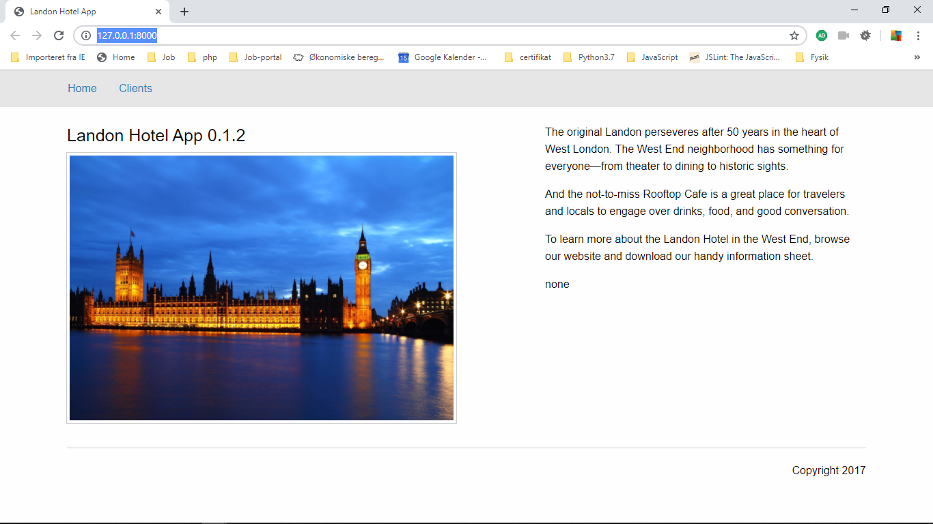

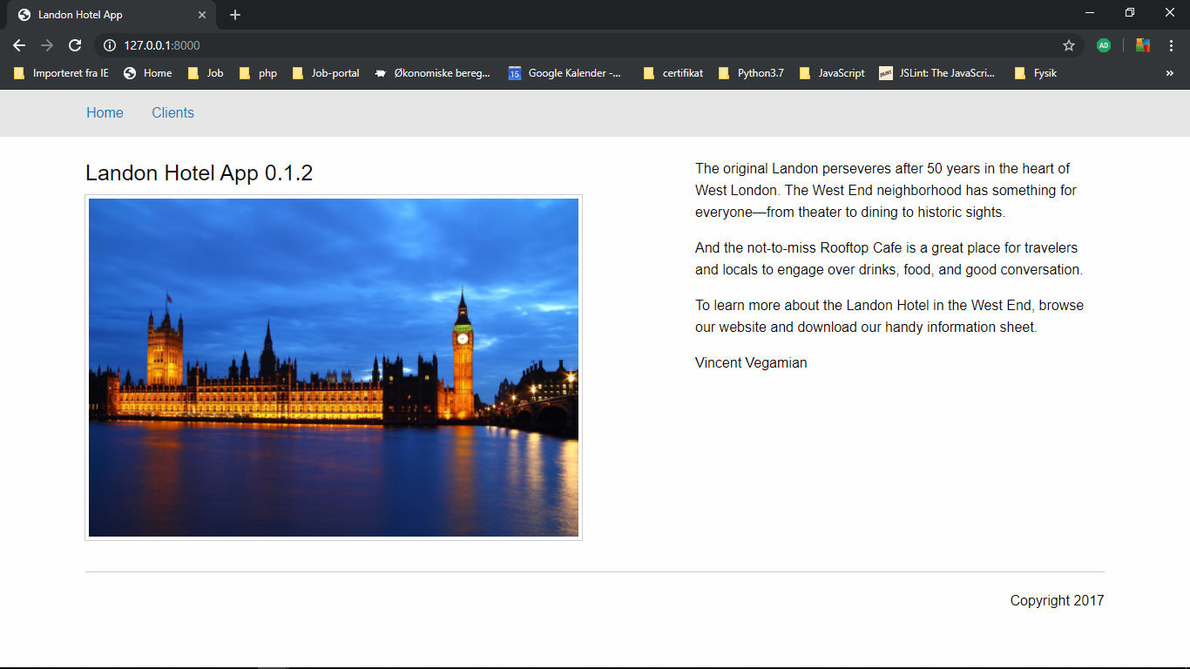

CSRF protection(Cross-Site Request Forgery attacks)

We want to keep our application simple, yet we don't want just anyone to be able to send data and make our application work. That is, unless we wanted to create an API. But since this is not the case, we want to avoid these so-called CSRF, or Cross-Site Request Forgery attacks. A Cross-Site Request Forgery attack implies that someone has figured out how our application works and wants to send garbage to our app. So, by sending the correct parameters, they could end up filling our database with thousands of useless records.

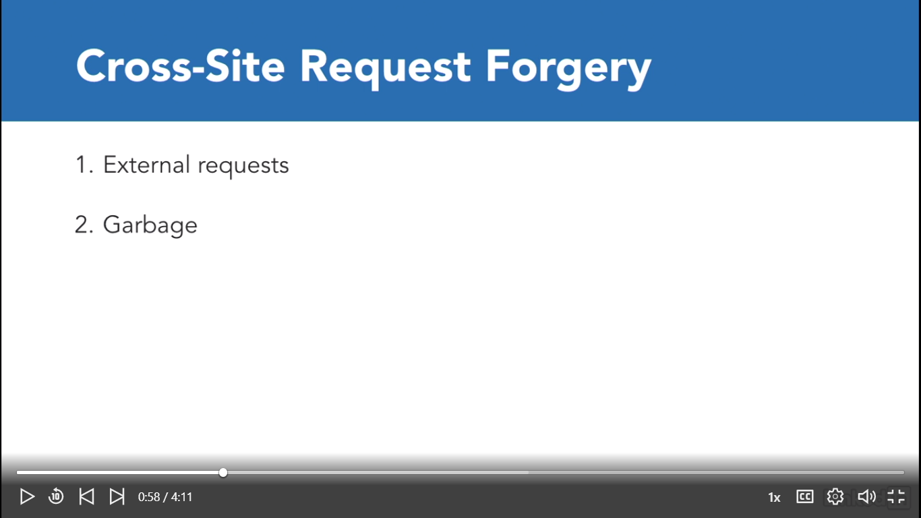

We could try and use PHP's referer value, but this can be easily spoofed since it's based on headers. Luckily for us, Laravel comes with a built-in middleware to handle this type of security. For the sake of development speed, all of our previous examples have the CSRF security check disabled.

Open:

C:\xampp\htdocs\landon_app_test\app\Http\Middleware\VerifyCsrfToken.php

**class** VerifyCsrfToken **extends** BaseVerifier  
{  
 */**  
 * The URIs that should be excluded from CSRF verification.  
 *  
 \** ***@var*** *array  
 */* **protected** $except = [  
 //  
 '*'  
 ];  
}

and remove ‘*’ to enable this.

**class** VerifyCsrfToken **extends** BaseVerifier  
{  
 */**  
 * The URIs that should be excluded from CSRF verification.  
 *  
 \** ***@var*** *array  
 */* **protected** $except = [  
 //  
 //'*'  
 ];  
}

Nu vi kan sende en form og får TokenMismatchException som nedenfor.

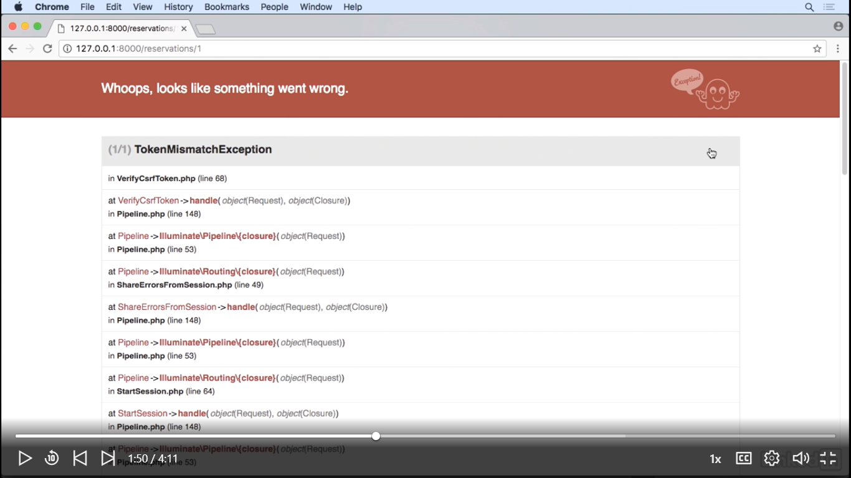

And we'll get a TokenMismatchException. So a Token Mismatch Exception simply means someone tried to do a request to our application without the proper data attached to it. So the way this works is that we generate that token for a request. We'll attach a token to the request, either by header or in an easier manner by adding a hidden field. Fortunately for us, Laravel has a helper for it. We just need to add the hidden field to every post delete request we might want to create. Let's add the hidden field to this form.

Open:

C:\xampp\htdocs\landon_app_test\resources\views\rooms\checkAvailableRooms.blade.php

And add {{ csrf_field() }} after form declaration

<div class="row">  
 <div class="medium-12 large-12 columns">  
 <h4>Clients/Booking</h4>  
 <div class="medium-2 columns">BOOKING FOR:</div>  
 <div class="medium-2 columns"><b>  
 {{$client->title}}   
 {{$client->name}}   
 {{$client->last_name}}  
 </b></div>  
 <form action="" method="post">  
 {{ csrf_field() }}  
 <div class="medium-1 columns">FROM:</div>  
 <div class="medium-2 columns"><input name="dateFrom" value="{{ $dateFrom }}" type="text" class="datepicker" /></div>  
 <div class="medium-1 columns">TO:</div>  
 <div class="medium-2 columns"><input name="dateTo" value="{{ $dateTo }}" type="text" class="datepicker" /></div>  
 <div class="medium-2 columns"><input class="button" type="submit" value="SEARCH" /></div>  
 </form>

Og tester med at klikke på SEARCH vi får ingen fejl som nedenfor

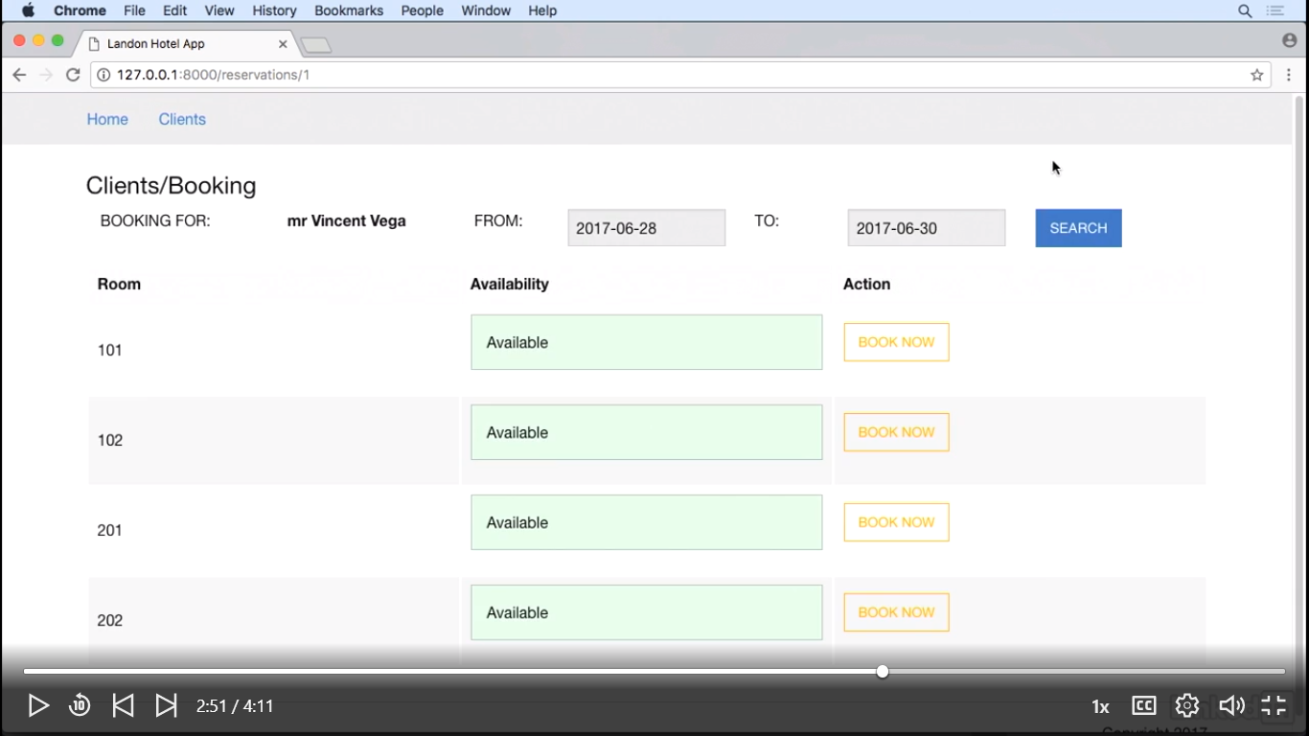

Vi få stadigvæk samme fejl, hvis vi klikke på EDIT så skal vi lave det samme for form.

C:\xampp\htdocs\landon_app_test\resources\views\client\form.blade.php

Så tilføjer vi {{ csrf_field() }}

Efter form declaration

<div class="row">  
 <div class="medium-12 large-12 columns">  
 <h4>{{ $modify == 1 ? 'Modify Client' : 'New Client' }}</h4>  
 <form action="{{ $modify == 1 ? route('update_client', [ 'client_id' => $client_id ]) : route('create_client') }}" method="post">  
 {{ csrf_field() }}   
 <div class="medium-4 columns">  
 <label>Title</label>  
 <select name="title">  
 **@foreach(** $titles **as** $title **)** <option value="{{ $title }}" >{{ $title }}.</option>  
 **@endforeach**

 We could also do it in Ajax request, but no part of this application is using Ajax request. This was a teaching exercise. In a real live scenario, we would do the CSRF checks as we build our forms. We would never disable the CSRF token check. And now, we are ready for our login.

Create a login form

We 've covered how to handle sessions let's take a look at how we can use them to create a login system for our app. Laravel comes with an integrated login mechanism. So let's set up our login form. So out of the box, Laravel comes ready to implement authentication and not only that it also comes with the controllers associated with this functionality. If we open our app,http controllers folder, auth folder we have our login, register, forgot password, and reset password controllers.

C:\xampp\htdocs\landon_app_test\app\Http\Controllers\Auth\ForgotPasswordController.php

C:\xampp\htdocs\landon_app_test\app\Http\Controllers\Auth\LoginController.php

C:\xampp\htdocs\landon_app_test\app\Http\Controllers\Auth\RegisterController.php

C:\xampp\htdocs\landon_app_test\app\Http\Controllers\Auth\ResetPasswordController.php

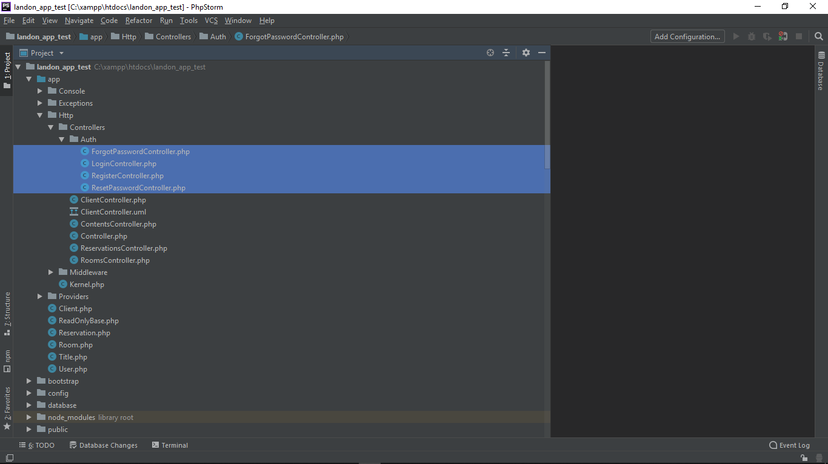

Let's close this one out and open our database migrations folder. Besides the migrations that we created for our client's rooms and reservations, we also already have migrations for a user table and also for password resetting. Since at this point we've already run our migrations we have both tables.

C:\xampp\htdocs\landon_app_test\database\migrations\2014_10_12_000000_create_users_table.php

C:\xampp\htdocs\landon_app_test\database\migrations\2014_10_12_100000_create_password_resets_table.php

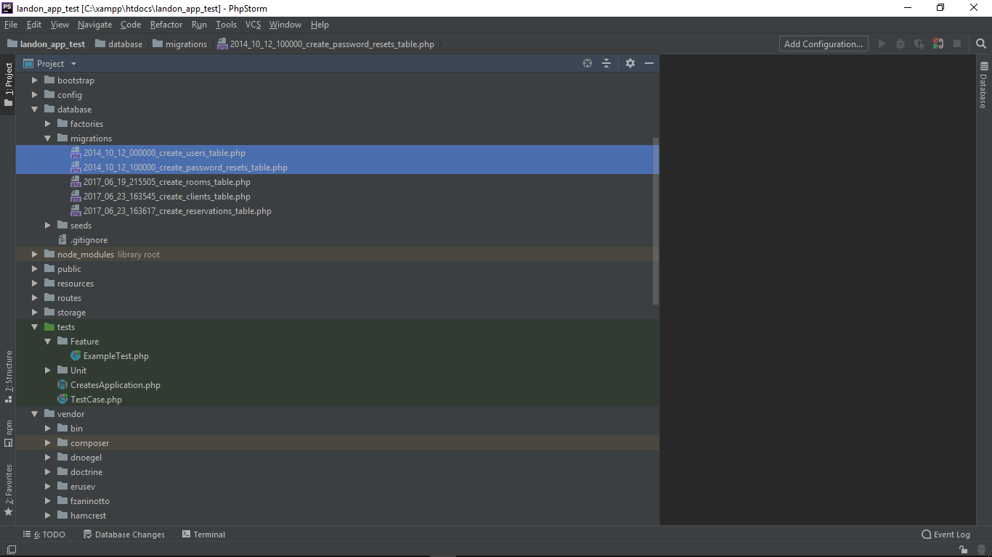

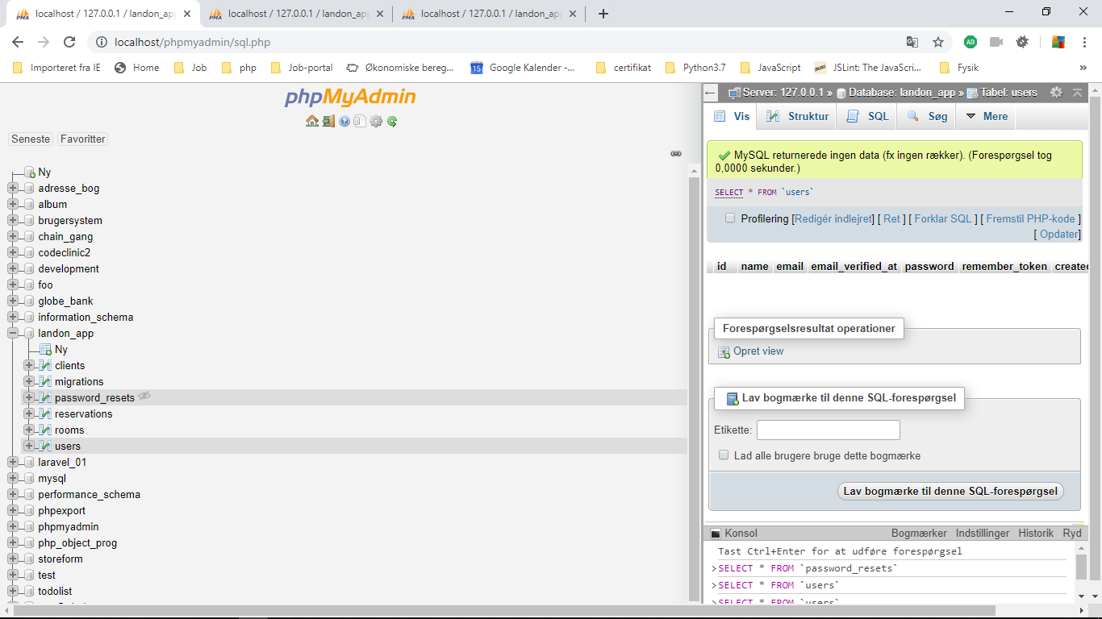

let's run php artisan make colon auth. This will create our login views.

**Husk**Der skal ikke laves ny layout/app.blade.php

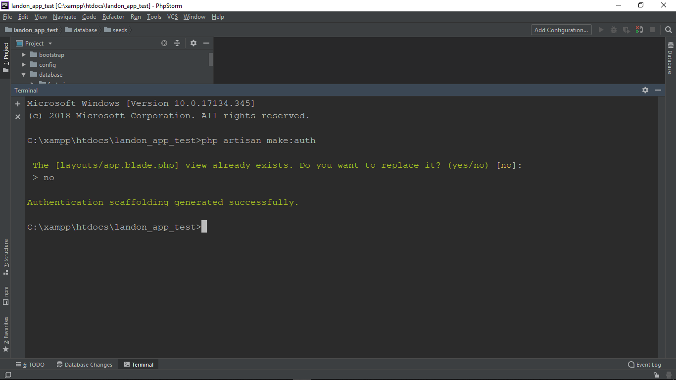

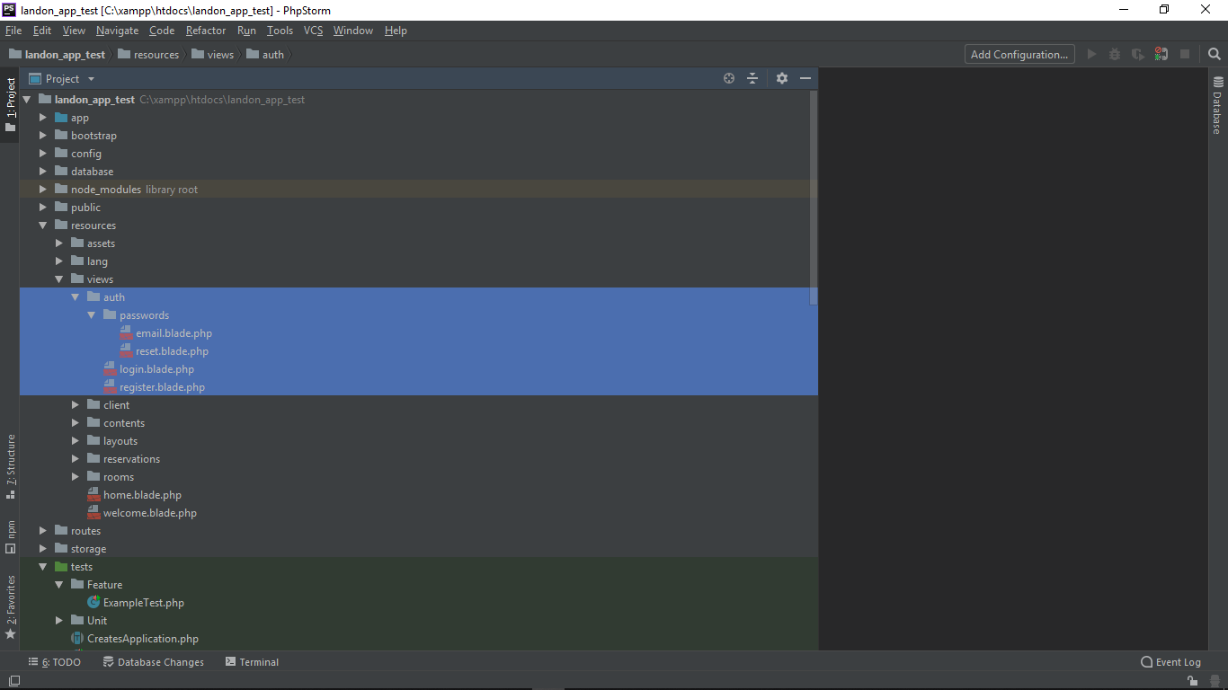

Derefter starter vi vores server: og til <http://127.0.0.1:8000/login>

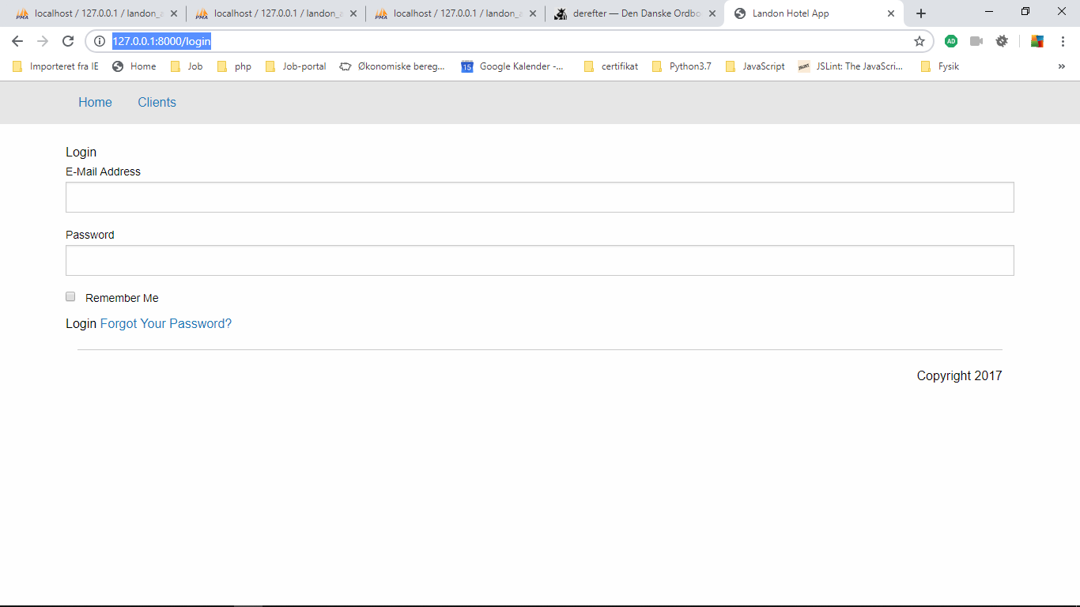

It's login and we have our login form however the views are configured to use the bootstrap front and framework but for our views and styles we have been using the foundational front and framework. So let's keep using our foundation classes.

Derfor åbner vi: C:\xampp\htdocs\landon_app_test\resources\views\auth\login.blade.php

And now let's look for the button that sends the form it should be on the form button right here and let's change the class to button success.

<div class="form-group">  
 <div class="col-md-8 col-md-offset-4">  
 <button type="submit" class="btn btn-primary">  
 Login  
 </button>

Ændres til:

<div class="form-group">  
 <div class="col-md-8 col-md-offset-4">  
 <button type="submit" class="button success hollow">  
 Login  
 </button>

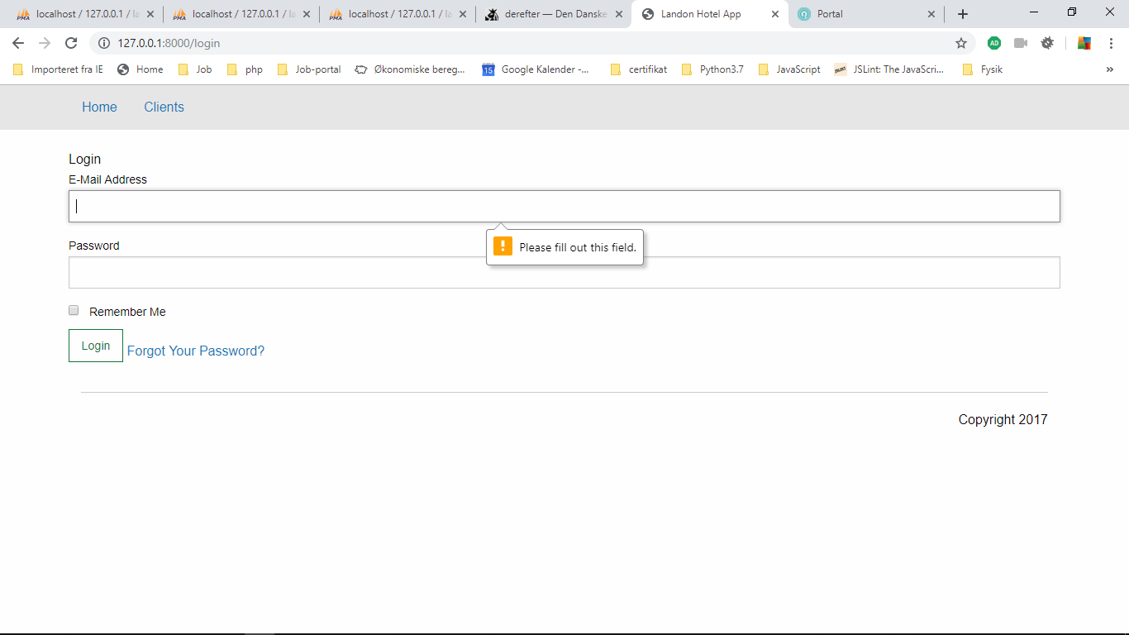

Ved at klikke på Login knappen, viser det sig, at vi har alledred validation på formen.

Make the login form work

So in order for our login form to work, we need to do a couple of things first. Let's first tweak our login controller.

C:\xampp\htdocs\landon_app_test\app\Http\Controllers\Auth\LoginController.php

**protected** $redirectTo = '/home';

ændres til:

**protected** $redirectTo = '/clients';

Now, let's add a user manually on the database. Let's generate a password. So let's open up our route web file, with command-p or control-p, web.php.And let's create a new route, and let's call it route, colon, colon, get. And in single quotes, generate/password.

Åben: C:\xampp\htdocs\landon_app_test\routes\web.php

Og tilføjer

Route::*get*('/generate/password', **function** (){  
 **return** bcrypt('123456789');  
});

Og åbner browseren: <http://127.0.0.1:8000/generate/password>

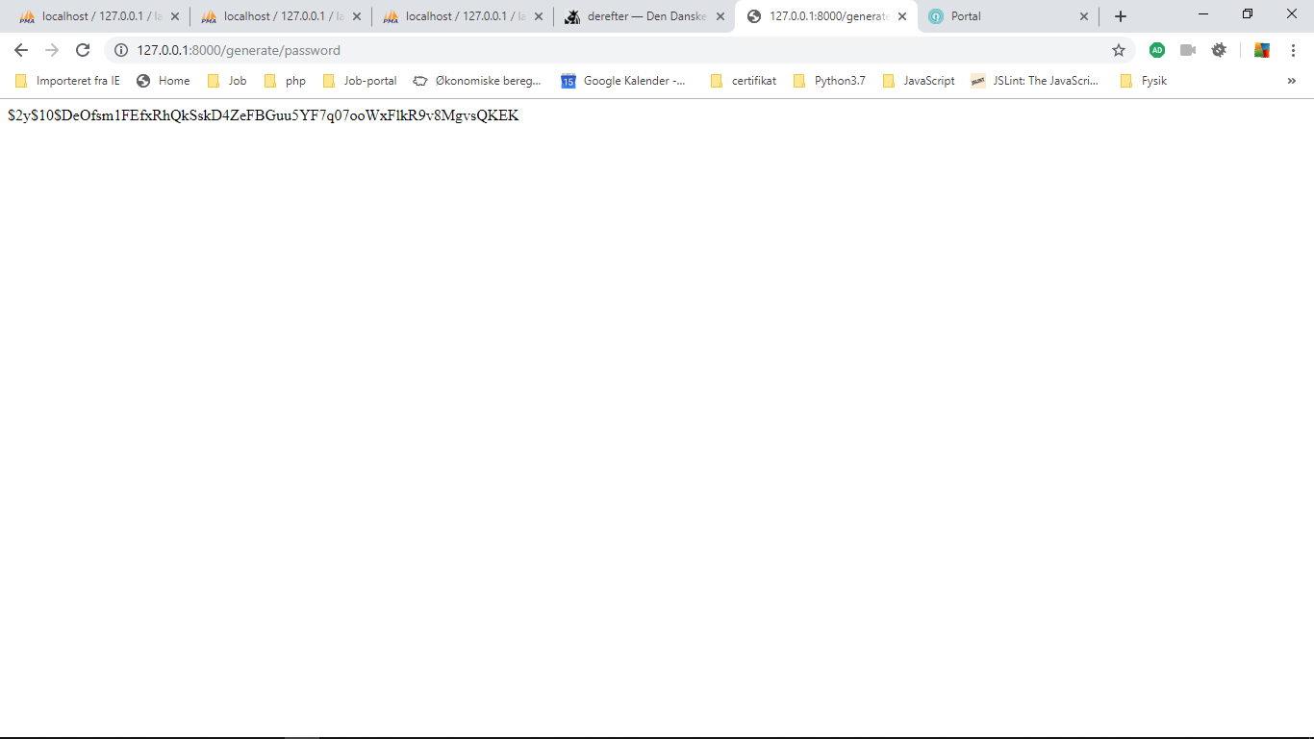

**husk** hvergang vi laver en refresh, ændres værdien i browseren.

Now if we refresh, it will change. This is because bcrypt is a non-deterministic function, which means that, even under the same circumstances, it won't return the same value, much like a date function with seconds and milliseconds. So let's just copy this string on the browse.

And let's go to our database. And let's run the following command. Insert into users values, and we start adding the values, this is going to be null,the user is going to be admin, and the username is going to be admin@example.com, comma, single quotes again, we paste, close single quotes, comma, null, null, null.

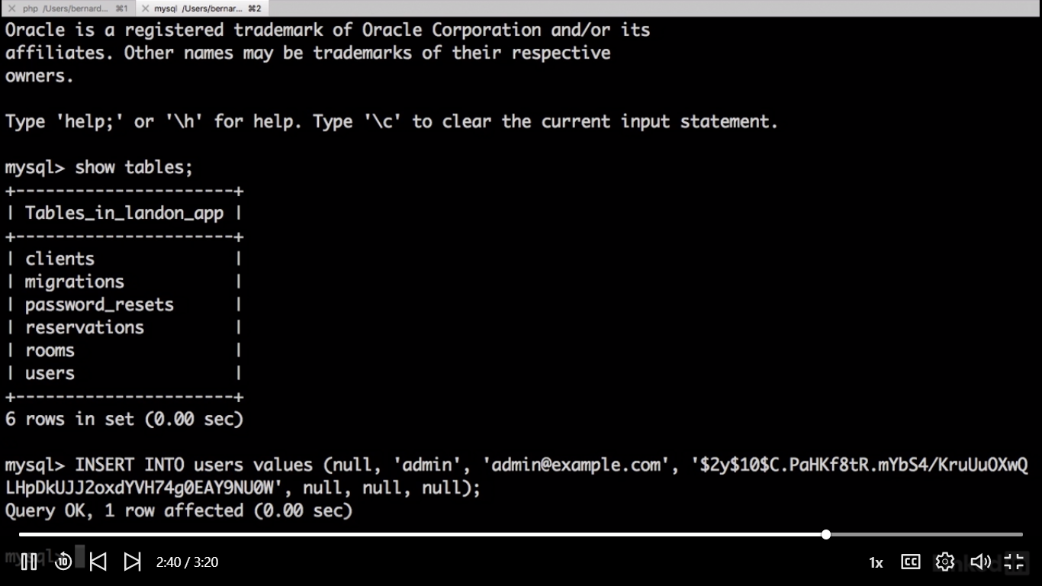

INSERT INTO `users` VALUES (null,'admin','admin@example.com', 'admin@example.com','$2y$10$DeOfsm1FEfxRhQkSskD4ZeFBGuu5YF7q07ooWxFlkR9v8MgvsQKEK', null,null,null);

NU logger vi med user : [admin@example.com](mailto:admin@example.com) password: 1234

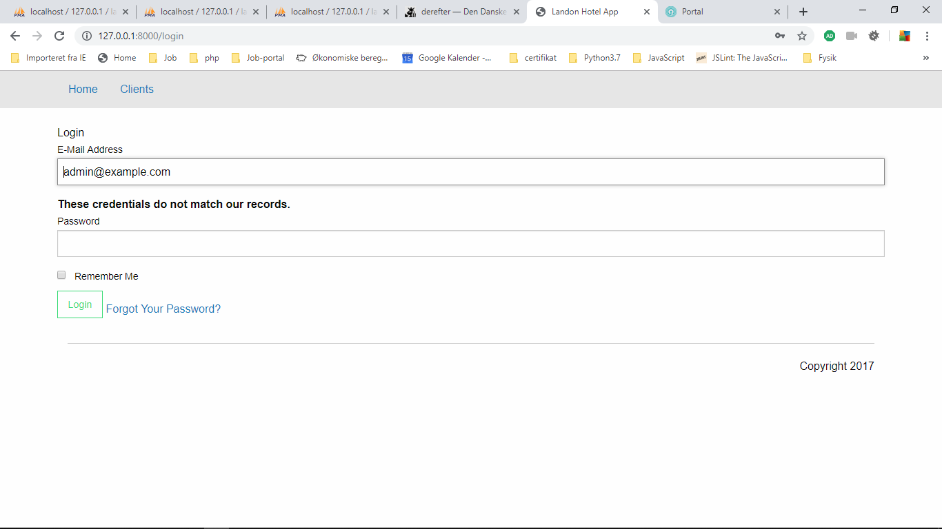

Derefter logger vi med NU logger vi med user : [admin@example.com](mailto:admin@example.com) password: 123456789

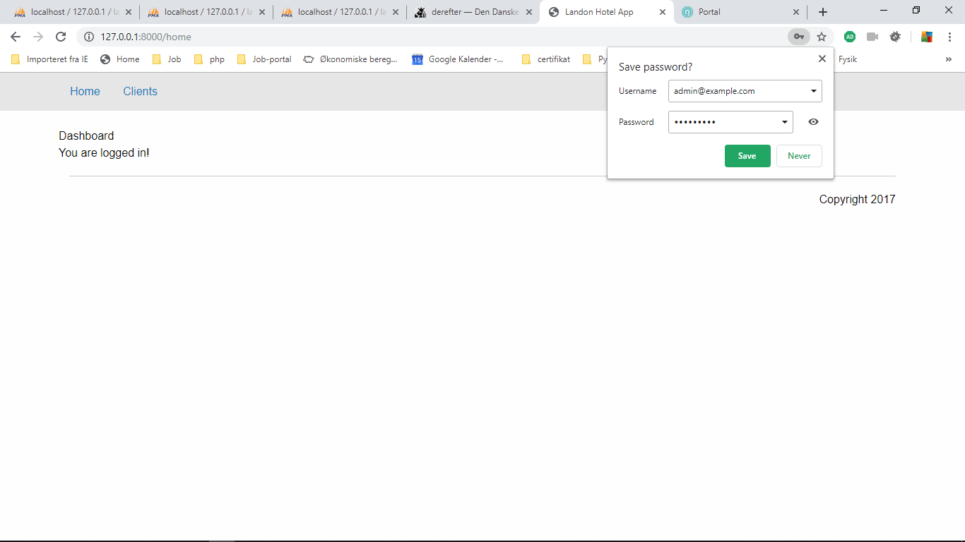

Application authentication

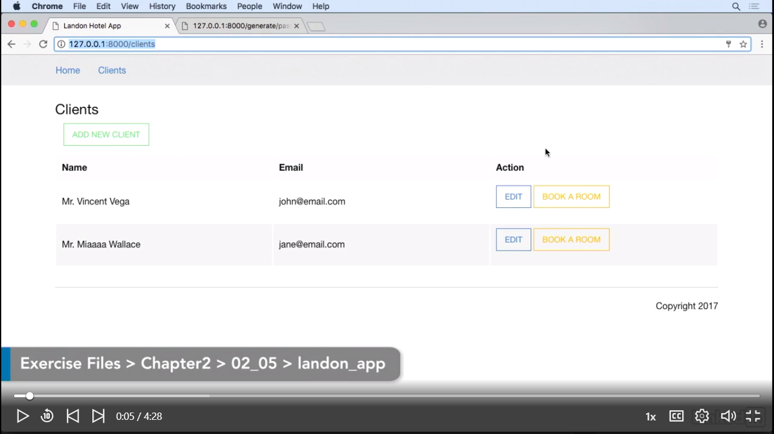

So now that we have our login ready, we need to restrict access to our resources. If we open a browser and open a window in incognito mode, and open our client's URL, we still have access to our client's data, even if we didn't log in. This is because we haven't told Laravel that these resources are restricted. Fortunately, Laravel already comes with a middleware to do this. So let's do it. Let's open Visual Studio code, and let's go to our web routes. Let's close our sidebar with control + b or command + b, and let's go to our client's route on line 15, and let's add the middleware to this route. You can do this by chaining middleware and inside middleware, between single quotes, off.

Så åbner vi : C:\xampp\htdocs\landon_app_test\routes\web.php

Route::*get*('/clients', 'ClientController@index')->name('clients')

->middelware('auth');

Åbner vi igen browseren for at tjekke i incontingent browser og kræver login.

You can do this by chaining middleware and inside middleware, between single quotes, off. So if we go back to our incognito window, and refresh, we're going to get redirected to our login page. We could do this for every route that we have. However, we have a simple way of doing it by groupingand assigning middleware to a group. So let's go back to our routes file.

C:\xampp\htdocs\landon_app_test\routes\web.php

And make authorized all routs from:

**<?php**/*  
|--------------------------------------------------------------------------  
| Web Routes  
|--------------------------------------------------------------------------  
|  
| Here is where you can register web routes for your application. These  
| routes are loaded by the RouteServiceProvider within a group which  
| contains the "web" middleware group. Now create something great!  
|  
*/  
  
Route::*get*('/', 'ContentsController@home')->name('home');  
Route::*get*('/clients', 'ClientController@index')->name('clients')->middleware('auth');  
Route::*get*('/clients/new', 'ClientController@newClient')->name('new_client');  
Route::*post*('/clients/new', 'ClientController@newClient')->name('create_client');  
Route::*get*('/clients/{client_id}', 'ClientController@show')->name('show_client');  
Route::*post*('/clients/{client_id}', 'ClientController@modify')->name('update_client');  
  
Route::*get*('/reservations/{client_id}', 'RoomsController@checkAvailableRooms')->name('check_room');  
Route::*post*('/reservations/{client_id}', 'RoomsController@checkAvailableRooms')->name('check_room');  
  
Route::*get*('/book/room/{client_id}/{room_id}/{date_in}/{date_out}', 'ReservationsController@bookRoom')->name('book_room');

To:

Route::*middlware*('auth')->group(**function** (){  
   
 Route::*get*('/', 'ContentsController@home')->name('home');  
 Route::*get*('/clients', 'ClientController@index')->name('clients');  
 Route::*get*('/clients/new', 'ClientController@newClient')->name('new_client');  
 Route::*post*('/clients/new', 'ClientController@newClient')->name('create_client');  
 Route::*get*('/clients/{client_id}', 'ClientController@show')->name('show_client');  
 Route::*post*('/clients/{client_id}', 'ClientController@modify')->name('update_client');  
  
 Route::*get*('/reservations/{client_id}', 'RoomsController@checkAvailableRooms')->name('check_room');  
 Route::*post*('/reservations/{client_id}', 'RoomsController@checkAvailableRooms')->name('check_room');  
  
 Route::*get*('/book/room/{client_id}/{room_id}/{date_in}/{date_out}', 'ReservationsController@bookRoom')->name('book_room');  
  
});

For at teste kan vi for example : <http://127.0.0.1:8000/clients/4>

Og vi sendes tilbage til login page.

And now we can open Clients, Edit, Clients Book, and now, for our last trick, we're going to create the logout link of our system.

So open C:\xampp\htdocs\landon_app_test\resources\views\layouts\app.blade.php

og tilfjøjer vi logout form

<div class="top-bar-right">  
 <ul class="dropdown menu" data-dropdown-menu="tckp8q-dropdown-menu" role="menubar">  
 <li role="menuitem">  
 <a href="{{ route('logout') }}"  
 onclick="event.preventDefault();  
 document.getElementById('logout-form').submit();">  
 Logout  
 </a>  
 <form id="logout-form" action="{{ route('logout') }}" method="POST" style="display: none;">  
 {{ csrf_field() }}  
 </form>  
 </li>  
 </ul>  
</div>

Og I browseren har vi Logout bar.

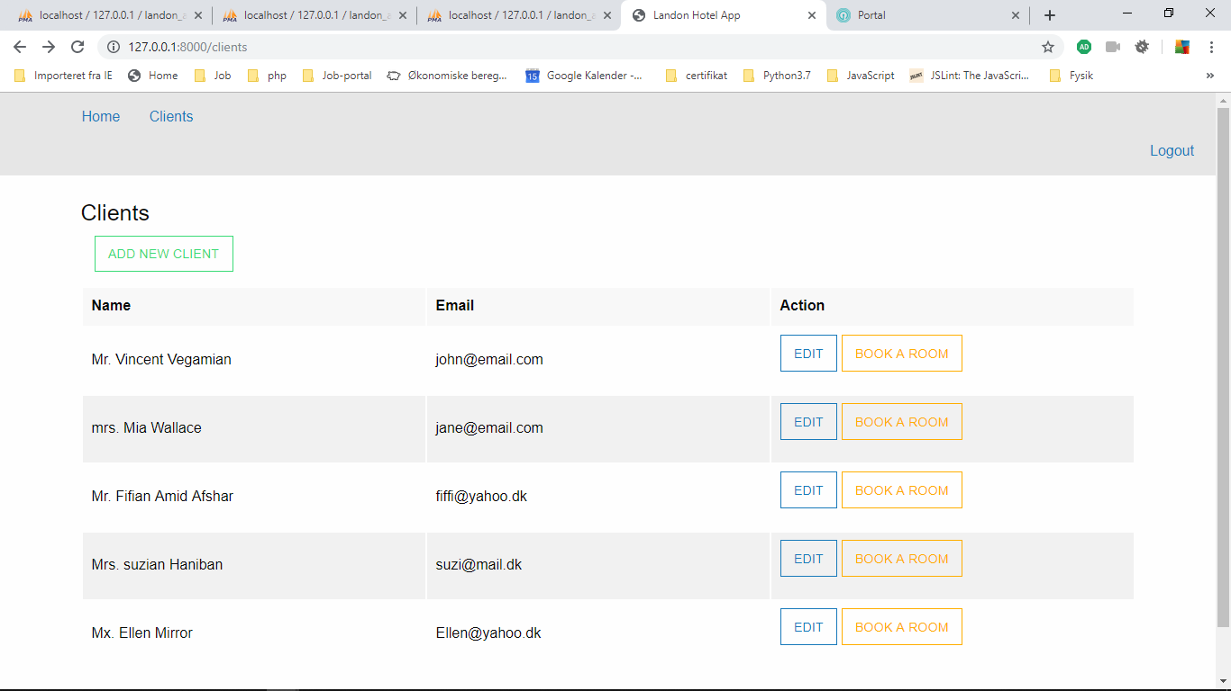

For at teste klikker vi på logout og se, at url´ er kræver login.

Force a download

C:\xampp\htdocs\landon_app_test\storage\framework\views\8c897515fac00c4540621bb2308de854ecd59178.php